Year 5 - Arithmetic Expectations
This series of documents aims to summarise the number facts, mental calculation strategies and the stage(s) of the progression towards the written methods for each of the four operations.
For each strategy, the concrete and pictorial representations have been suggested. However, to keep the document to a more manageable size, the imagery has not been shown explicitly as this should be found in your school’s agreed mental calculations policies.
The strategies used within this document are taken from the Lancashire Mathematics Team Progression in Mental Calculation Strategies Policies and the Progression Towards Written Methods Policies.
See www.lancsngfl.ac.uk/curriculum/primarymaths for the full policies.

Each strategy will require specific modelling (teaching) and sufficient practice for children to develop confidence, accuracy and fluency in performing them.
Children should also be taught when it is appropriate to use each strategy, by looking at the numbers involved and making effective decisions. Again, this is a sign of a child’s fluency in mathematics; being able to recognise which strategy best suits a given calculation, rather than always using the same method regardless of the numbers involved.

Acknowledgements
Special thanks to the following teachers who helped to create these documents:
Sue Byrom – Colne Park Primary Naomi Tyson – Gisburn Road Community Primary Hannah Blackburn – Lowerhouse Juniors
Tara Warbrick – Colne Park Primary Nick Browne – Gisburn Road Community Primary Jess Dornan – Lowerhouse Juniors
Jane Dempsey – Burnley Springfield Primary Laura Mitchell – Burnley St Stephen’s CE Primary Michelle Hume – Whittlefield Primary
Andrew Douglas – Burnley Springfield Primary Moira Waller – Burnley St Stephen’s CE Primary Stephen Riley – Whittlefield Primary

Arithmetic Expectations – Year 5
Skills | Examples
Counting
Count forwards or backwards in steps of powers of 10 for any given number up to  1 000 000. | Count on from 34 642 in hundreds.  What four numbers would come next in this counting sequence? 422 734, 412 734…
Count forwards or backwards in decimal steps. | Continue this count: 4.4, 3.8, 3.2,…  What four numbers would come next in this counting sequence? 2.16, 2.27, 3.38…
Find 0.01, 0.1, 1, 10, 100, 1000 and other powers of 10 more or less than a given number. | 154 041 – 100 474 985 + 1 000 202 883 – 10 000  23.47 + 0.1 6.07 – 0.1 31.09 + 0.01 12.3 – 0.01
Number Facts
Recall addition and subtraction facts for 1 and 10 (with numbers to one decimal place). | 0.6 + 0.4 = __ 0.2 + __ = 1 1 = __ + 0.5 1 – 0.3 = __ 1 – __ = 0.1 0.7 = 1 – __  1.3 + 8.7 = __ 2.5 + __ = 10 10 = __ + 4.6 10 – 5.2 = __ 10 – __ = 6.3 1.9 = 10 – __
Recall related tables facts for multiples of 10 | 70 x 6  8 x 40  90 x 6
Recall prime numbers up to 19 | Instantly know the prime numbers 2, 3, 5, 7, 11, 13, 17 and 19
Recall square (²) numbers up to 12 x 12 | Instantly know the square of all numbers to 12:  1² = 1, 2² = 4, 3² = 9, 4² = 16, 5² = 25, 6² = 36, 7² = 49, 8² = 64, 9² = 81, 10² = 100, 11² = 121 and 12² = 144
Mental Calculation Strategies – Addition and Subtraction
Derive and use addition and subtraction facts for 1 (with decimal numbers to two decimal places)  Concrete – (if necessary) place value counters  Pictorial – number line | 0.45 + __ = 1  __ + 0.27 = 1  1 = 0.39 + __  1 = __ + 0.78  1 – 0.08 = __  1 – __ = 0.61  0.54 = 1 – __  __ = 1 – 0.89

Partition and combine multiples of thousands hundreds, tens and ones.  Concrete (if necessary) – place value counters  Pictorial – number line | 4300 + 1400 4300 add 1000 = 5300 then add 400 = 5700  364 + 250 364 add 200 = 564 then add 50 = 614  3600 – 1200 3600 subtract 1000 = 2600 then subtract 200 = 2400  432 – 240 432 subtract 200 = 232 then subtract 40 = 192  5124 + 1352 5124 add 1000 = 6124 then add 300 = 6424 then add 50 = 6474  then add 2 = 6476  (not crossing any boundaries)  7584 – 2351 7584 subtract 2000 = 5584 then subtract 300 = 5284 then subtract 50 = 5234 then subtract 1 = 5233  (not crossing any boundaries)
Partition and combine multiples of ones and tenths.  Concrete (if necessary) – place value counters  Pictorial – number line | 5.4 + 3.2 5.4 add 3 = 7.4 then add 0.2 = 7.6  4.7 – 2.5 4.7 subtract 2 = 2.7 then subtract 0.5 = 2.2
Identify and use knowledge of number bonds within a calculation and identify related facts, e.g. 1.5 + 2.7 from 15 + 27  Concrete (if necessary) – place value counters | 1.2 + 0.8 using knowledge of 12 + 8 = 20  2.5 + 1.3 using knowledge of 25 + 13 = 38  3.8 + 4.5 using knowledge of 38 + 45 = 83  2 – 0.7 using knowledge of 20 – 7 = 13  4.6 – 1.5 using knowledge of 46 – 15 = 31  8.3 – 5.4 using knowledge of 83 – 54 = 29
Bridge through 10 when adding or subtracting a single digit number (partitioning, e.g. 58 + 5 = 58 + 2 + 3 or 76 – 8 = 76 – 6 – 2)  Concrete (if necessary) – Diennes equipment, place value counters  Pictorial – number line | 594 + 170 as 594 + 6 + 164 = 600 + 164  1995 + 278 as 1995 + 5 + 273 = 2000 + 273  703 – 128 as 703 – 3 – 125 = 700 – 125  3002 – 87 as 3002 – 2 – 85 = 3000 – 85
Find differences by counting up through the next multiple of 1, 10, 100 or 1000  Concrete (if necessary) – place value counters  Pictorial – number line | 604 – 289 289 + 11 = 300 + 300 = 600 + 4 = 604 so the difference is 315  523 – 160 160 + 40 = 200 + 300 = 500 + 23 = 523 so the difference is 363  1200 – 785 785 + 15 = 800 + 400 = 1200 so the difference is 415  5003 – 1960 1960 + 40 = 2000 + 3003 = 5003 so the difference is 3043  7.3 – 2.8 2.8 + 0.2 = 3 + 4 = 7 + 0.3 = 7.3 so the difference is 4.5  20.1 – 6.7 6.7 + 3.3 = 10 + 10.1 = 20.1 so the difference is 13.4
Add or subtract a multiple of 10 and adjust (for those numbers close to multiples of 10)  Concrete (if necessary) – Diennes equipment, place value counters  Pictorial – number line | 257 + 68 as 257 + 70 – 2 = 327 – 2  325 + 298 as 325 + 300 – 2 = 625 – 2  764 – 88 as 764 – 90 + 2 = 674 + 2  876 – 397 as 876 – 400 + 3 = 476 + 3
Mental Calculation Strategies – Multiplication and Division
Multiply/divide whole numbers and decimals by 10, 100 and 1000  Concrete (if necessary) – Diennes equipment, place value counters  Pictorial – place value chart | 75.91 x 10 874 ÷ 10  5.07 x 10 60.1 ÷ 10  670.4 x 100 7043 ÷ 100  360 x 1000 48 750 ÷ 1000  0.76 x 1000

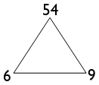  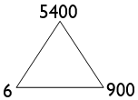  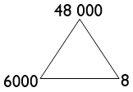  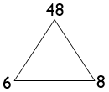  Use related facts to multiply Th000 by a one-digit number and divide a ThH00 by a one-digit number  Pictorial – place value chart for multiplying/dividing by 1000,  related facts multiplication trio and related facts division trio | 3000 x 3 related to 3 x 3 = 9  This should be understood as ‘three thousand threes’.  As the number of 3s is 1000x greater than three threes, so the product is 1000x greater.  7000 x 5  8000 x 9  7200 ÷ 9 related to 72 ÷ 9  This should be understood as ‘how many nines in 7200? Compared to how many nines in 72?’  As the dividend is 100x greater, then the number of nines in it will be 100x greater.  3000 ÷ 6  9600 ÷ 8
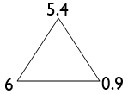  Use related facts to multiply 0.t by a one-digit number  Pictorial – related facts multiplication trio | 0.3 x 7 related 3 x 7 = 21  The number of 7s is 10x less, so the product will be 10x less.  0.6 x 9  0.5 x 4
Use factor pairs to multiply T0 x T0  Pictorial – place value chart for multiplying by 100 | 30 x 60 becomes 3 x 10 x 6 x 10 reordered as 3 x 6 x 10 x 10  70 x 80 becomes 7 x 10 x 8 x 10 reordered as 7 x 8 x 10 x 10  50 x 40 becomes 5 x 10 x 4 x 10 reordered as 5 x 4 x 10 x 10
Use compensation to multiply H99 by a one-digit number  NB H99 represents a three-digit number with 9 tens and 9 ones  Pictorial – rectangular array or a rectangle with given dimensions | 599 x 4 considered as 600 x 4 – 1 x 4 (read as ‘six hundred fours subtract one four’)  399 x 6 considered as 400 x 6 – 1 x 6 (read as ‘four hundred sixes subtract one six’)  699 x 9 considered as 700 x 9 – 1 x 9 (read as ‘seven hundred nines subtract one nine’)
Use partitioning to multiply U.t by a one-digit number  Pictorial – partitioning diagram using grid method strategy | 6.7 x 4 becomes 6 x 4 + 0.7 x 4  3.2 x 7 becomes 3 x 7 + 0.2 x 7  8.5 x 6 becomes 8 x 6 + 0.5 x 6
Use partitioning to double or halve numbers including those with two decimal places  Concrete (if necessary) – place value counters  Pictorial – partitioning diagram | Double 56.7 Find half of 4.62  Double 485.6 Find half of 18.46  Double 8.59 Find half of 8.94  Double 36 742 Find half of 17.92  Find half of 32 784
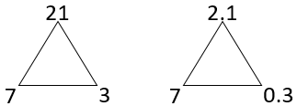  Use related facts to divide U.t by a one-digit number  Pictorial – place value chart, related facts division trio  e.g. 21 ÷ 7 = 3 then 2.1 ÷ 7 = 0.3 | 2.1 ÷ 7 related to 21 ÷ 7 = 3  This should be understood as ‘how many sevens in 2.1? Compared to how many sevens in 21?’  As the dividend is 10x smaller, then the number of sevens in it will be 10x smaller.  3.6 ÷ 9  4.8 ÷ 4
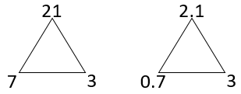  Use related facts to divide U.t by a 0.t  Pictorial – place value chart, related facts division trio  e.g. 21 ÷ 7 = 3 then 2.1 ÷ 0.7 = 3 | 2.1 ÷ 0.7 related to 21 ÷ 7 = 3  This should be understood as ‘how many 0.7s in 2.1? Compared to how many sevens in 21?’  As the dividend is 10x smaller and the divisor is 10x smaller, then the answer (quotient) will be the same.  3.6 ÷ 0.9  4.8 ÷ 0.4
Use partitioning to divide HTU by a one-digit number  Concrete (if necessary) – Diennes equipment, place value counters  Pictorial – part-part-whole diagram | 756 ÷ 9 By partitioning into 720 and 36 (two multiples of 9 totalling 756)  765 ÷ 5 By partitioning into 500 and 250 and 15 (three multiples of 5 totalling 765)  861 ÷ 7 By partitioning into 700 and 140 and 21 (three multiples of 7 totalling 861)

Progression Towards Written Calculation Strategies – Addition
This final stage of the method should have been achieved in Year 3, and should be continued to be used for all written addition calculations.  The first example would be explained as follows:  5 + 8 = 13, put 3 down and carry the 10 (written as a 1 in the tens column)  20 + 40 + 10 that was carried over = 70 (7 written in the tens column)  600 + 0 = 600 (6 written in the hundreds column)  Children will be expected to use this method for adding numbers with up to seven digits, numbers involving decimals and adding any number of amounts together.  Supported (if necessary) by the use of place value counters. | 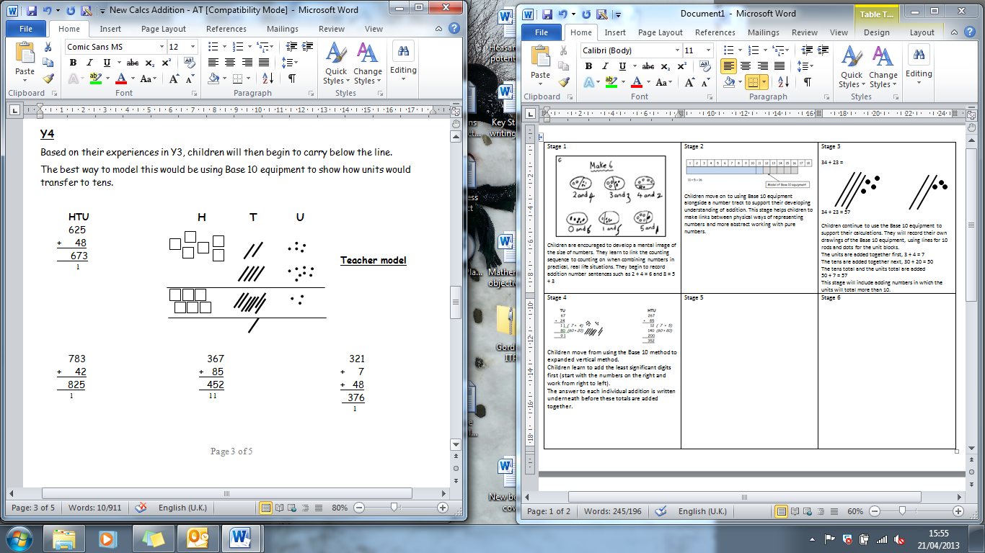  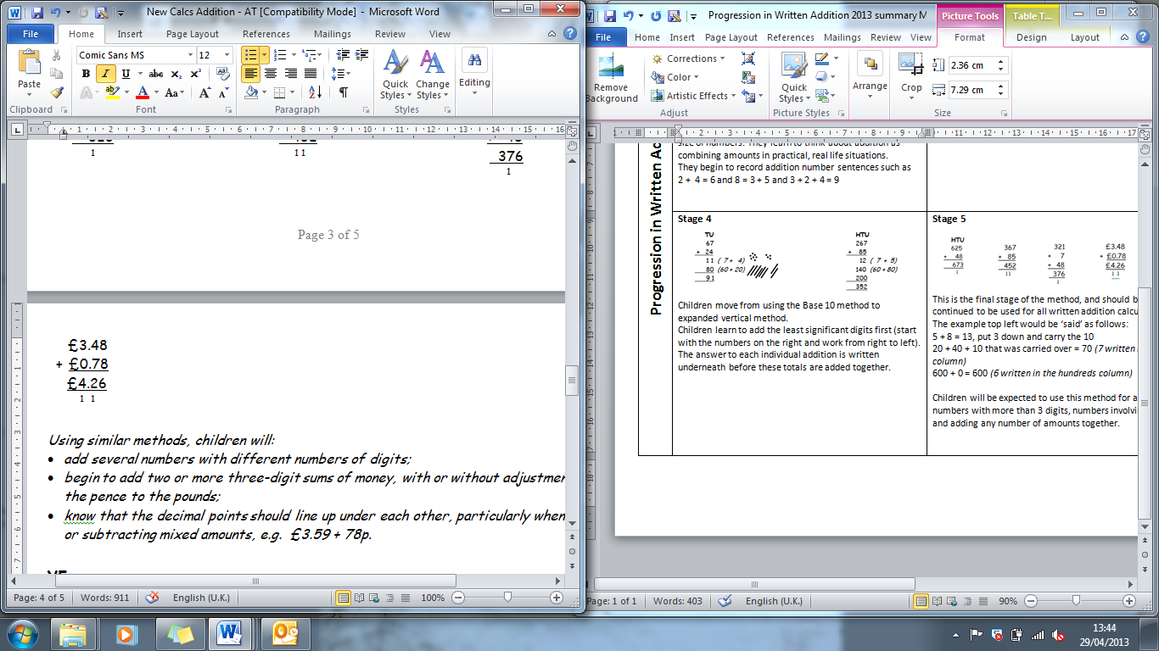
Progression Towards Written Calculation Strategies – Subtraction
This final stage is the compact method of decomposition should have been achieved in Year 4, and should be continued to be used for all written subtraction calculations.  Children will be expected to use this method for subtracting numbers with up to seven digits and numbers involving decimals.  Supported (if necessary) by the use of place value counters. | 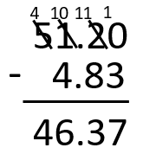  The example shown would be explained as follows:  We are subtracting 86 from 754. Start with the least  significant place value column.  Are there enough hundredths to subtract 3 hundredths?  No – so let’s exchange a tenth from the tenths column for  ten hundredths. 2 tenths and 0 hundredths becomes 41 tenth and  10 hundredths.  10 hundredths subtract 3 hundredths = 8 hundredths  Are there enough tenths to subtract 8 tenths?  No – so let’s exchange a one from the ones column for ten tenths.  1 one and 1 tenth becomes 0 ones and 1 tenths.  11 tenths subtract 8 tenths = 3 tenths.  Are there enough ones to subtract 4 ones?  No – so let’s exchange a ten from the tens column for ten ones. 5 tens and 0 ones becomes 4 tens and 10 ones  10 – 4 = 6  4 tens (40) – 0 tens = 4 tens (40)  Answer 46.37
Progression Towards Written Calculation Strategies – Multiplication
As the grid method for multiplication supports children’s number sense and appreciation of the values of each digit, schools can decide if this is the final stage of written multiplication.  It is often easier for children to keep track of the partial products calculated by using the grid method rather than the compact vertical method.  Concerns over ‘acceptable methods’ for 2 mark questions in the end of key stage 2 test should be weighed up against the improved chance of gaining 2 marks for the correct answer by using the grid method.  Optional  If schools wish to proceed to the compact vertical method for written multiplication then this is how it should progress, with different colours for the partial products to highlight how the steps taken are the same, just in a different order. | 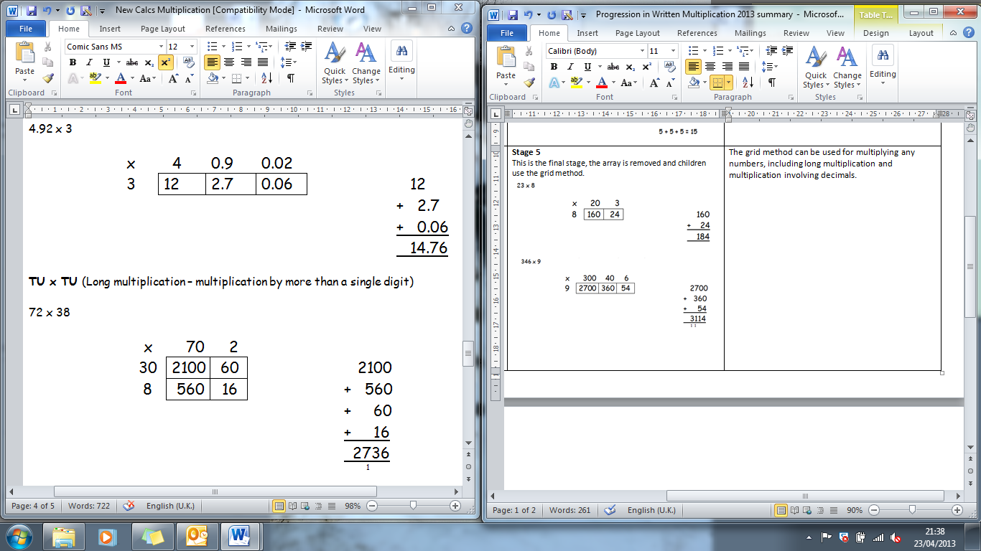  Children may add these  mentally.  Children may add these mentally.  Optional  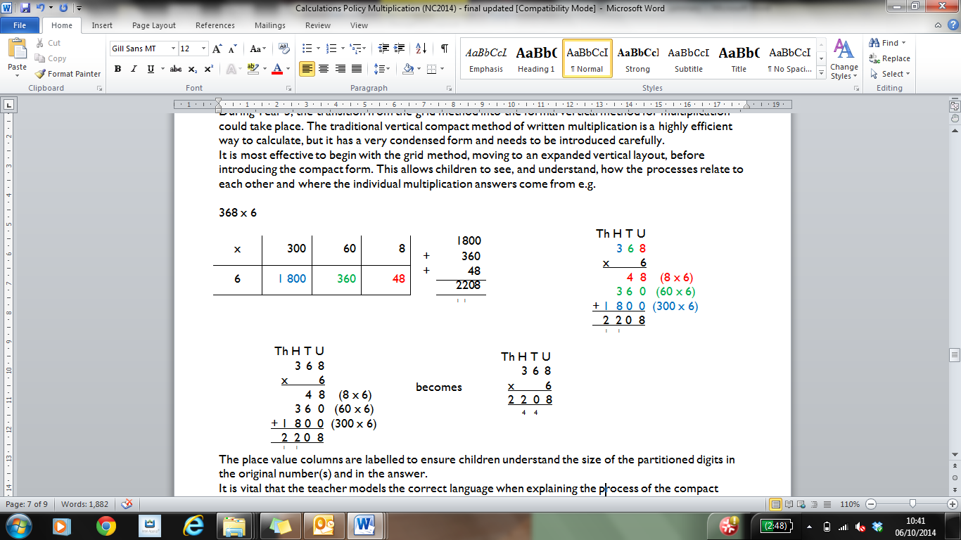
Progression Towards Written Calculation Strategies – Division
As the chunking method for division supports children’s number sense and appreciation of the values of each digit, schools can decide if this is the final stage of written division. It can be used for both short and long division (Year 6 expectation) and leads to more efficient mental methods.  As children develop their understanding of this method, they should use ever more efficient steps. The menu box may not need to be written, but the children should continue to think in this way. | 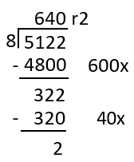  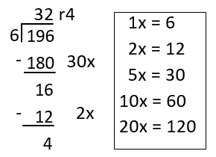
Decision Making
When calculating, children should ask themselves:
- do I know the answer because it is a fact I have learnt?
- can I work it out easily in my head?
- can I use some equipment or a jotting?
- do I need to use the written method?
The strategies used within this document are taken from the Lancashire Mathematics Team Progression in Mental Calculation Strategies Policies and the Progression Towards Written Methods Policies.
See www.lancsngfl.ac.uk/curriculum/primarymaths for the full policies.

