Year 3 - Arithmetic Expectations
This series of documents aims to summarise the number facts, mental calculation strategies and the stage(s) of the progression towards the written methods for each of the four operations.
For each strategy, the concrete and pictorial representations have been suggested. However, to keep the document to a more manageable size, the imagery has not been shown explicitly as this should be found in your school’s agreed mental calculations policies.
The strategies used within this document are taken from the Lancashire Mathematics Team Progression in Mental Calculation Strategies Policies and the Progression Towards Written Methods Policies.
See www.lancsngfl.ac.uk/curriculum/primarymaths for the full policies.

Each strategy will require specific modelling (teaching) and sufficient practice for children to develop confidence, accuracy and fluency in performing them.
Children should also be taught when it is appropriate to use each strategy, by looking at the numbers involved and making effective decisions. Again, this is a sign of a child’s fluency in mathematics; being able to recognise which strategy best suits a given calculation, rather than always using the same method regardless of the numbers involved.

Acknowledgements
Special thanks to the following teachers who helped to create these documents:
Sue Byrom – Colne Park Primary Naomi Tyson – Gisburn Road Community Primary Hannah Blackburn – Lowerhouse Juniors
Tara Warbrick – Colne Park Primary Nick Browne – Gisburn Road Community Primary Jess Dornan – Lowerhouse Juniors
Jane Dempsey – Burnley Springfield Primary Laura Mitchell – Burnley St Stephen’s CE Primary Michelle Hume – Whittlefield Primary
Andrew Douglas – Burnley Springfield Primary Moira Waller – Burnley St Stephen’s CE Primary Stephen Riley – Whittlefield Primary

Arithmetic Expectations – Year 3
Skills | Examples
Counting
Find 1, 10 or 100 more or less than a given number. | 229 + 1 = __ 229 + 10 = __ 229 + 100 = __  200 = __ + 1 479 + __ = 480 726 + __ = 826  400 – 1 = __ 261 – 10 = __ __ = 812 – 100
Count from 0 in multiples of 4, 8, 50 and 100 | Count from 0 in fours  Count from 0 in eights  What number is missing from this counting sequence? 0, 8, 16, 32, 40, 48  What number would come next in this counting sequence? 0, 50, 100, 150, 200, __  What number comes immediately after 600 when counting up in steps of 100?
Count up and down in tenths. | Count on from 0 in tenths.  What would come next in this counting sequence? 0, $\frac{1}{10}$, $\frac{2}{10}$, $\frac{3}{10}$, $\frac{4}{10}$  What is missing from this number sequence? $\frac{7}{10}$, $\frac{6}{10}$, $\frac{5}{10}$, $\frac{3}{10}$, $\frac{2}{10}$
Number Facts
Recall addition and subtraction facts for 100 (multiples of 5 and 10). | 100 – 30 = __ 20 + __ = 100 100 = __ + 5  100 – 45 = __ 100 – __ = 15 65 = 100 – __
Recall and use multiplication division facts for the 3, 4 and 8 multiplication tables. | 6 x 3 = __ 2 x 4 = __ 4 x 8 = __  20 = 4 x __ 21 = 3 x __ 32 = __ x 8 __ x 4 = 28  30 ÷ 3 = __ 24 ÷ 4 = __ 72 ÷ 8 = __ 3 = 36 ÷ __  __ = 32 ÷ 4 __ = 48 ÷ 6
Mental Calculation Strategies - Addition and Subtraction
Identify and use knowledge of number bonds within a calculation.  Concrete – tens frames, Diennes equipment, place value counters  Pictorial – Diennes jottings, number line | 42 + 38 42 + 30 + 8 (recognising that 2 and 8 is a number bond to 10, so the answer will be a multiple of 10)  60 – 28 60 – 20 – 8 (using knowledge that 10 – 8 = 2, so 40 – 8 = 32)  120 – 50 120 – 20 – 30 (using knowledge of number bonds to 100, leaving an  answer of 70)
Derive and use addition and subtraction facts for 100  Concrete – Diennes equipment, place value counters, beadstring  Pictorial – Number line | 100 – 43 = __ 22 + __ = 100 100 = __ + 9  100 – 76 = __ 100 – __ = 48 66 = 100 – __
Derive and use addition and subtraction facts for multiples of 100 that total 1000  Concrete – Diennes equipment, place value counters  Pictorial – Diennes jottings | 1000 – 300 = __ 200 + __ = 1000 1000 = __ + 500  1000 – 400 = __ 1000 – __ = 100 600 = 1000 – __
Reorder numbers in a calculation.  Concrete – tens frames, Diennes equipment, place value counters  Pictorial – Diennes jottings, number line | 23 + 54 54 + 23  12 + 19 + 12 12 + 12 + 19 (using knowledge of doubles)  6 + 8 + 4 6 + 4 + 8 (using knowledge of number bonds to 10)  70 + 50 + 30 70 + 30 + 50 (using knowledge of number bonds to 100)
Partition and combine multiples of hundreds, tens and ones.  Concrete – Diennes equipment, place value counters, beadstring  Pictorial – number line | 526 + 200 counting on in hundreds  137 + 40 counting on in tens  272 + 8 counting on in ones (or using knowledge of bonds to 10)  428 – 200 counting back in hundreds  323 – 70 counting back in tens  693 – 8 counting back in ones  37 + 15 37 add 10 and 5 = 37 add 10 add 5 (crossing tens boundaries)  42 – 25 42 take away 20 and 5 = 42 take away 20 take away 5 (crossing tens  boundaries)
Find differences by counting up through the next multiple of 10 or 100  Pictorial - number line | 60 – 43 useful for time calculations, e.g. a journey time from 2:43 until 3:00  53 – 38 efficient because the numbers are close to each other  104 – 95 efficient because the numbers are close to each other  200 – 86 useful for money calculations, e.g. change from £2 when spending 86p
Bridge through 10 when adding or subtracting a single digit number (partitioning, e.g. 58 + 5 = 58 + 2 + 3 or 76 – 8 = 76 – 6 – 2 )  Pictorial - number line | 35 + 7 as 35 + 5 + 2  97 + 6 as 97 + 3 + 3  178 + 5 as 178 + 2 + 3  42 – 7 as 42 – 2 – 5  204 – 6 as 204 – 4 – 2  371 – 5 as 371 – 1 – 4
Add or subtract 9, 19, 29 etc by rounding and compensating  Pictorial - number line | 34 + 29 as 34 + 30 – 1  127 + 49 as 127 + 50 – 1  96 – 39 as 96 – 40 + 1  273 – 59 as 273 – 60 + 1
Mental Calculation Strategies – Multiplication and Division
Derive and use doubles of all numbers to 100 and corresponding halves.  Concrete - Diennes equipment, place value counters  Pictorial – part – part – whole diagram | Double 46 Halve 86  29 + 29 Find half of 54  38 x 2 92 ÷ 2
Derive and use doubles of all multiples of 50 to 500  Concrete - Diennes equipment, place value counters  Pictorial – part – part – whole diagram | Double 350  400 + 400  450 x 2
Multiply a one- or two-digit number by 10 and a one-digit number by 100  Concrete - Diennes equipment, place value counters  Pictorial - place value chart | 3 x 10  7 x 100  62 x 10
Within known tables, use related facts to multiply T0 by a one-digit number NB T0 represents a two-digit multiple of ten.  Concrete – Diennes equipment, place value counters  Pictorial – Diennes jottings | 60 x 3  related to 6x3 because 60 x 3 = 10 x 6 x 3 which can be reordered to 6 x 3 x 10  50 x 4  related to 5 x 4 because 50 x 4 = 10 x 5 x 4 which can be reordered to 5 x 4 x 10  30 x 8  related to 3 x 8 because 30 x 8 = 10 x 3 x 8 which can be reordered to 3 x 8 x 10
Within known tables, use partitioning to multiply T1 by a one-digit number  Pictorial - Show array using squared paper. | 31 x 4 = 30 x 4 add 1 x 4 (said as ‘thirty fours add one four’)  31 x 4 = 120 + 4  31 x 4 = 124  61 x 4  31 x 8
Use compensation to multiply 19 by a one-digit number  Pictorial - Show array using squared paper. | 19 x 4 = 20 x 4 subtract 1 x 4 (said as ‘twenty fours subtract one four’)  19 x 4 = 80 – 4  19 x 4 = 76  19 x 3  19 x 5  19 x 8
Use partitioning to double any two-digit number  Concrete – Diennes equipment, place value counters  Pictorial – Diennes jottings, part-part-whole diagram to double e.g. double 76 | Double 39, double 52, double 85
Use related facts or partitioning to double any multiple of 50 to 500  Concrete – Diennes equipment, place value counters  Pictorial – Diennes jottings, part-part-whole diagram to double e.g. double 350 | Double 250, double 450, double 150
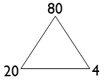  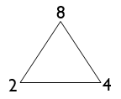  Use related facts to divide T0 by a one-digit number  NB T0 represents a multiple of ten  Concrete – Diennes equipment, place value counters  Pictorial – Diennes jottings, division trio e.g. 8 ÷ 2 = 4 then  80 ÷ 20 = 4 | 60 ÷ 3 related to 6 ÷ 3  80 ÷ 40 related to 8 ÷ 4  90 ÷ 3 related to 9 ÷ 3
Use partitioning to halve even numbers up to 200  Concrete – Diennes equipment, place value counters  Pictorial – Diennes jottings, part-part-whole diagram to halve e.g. halve 154 | Find half of 162 by partitioning into 160 and 2  Find half of 94 by partitioning into 80 and 14  Find half of 136 by partitioning into 120 and 16

Progression Towards Written Calculation Strategies – Addition
Introduce column method of addition.  Concrete – Diennes equipment, place value counters (if necessary)  Pictorial – Diennes jottings in column (to illustrate place value of each digit) | 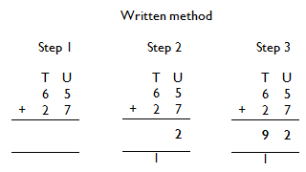  65+27  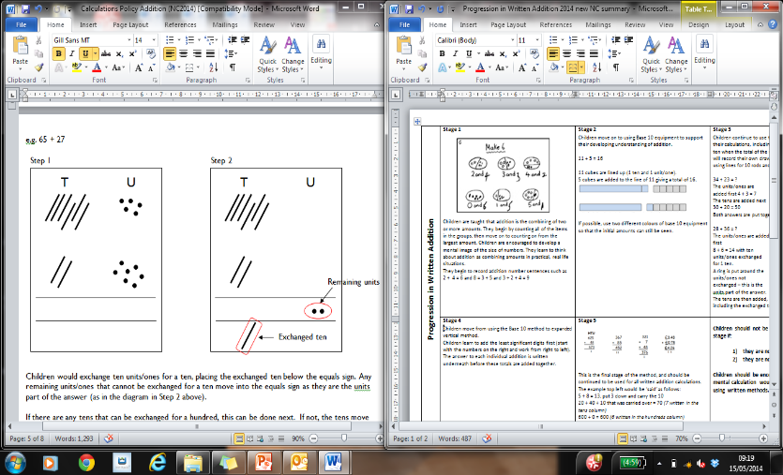  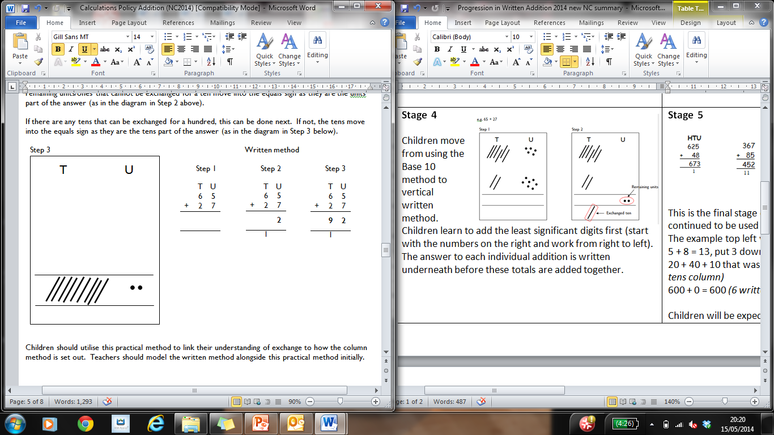
Progression Towards Written Calculation Strategies – Subtraction
Introduce column method of subtraction.  Concrete – Diennes equipment, place value counters (if necessary)  Pictorial – Diennes jottings in column (to illustrate place value of each digit) | 89 – 57  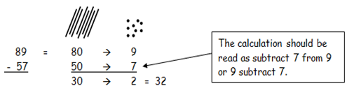  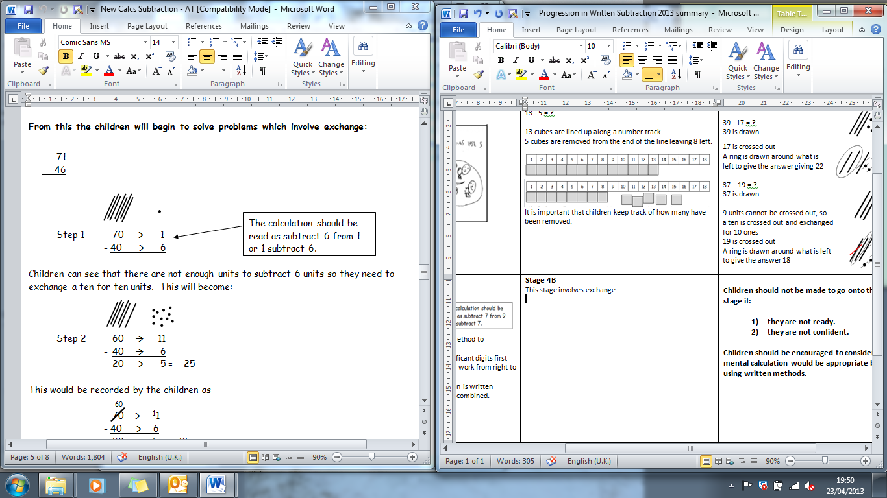  Exchanging  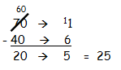  becomes moving to
Progression Towards Written Calculation Strategies – Multiplication
Multiplication of a two digit number by a one digit number – grid method  Pictorial – rectangular arrays on squared paper | 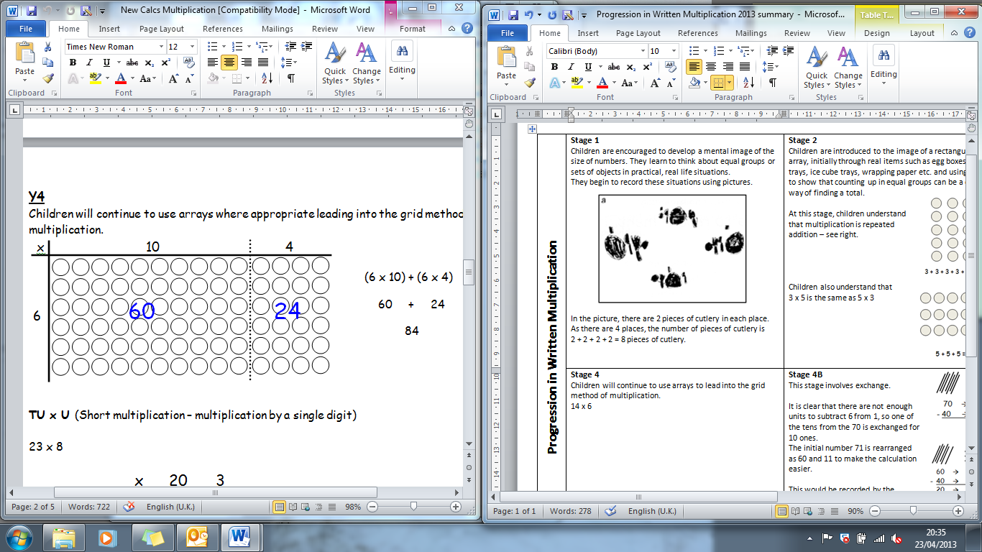  60 + 24 = 84  So 14 x 6 = 84  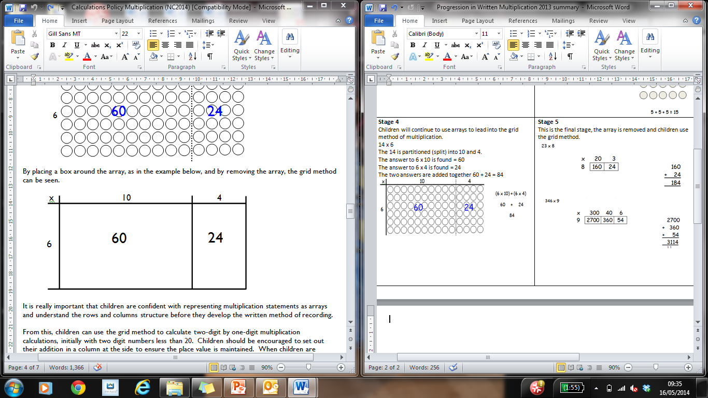  60 + 24 = 84  So 14 x 6 = 84

Progression Towards Written Calculation Strategies – Division
Division using a vertical number line to show efficient repeated subtraction  Concrete – cubes, Diennes equipment  Pictorial – number line | 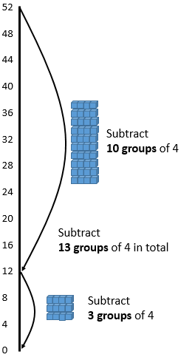  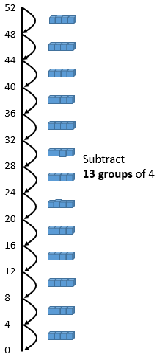  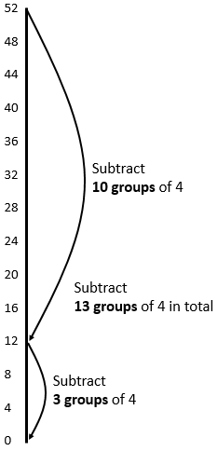
Decision Making
When calculating, children should ask themselves:
- do I know the answer because it is a fact I have learnt?
- can I work it out easily in my head?
- can I use some equipment or a jotting?
- do I need to use the written method?
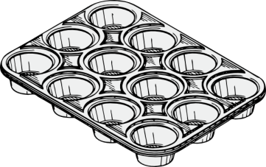

The strategies used within this document are taken from the Lancashire Mathematics Team Progression in Mental Calculation Strategies Policies and the Progression Towards Written Methods Policies.
See www.lancsngfl.ac.uk/curriculum/primarymaths for the full policies.

