W/B  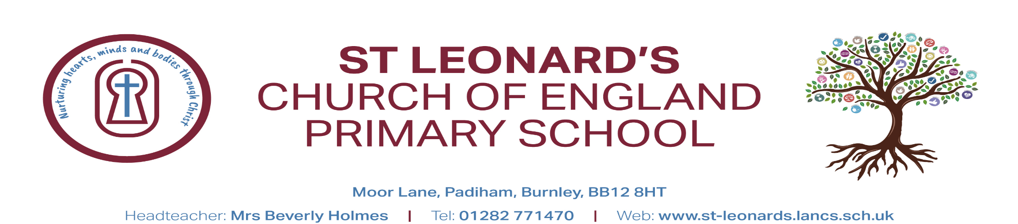 | 2nd September 2025 | 8th September | 15th September | 22nd September 2025 | 29th September 2025 | ^{6th October 2025} | ^{14th July 2025}
Theme | All about me | All about me | All about me | All about me | All about me
Focused Text  FD | 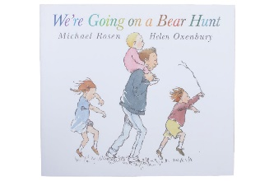 | Seaside non fiction book | 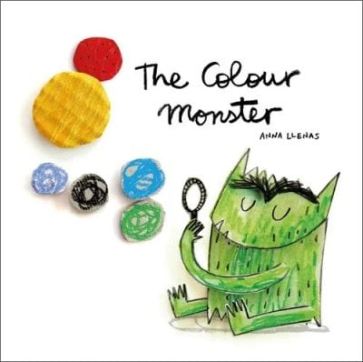 | 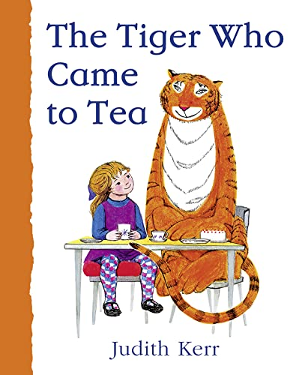 |  | 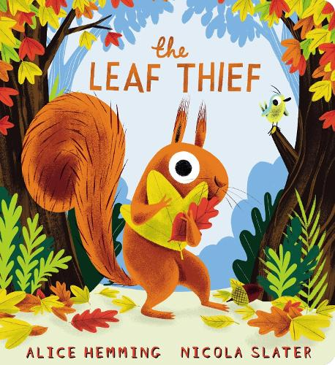 | 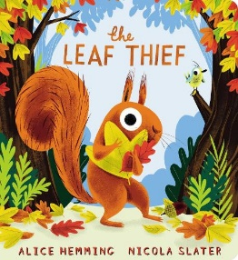
Literacy | Ascribing meaning to marks | Pre writing patterns  Ascribe meaning to marks  Hearing initial sounds | Orally blend cvc words | Orally blend cvc words  To begin to form some recognisable letters | Orally re-telling the story  Using story language  Applying phonics knowledge when making marks | Form recognisable letters of which they have been taught. | Begin to write cvc words
C&L | Children will talk in front of small groups and their teacher | Children will be able to understand how to listen carefully. | Answer basic what questions | Children will begin to offer their own ideas | Use recently introduced vocabulary in their play | Express their feelings by using full sentences | Use and and but/because to connect sentences and add more meaning
PD | EYFS Lancashire unit  Children will accurately draw lines, circles and shapes to draw pictures  Encourage tripod grip | EYFS Lancashire unit  Gross motor activities  Children will accurately draw lines, circles and shapes to draw pictures  Encourage tripod grip | EYFS Lancashire unit  Learn how to use basic tools with some control  Encourage tripod grip | EYFS Lancashire unit  Gross motor activities  Fine motor activities  Encourage tripod grip | EYFS Lancashire unit  Show accuracy and care when drawing  Encourage tripod grip | EYFS Lancashire unit  Focus on using cutlery correctly | EYFS Lancashire unit
PSED | Follow a one step instruction.  Devise class rules  My happy mind | Children will seek support from adults and gain confidence to speak to peers and adults.  My happy mind | Recognising different emotions  My happy mind | Confident to try new activities  My happy mind | Work and play cooperatively  My happy mind | Follow class rules  My happy mind | Hand washing.
Maths | Red Rose -  1:1 correspondence up to 5.  Careful counting to 5  Recognise numeral 1  Numeral formation | Red Rose-  Recognise numeral 2  Subitise 1 and 2 and introduce  Numeral formation | Red Rose  Recognise numeral 3  Subitise 1,2,3  Careful counting  Numeral formation | Red Rose-  Recognise numeral 4  Subitise 1,2,3,4  Careful counting  Numeral formation | Red Rose-  Recognise numeral 5  Subitise 1,2,3,4,5  Part part whole  Careful counting  Numeral formation | Red Rose-  Recognise numeral 6  Subitise 1,2,3,4,5  Part part whole  Numeral formation  Deep understand of compostition | Red Rose  Recognise numeral 7  Subitise 1,2,3,4,5  Part part whole
UTW | They will talk about members of their immediate family. | Children can order life stages. | Naming basic body parts. | Children will understand the same and different -making comparisons with each other | Our school grounds | My house | Our local area
EAD | Charanga scheme of work  Use colour for a purpose  Nursery rhymes and action songs | Charanga scheme of work  Use colour for a purpose  Nursery rhymes and action songs | Charanga scheme of work  Children will experiment mixing with colours.  Listening to different styles of music | Charanga scheme of work  Improvising and playing classroom instruments  Sharing creations | Charanga scheme of work  Sharing creations | Charanga scheme of work  Experimenting collage and textures. | Charanga scheme of work
RE | Questful RE scheme | Questful RE scheme | Questful RE scheme | Questful RE scheme | Questful RE scheme | Questful RE scheme | Questful RE scheme

