EYFS Progression of skills – Writing
Nursery  Three- Four Years  . Use some of their print and letter knowledge in their early writing. For example: writing a pretend shopping list that starts at the top of the page; write ‘m’ for mummy. Writing.3-2  - Write some or all of their name. Writing.3-4  . Write some letters accurately. Writing.3-4 Handwriting - PD  .Use a comfortable grip with good control when holding pens and pencils. PD FMS.3-4  .Show a preference for a dominant hand. PD FMS.3-4 |  |  |  | Reception  . Form lower-case and capital letters correctly. Writing-Reception  . Spell words by identifying the sounds and then writing the sound with letter/s. Writing-Reception  . Re-read what they have written to check that it makes sense. Writing-Reception  . Write short sentences with words with known letter-sound correspondences using a capital letter and full stop. Writing- Reception  Handwriting - PD  Develop their small motor skills so that they can use a range of tools competently, safely and confidently. Suggested tools: pencils for drawing and writing. PD.FMS - Reception  Develop the foundations of a handwriting style which is fast, accurate and efficient. PD.FMS - Reception. |  |  | Writing- ELG .  . Write recognisable letters, most of which are correctly formed. Writing-ELG  - Spell words by identifying sounds in them and representing the sounds with a letter or letters. Writing-ELG  - Write simple phrases and sentences that can be read by others. Writing-ELG  Handwriting - PD  . Hold a pencil effectively in preparation for fluent writing- using the tripod grip in almost all cases. FMS-ELG
Early Steps  Making Marks | I explore making marks, but I do not communicate meaning.  Random scribbling.  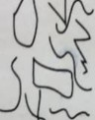 | I draw basic pictures. I use lines to look like writing. Scribble writing  Left to right direction I begin to assign meaning.  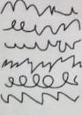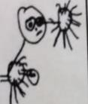 | I write symbols and shapes that look like writing.  I assign meaning to the marks  Attempts to write name  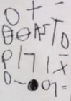 |  | I write random letters but there is no connection between letters and sounds. I talk about my writing and give meaning.  Writes name from memory  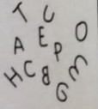 | I use letter strings which travel from left to right and top to bottom.  I attempt to ‘read’ my  writing.  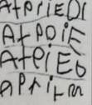 |  | I write letters with spaces between them to resemble the idea of words.  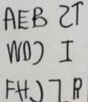 | I copy words that I see in the environment around me.  I often do not know what the words say.  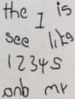

Developing Writing  Words | I am beginning to hear initial sounds and attempt to write these down.  m - mum letter for name | I can hear initial sounds in words and write the letters down to match.  c - cat d- dog p - pig | I can hear initial and final sounds.  Ct-cat  Dg-dog | I can spell out and write down vc cvc words by matching letters and sounds, using Fred Fingers. at in up  cat dog pig | I can write High Frequency decodable and tricky words from memory.  mum dad. and can I go to the no into | I can spell out words with consonant clusters, vowel digraphs and trigraphs.  buzz fill. mess ship. chip thing rush boat sheep now soil chair night. Pure.  Expected | I write more challenging words with a sound knowledge. I use different spelling choices and more syllables. Plausible attempts  Phase 4
Developing Writing  Sentences | I can formulate and say a simple sentence for writing. | I can orally compose a sentence and hold it in my memory before I start to write it. | I can write a series of beginning letters and sounds for my phrase.  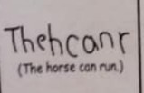  There may be no spaces between words. | Begins to be readable to others.  Start to put finger spaces between my words and to use known words. I start to read my sentence.  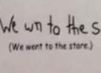 |  | I can write a sentence with a full stop and capital letter. I can re-read it and check that it makes sense. Others can read my sentence.  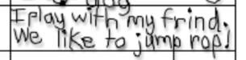
 |  | Repeats & recalls |  | Expected
READINESS FOR YEAR ONE:
- Hold pencil with the tripod grip, pens and other marking making tools appropriately so that they can make marks in an increasingly controlled way.
- Use digraphs when spelling
- I can write dictated sentences that include phase 2, 3 and 4.
- Write simple sentences that can be read by others (including the use of finger spaces)
- Start to develop an understanding of capital letters and full stops
- Begin to spell some common exception words

