Things I already know: I can recognise things I can be grateful for even in hard situations.

My Happy Mind - Appreciate

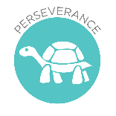

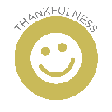

Theological Links
‘God saw all that he had made, and it was very
good.’ (Genesis 1:31)

FRUITS
Treat ourselves and others with Respect and Dignity – We were made by God, in his image, and he wants us to look after ourselves.
Key Vocabulary
medical professional, emergency, first aid
First Aid

FRUITS
Faith – God has given us a wonderful world to live in and we feel good when we remember the good things we experience.

Key Vocabulary
Gratitude Domino Effect

Key Knowledge
Be able to identify a range of aspects of ourselves that we are grateful for.

Theological Links
‘Give thanks to the Lord, for he is good, for his steadfast love endures forever.’
(Psalms 136:1)

Creative Thinking: To set goals, in each bit of learning, to be the best you can be and take time to check and improve.

Things I already know: I know which emergency services are available and how to contact them.

Key Knowledge
Know how to respond and react in an emergency situation; how to identify situations that may require the emergency services and how to contact them and what to say.

Things I already know: I know about the importance of taking medicines safely.

Drugs, Alcohol and Tobacco

FRUITS
Treat ourselves and others with Respect and Dignity – We were made by God, in his image, and he wants us to look after ourselves.

Theological Links
‘God saw all that he had made, and it was very
good.’ (Genesis 1:31)
‘
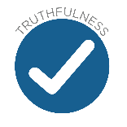
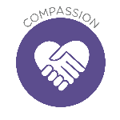
FRUITS
Intellect –The internet is has a wealth of information but we must
interpret it and use it wisely.

Theological Links
‘The one who gets wisdom loves life; the one who cherishes understanding will soon prosper.’ (Proverbs 19:8)

Key Vocabulary
inappropriate content, age restrictions, social
media, internet safety, edited content, fake information, online risk
Key Knowledge
Know ways to assess the reliability of information online.
Identify things which are appropriate to share on line and those that are not.

Things I already know: I know how to keep safe on the internet including sharing information and age restrictions.

Media Literacy and Digital Resilience

Key Knowledge
Know about the risks and effects of legal drugs common to everyday life (e.g. cigarettes, ecigarettes/vaping, alcohol and medicines) and their impact on health.

Key Vocabulary
drugs, substances, laws, legal, illegal, drugs, alcohol, tobacco, media, risks, effects

