Things I already know: I can use happy breathing and other techniques to help when goals are tricky.

My Happy Mind - Engage

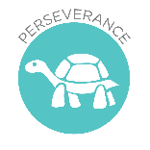

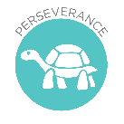
Key Knowledge

Know strategies for keeping safe in the local environment or unfamiliar places (rail, water, road) and firework safety.

Key Vocabulary
hazard, risk, avoid, unattended
FRUITS
Treat ourselves with Respect and Dignity – We were made by God and he wants us to look after ourselves.

Theological Links
‘God saw all that he had made, and it was very good.’ (Genesis 1:31)

Resilient Learning: To have a range of strategies for managing emotions when learning is hard and frustrating.

Things I already know: I know about how to keep safe at home (including around electrical appliances) and fire safety (e.g. not playing with matches and lighters).

Keeping Safe

Key Knowledge
Set a goal and identify progress.

Theological Links
‘I can do all things through him who strengthens me.’ (Philippians 4:13)

FRUIT
Faith - We have many talents and can use happy breathing, or other techniques such as prayer, to help us keep calm and focus on our goals.
Key Vocabulary
Resilience,
Dopamine

