Communities

Things I already know: I recognise the different roles and responsibilities people have in their community.


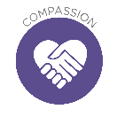
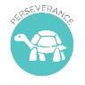
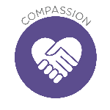
Theological Links
‘Jesus wept.’ (John 11: 35)
‘Blessed are those who mourn, for they will be comforted.’ (Matthew 5:4)

FRUIT
Faith – Know that whatever our faith we miss those who are no longer with us.
Salvation – Christians believe that when you die your spirit goes to be with God in heaven.
Key Vocabulary
grief, loss,
passing away
Critical Thinking: To look for patterns and identify connections between different learning and lessons.

Key Knowledge
Understand that change and loss, including death, can affect feelings

Things I already know: I can recognise the ways in which we are all unique. I know how people's needs change when growing and changing from young to old.

Ourselves, Growing and Changing

Theological Links
‘The Lord God took the man and put him in the Garden of Eden to work it and take care of it.’ (Genesis 2:15)
FRUITS
Relationships – We were made by God in his image to look after each other and the world we live in.
Key Vocabulary compassion, opinion, environment
Key Knowledge
Identify ways to protect the environment in school and at home; know how everyday choices can affect the environment (e.g. reducing, reusing, recycling, food choices.

Things I already know: I know what rules are, why they are needed, and why different rules are needed for different situations.

Shared Responsibilities

Theological Links
The Story of the Good Samaritan
(Luke 10:29-37)
‘
FRUITS
Treat others with Respect and Dignity – We value the contribution of a whole range of people, not just those who look, think or speak like us.
We know that excluding others because they are different is wrong.
Key Vocabulary
respect, diversity, contribute
Key Knowledge
Identify the benefits of living in a diverse community and the value of diversity within communities.

