Things I already know: I know what goals are and how to set a goal.

My Happy Mind - Engage

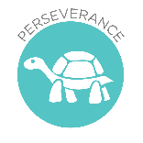

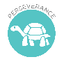
Resilient Learning: To see mistakes as an opportunity to learn and get better at something.

Key Knowledge
Recognise that some things are private and the importance of respecting privacy; that parts of their body covered by underwear are private.

Key Vocabulary safe, unsafe, secret, surprise, permission, physical contact, uncomfortable
FRUITS
Treat others with respect and dignity – God loves us all and we are worthy of respect and care from others.
Theological Links
‘For God loved the world so much that he gave his only Son, so that everyone who believes in him may not die but have eternal life.’ (John 3:16)
Things I already know: I know that I should be respect others and they should respect me.

Safe Relationships

Key Knowledge
Use happy breathing and other techniques to help when goals are tricky.

Key Vocabulary
Perseverance, Goal Setting, ‘Feel Good, Do Good’, Believe to Achieve,
Habits

FRUIT
Faith - We have many talents and can use happy breathing, or other techniques such as prayer, to help us keep calm and focus on our goals.
Theological Links
‘I can do all things through him who strengthens me.’ (Philippians 4:13)

