Ourselves, Growing and Changing

Things I already know: I know I am special. I can identify my feelings.

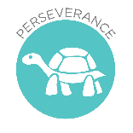
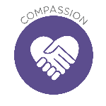
Key Knowledge
Recognise the ways in which we are all unique.
Know how people's needs change when growing and changing from young to old.

Critical Thinking: To think of questions, linked to the learning, which you would like to know the answer to.

Key Vocabulary
grow,
change,
needs,
stage,
baby,
child,
adult,
young,
old

FRUIT
Uniqueness – Each one of us is a unique individual and have different gifts and talents.
Theological Links
‘I am fearfully and wonderfully made.’ (Psalm 139)

