My Happy Mind - Appreciate

Things I already know: I know how to be grateful for other people. I know how being grateful makes me feel.


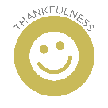
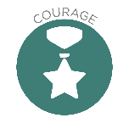
Things I already know: I know how to brush my teeth and keep clean.

Key Knowledge
Be able to identify various ways to keep healthy.

Key Vocabulary
healthy,
unhealthy,
habits,
hygiene,
routine,
germs,
spreading

Healthy Lifestyles

Creative Thinking: To use your different senses to help you learn.

Theological Links
‘God saw all that he had made, and it was very good.’ (Genesis 1:31)

Theological Links

‘Give thanks to the Lord, for he is good, for his steadfast love endures forever.’
(Psalms 136:1)

FRUITS

Treat ourselves with Respect and Dignity – We were made by God and he wants us to look after ourselves.

FRUITS

Faith – God has given us a wonderful world to live in and we feel good when we remember the good things we experience.
Key Vocabulary
Appreciate,
Grateful,
Wheel of Gratitude

Key Knowledge
Know that we can be thankful for people, experiences and ourselves, not just material things.
Identify people, experiences and things about ourselves we appreciate.

