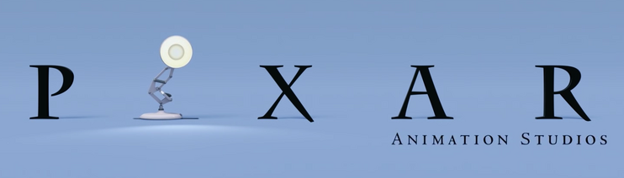
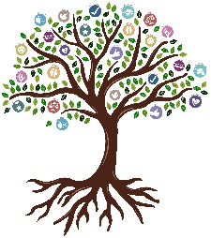
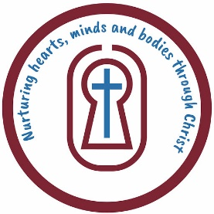
ANIMATION
Chestnut, Maple and Sycamore
KNOWLEDGE ORGANISER

Overview |  |  | Key Vocabulary
Computer-Generated Imagery  CGI stands for Computer-Generated Imagery, and it’s when we use computers to create pictures or videos that look real, even though they’re made entirely on the computer.  Imagine watching movies like Toy Story or Jurassic Park—all the characters and scenes in those movies that look like they are in real life were created with CGI! It’s like making 3D characters, worlds, and special effects using a computer instead of using real actors or things.  CGI helps make things like explosions, flying spaceships, or even talking animals look super cool and believable, even though they don't exist in real life!  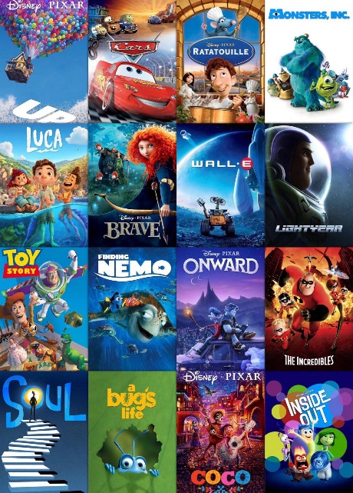 |  |  | - Staging: This is how you set up everything in a scene, like where characters stand, where the camera is, and what’s in the background. It’s like setting the stage for a play or movie to make it look cool and interesting!  - Aspect Ratio: This is the shape of the screen. It tells you how wide or tall the screen is. For example, a typical TV screen might be wide (like 16:9), while a square screen (like some old TVs) is a 1:1 ratio.  - Computer Generated Imagery (CGI): CGI is when computers are used to make pictures or videos look like real things, even though they’re made on a computer. It’s how we get things like talking animals, explosions, or special effects in movies.  - Angles: Angles are where the camera is placed when filming. If the camera is higher up, it might make someone look small; if it’s lower, they might look taller or more powerful. Changing the angle can change how we see the scene!  - Overlay: This means adding something on top of a picture or video. For example, putting words on the screen, or adding special effects like sparkles or shadows over a scene.  - Cut Scene: A cut scene is a part of a video or game where the action stops, and the story is told through a short movie or animation. It helps explain what’s happening or shows something exciting!
Introduction to Plotagon

Plotagon is an awesome app that lets you create your own animated stories! It’s like being the director of your own movie, and you don’t need to be a great artist to do it. You start by choosing characters from a list of fun, customizable ones. You can pick how they look, what they wear, and even how they act! You can make characters talk, move, and interact with each other just like in real life.

Once you’ve picked your characters, you get to choose the setting for your story, like a classroom, a park, or even a space station. The app has lots of different places you can pick from, or you can create your own! Then, you can write the script, which means telling the characters what to say and do. You can even add special effects, like sound or background music, to make your story even cooler.

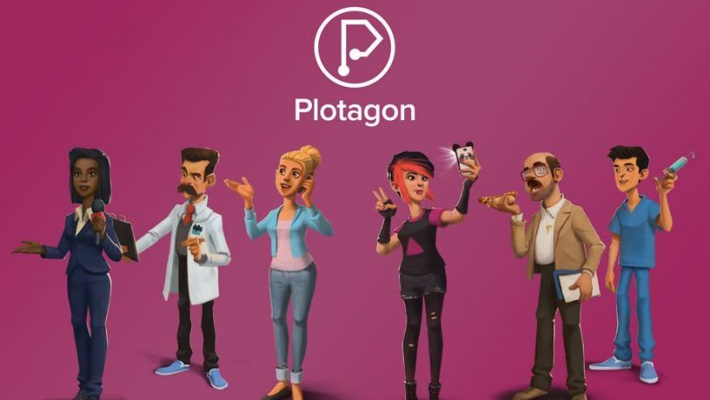
After you finish, Plotagon takes all your words and turns them into a full animation. It’s like magic—your story comes to life on the screen! Whether you want to make a funny adventure, a mystery, or a dramatic moment, Plotagon makes it easy to create whatever you can dream up. And the best part is, you can share your animations with friends and family, or even show them off online!

 |  |  | Questions I Can Answer | FRUITS
 |  |  | - Can you record animations of different characters and edit them together to create an interview?  - Can you plan, write a script, and create a 3D animation to explain something or tell a story?  - Can you put clips of mixed media in a timeline and record a voiceover for them?  - Can you trim and cut film clips and add titles and transitions?  - Can you add music and sound effects to your films?  - Can you add animated titles and transitions to your video projects? | - Faith: Faith is believing in yourself or others. Like when an inventor trusts their ideas to fix a problem, or when a character believes their friends will help them.  - Relationships: Relationships are about characters working together, helping each other, and solving problems as a team.  - Uniqueness: Being unique means being different in a special way, like having a talent or idea that no one else has.  - Intellect: Intellect is about using your brain to solve problems, think of smart ideas, and be creative.  - Treat Others with Respect: This means being kind and fair to others, even when you don’t agree. It’s about listening to and understanding people.  - Salvation: Salvation is when a character fixes a big problem or helps someone in need, showing that you can grow and change.

