
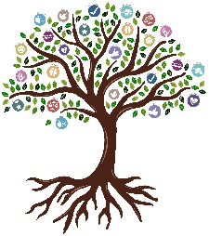

ANIMATION
Beech, Rowan and Willow
KNOWLEDGE ORGANISER

Overview |  |  | Key Vocabulary
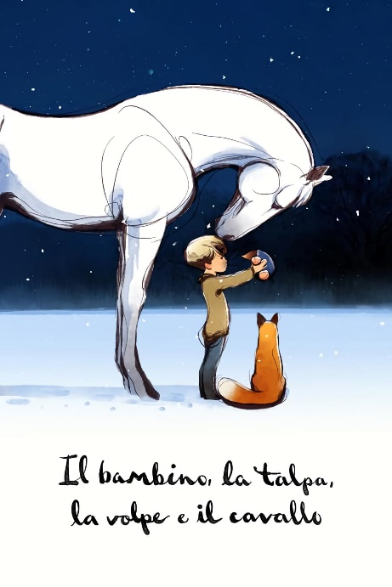  Hand Drawn Animation  - Hand-drawn animation is when artists draw each picture by hand to create movement. Imagine you draw a picture of a character, then draw the same character again, but this time, they’re doing something different, like waving. You keep drawing the character with tiny changes in each picture, and when you flip through the pictures really fast, it looks like the character is moving!  It's like flipping through a flipbook, where each page has a new picture, and they all tell a story when you look at them quickly. Some classic cartoons, like Tom and Jerry or Looney Tunes, were made this way!  Even though computers are used now for some of the drawings, many animations still start with the old-school way—by drawing each frame by hand! |  |  | - Animate: To make pictures or objects move, like in cartoons or videos.  - Resize: To make something bigger or smaller.  - Undo: To fix a mistake by going back to what you did before.  - Redo: To try something again after you've undone it.  - Line Draw: To make a picture or shape using a line, like drawing a straight or curved line.  - Build In: To add or bring something into a project, like adding an image or effect.  - Format: To change how something looks, like the size or colour of text or a picture.  - Ordering: To decide which things go in front or behind other things, like stacking pictures in the right order.
Introduction to Keynote
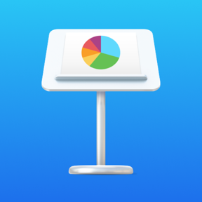
To use the Keynote app for animations, first open the app and start a new presentation. You can choose a blank slide or pick a fun template. Then, add pictures, shapes, or text by tapping the plus (+) sign. Once you have your objects, you can animate them by selecting an object and choosing the

Animate option. Keynote allows you to make things move, fade, pop up, or spin. You can decide when the animation happens, like after a click or automatically. If you have more than one slide, you can add transitions to make your slides change in a fun way, like fading or sliding.

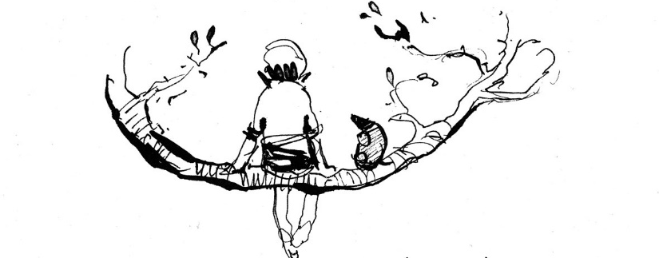
After you’re done, tap Play to preview your animations and adjust anything you want to change. Finally, save or share your animated presentation to show it off to others! Keynote makes it easy to create fun animations that bring your ideas to life.

 |  |  | Questions I Can Answer | FRUITS
 |  |  | - Can you create animations of faces that look like they’re really talking in a role?  - Can you use animation tools in presentation software to make simple animations?  - Can you take multiple animations of a character you made and put them together for a longer video?  - Can you use the line draw tool to create animations?  - Do you know how to add animated titles and transitions to your work?  - Can you use shapes and drawing tools to make digital art?  - Can you make responsible choices about your online identity, depending on the situation? | - Faith - Stories can explore trust in something unseen, like believing in hope or kindness even in difficult times.  - Relationships - Conflict and resolution in relationships can be a key part of the story, showing empathy and cooperation.  - Uniqueness – The animation can highlight the importance of embracing differences and valuing individuality.  - Intellect- Characters might use their knowledge to help others, solve mysteries, or invent creative solutions.  - Treat Others with Respect - The animation can show characters treating one another with kindness and fairness.  - Salvation - A story might show a character being saved from a difficult situation, whether physically, emotionally, or spiritually.

