Physical Education
Questions I can answer
FRUITS
Significant people
Throwing and Catching
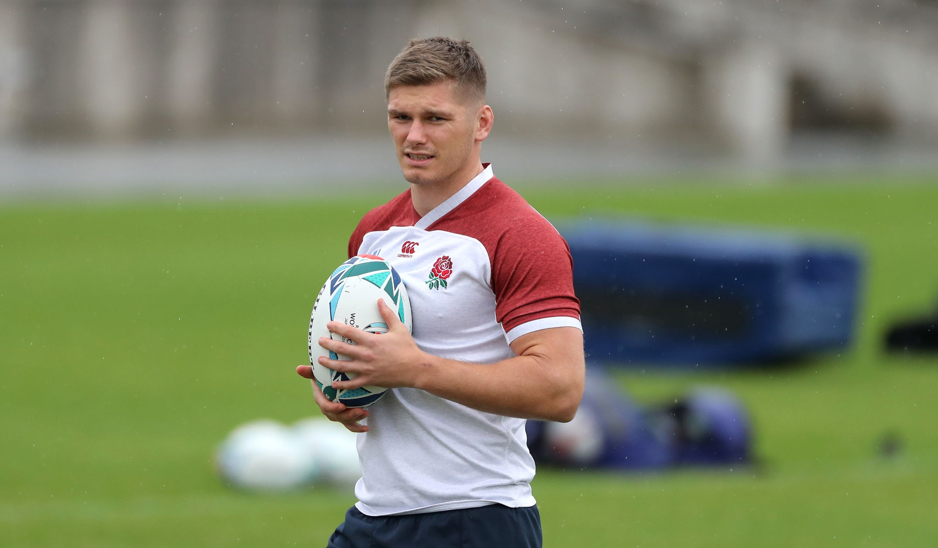
KS1 – Spring 2 2025
Owen Farrell – English Rugby Union Player
Am I able to throw and catch a ball independently?

Can I work with a partner to throw and catch a ball?

Am I able to focus and throw the ball in the direction I am aiming for?
I know how to throw a ball in the direction I am aiming for.
I know how to catch a ball.

Faith – How different cultures and religions come together and compete.
Relationships – Working together as a team.
Uniqueness – Everyone is unique in their own way.
Intellect – How we use our knowledge to throw and catch.
Treat Others with Respect – Treat everyone with respect.
Salvation – Understanding that it is okay to not always win, just know to keep going!

Resources- items needed to carry out a throwing and catching activity. E.g- ball, beanbag, flyers, etc.
Direction- to focus on which direction you want the ball to go.
Hand-eye coordination- this skill is important to be able to throw & catch, practice makes perfect!
Key Facts
- The most common throws are under arm and over arm throw.
- It is important to have good hand – eye coordination.
- Gross motor skills are vital to support fine motor skills.
- Throwing and catching skills are used in all ball games- e.g- netball, cricket, rugby, handball, basketball, and boccia.

Things I already know
Key Vocabulary

