Questions I can answer
What are the four seasons?
What changes occur during the season of Autumn?
What happens to a deciduous tree through the seasons?
What happens when the weather is frosty?
FRUITS
Seasonal Changes
Science
KS1 – Autumn 2 2024
Faith – Know the importance of looking after the world that God created for us.
Relationships–Working together and sharing equipment to observe and perform simple scientific tests.
Treat others with Respect and Dignity – Treat each other with respect by caring for our local environment by picking up litter, recycling, etc. Working together to complete simple tests.

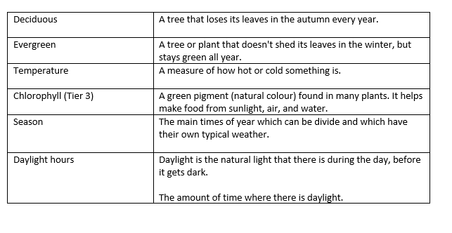

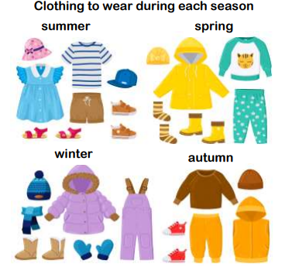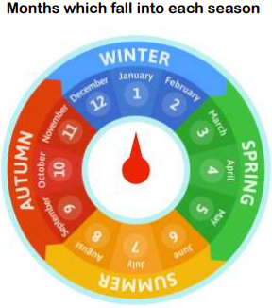
Key Facts
There are four seasons in a year: Autumn, Winter, Spring and Summer.
Each season lasts 3 months.
Deciduous trees are trees that lose their leaves every year.
Evergreen trees have green leaves all year round.
Daylight hours change through the seasons.
I know there are four seasons in a year –Autumn, Winter, Spring and Summer.
I know the weather changes during these seasons.
I know the basic weather types: sunny, cloudy, rain, snow, hail, windy, foggy.

Things I already know
Key Vocabulary

