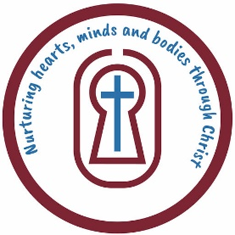
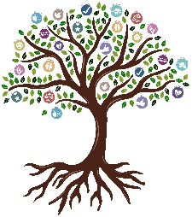
St Leonard’s CofE Primary School
Religious Education
YEAR 5 KNOWLEDGE ORGANISER

Key things I already know… |  |  | He Qi - Painter  He Qi is a Chinese artist who is known for creating beautiful paintings that often tell Bible stories. His art uses bright colors and special designs to make people think about God and faith in a unique way.  Fenwick Lawson - Sculptor  Fenwick Lawson is an artist from England who creates sculptures. One of his most famous works is a statue called The Good Shepherd, which shows Jesus caring for his sheep.  John Reilly - Painter  John Reilly is an artist who paints pictures that tell stories, often with a religious theme. His paintings are colorful and are meant to inspire people to think about their faith and the world around them.  Geraldine Elschner - Illustrator  Is an author who writes books about art and culture. She helps people, especially children, learn more about famous artists and their work, especially how art connects with history and faith. | Significant people | 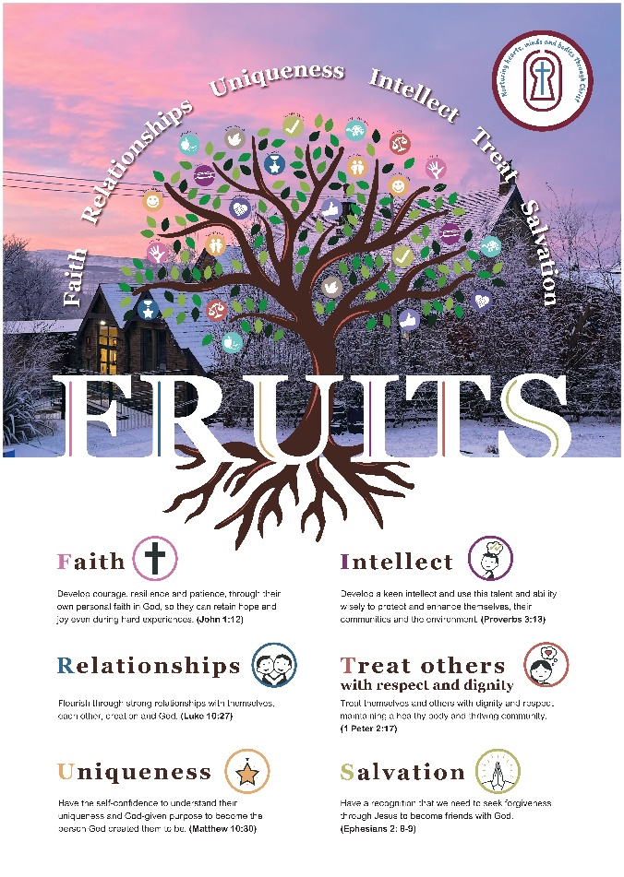
To enjoy and understand Christian art, it's helpful to know some important Bible stories and their meanings because these stories are often shown in art. You should also understand big Christian ideas like salvation (being saved), forgiveness, and what God is like, since these ideas appear in different kinds of art. Learning how people in different countries practice Christianity helps you see the variety of art from around the world. Recognizing symbols like the cross, lamb, or halo, and knowing what they stand for, is also important. Understanding how art is used in churches, both in the past and today, helps you see how art can help people think about their faith. Being able to talk about art, share your ideas, and listen to others will also help. With this knowledge, you'll feel more confident in enjoying and thinking about Christian art. |  |  |  | 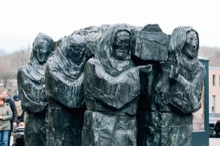  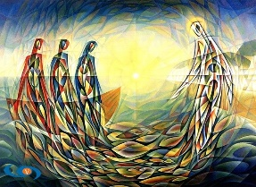  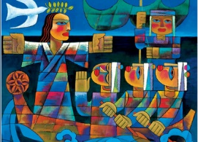  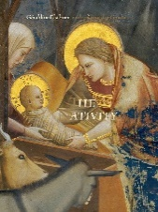
Key knowledge…
- Christianity is a faith followed by people all over the world, from many different cultures.
- Some people show their love for God and their beliefs through art.
- Christian art can help people grow closer to God and feel stronger in their faith.
- Think about how the artwork makes you feel or why it catches your attention.
- Ask big questions like “What is the purpose of life?” “Why are we here?” or “Who is God?”
- Think about what the artwork might mean to you or how it makes you feel inside.
- Know that Christianity is practiced by many different kinds of people around the world.
- See how art can teach us, inspire us, and help people feel closer to God.
through art? |  | How do Christians express their faith through art?
Key Vocab/Essential vocab  Sculpture: A sculpture is a type of art that you can touch. It is made by shaping things like stone or clay into a 3D shape, like a statue.  Renaissance paintings: These are paintings made a long time ago, showing people and nature in a very real and detailed way. Many show Bible stories.  Stained glass: Stained glass is colorful glass used in windows. It can make pictures or patterns, often found in churches.  Icons: Icons are special pictures of important people or stories in Christianity, like Jesus, that help people focus on their faith.  Modern art: Modern art is artwork made today. It can look different or unusual, and it shows the artist’s feelings or ideas.  Textiles: Textiles are things made from cloth, like blankets or wall hangings. Artists use fabric to make pictures or designs.  Interpretation: Interpretation is how you understand or explain something. When you look at art, your interpretation is your own idea of what it means.  Icon: An icon is a special picture, often of holy people, used in churches to help people think about their faith. | Questions I Can Answer
- What do you find interesting or puzzling about this piece of artwork?
- Can you tell the Bible story shown in the painting and explain its meaning?
- How do you think this artwork helps someone understand the Bible story, God, or a Christian idea better?
- Why do some pieces of artwork inspire you?
- How can you talk about a piece of Christian art using the right words and ideas about faith?
- How can a piece of religious art help answer big questions about life and faith?
- What do you think about this artwork? How do you feel about it, and what do you think others might say?

 |  |  |  | 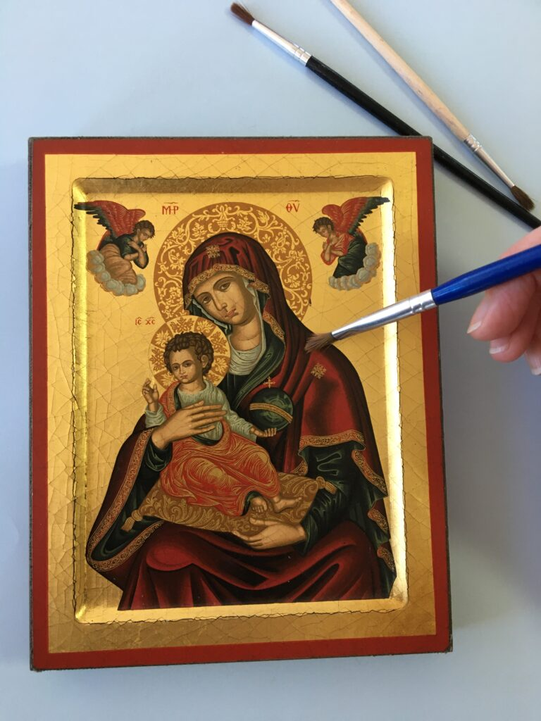 |  | FRUITS
Faith - Faith means believing in God. Christian artists show their faith by painting Bible stories or symbols like crosses to help others think about God.
Relationships - Relationships are how we connect with people. Christians believe in having a close relationship with God and others. Artists might paint pictures of Jesus helping people to show love and care.
Uniqueness - Uniqueness means being special. Christians believe everyone is unique because God made them that way. Artists use their own special styles to share their love for God.
Intellect- Intellect means using your mind to think and understand things. Christian artists use their minds to think about God and create art that helps people learn and think about their faith.
Treat Others with Respect - This means being kind and fair to others. Christian artists show respect in their work by creating art that teaches kindness, love, and forgiveness.
Salvation - Salvation means being saved by God. Christians believe Jesus came to save everyone. Artists paint pictures of Jesus to remind people of His love and how He saved us.

