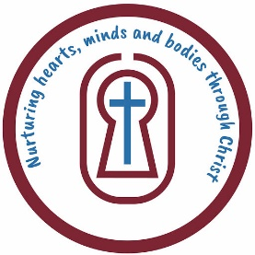
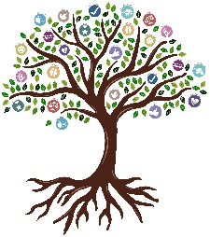
St Leonard’s CofE Primary School
Religious Education
YEAR 5 KNOWLEDGE ORGANISER
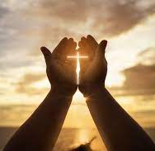
Key things I already know… |  |  | Jesus – Jesus is the main person in the Easter story. He is God's Son, and He came to teach people about love and kindness. He was crucified (nailed to a cross) and died, but three days later, He came back to life!  Peter – Peter was one of Jesus' closest friends. He promised he would never leave Jesus, but when Jesus was arrested, Peter was scared and said he didn't know Jesus.  Judas Iscariot – Judas was one of Jesus' disciples, but he made a bad choice. He betrayed Jesus and told the soldiers where to find Him, which led to Jesus' arrest.  Pontius Pilate – Pilate was the Roman governor in charge at the time. Even though he didn’t think Jesus had done anything wrong, he agreed to have Jesus crucified because the people wanted it.  Mary Magdalene – Mary Magdalene was a friend of Jesus. She went to His tomb after He died and was the first to find it empty. Then, she saw Jesus alive again and went to tell the others.  The Roman Soldiers – These soldiers followed Pilate’s orders and were the ones who nailed Jesus to the cross. They also made fun of Jesus before He died.  The High Priests – The high priests were the leaders of the Jewish church. They didn’t like that Jesus was teaching people about God's love and power, so they helped plan for Him to be arrested and killed | Significant people | 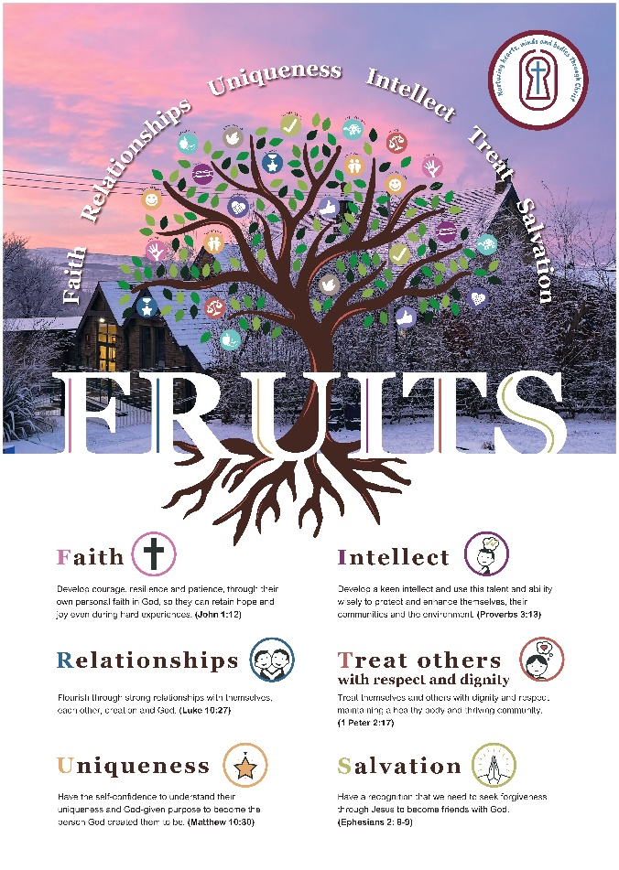
The events of Palm Sunday, Holy Week, and Easter are full of both joy and sadness. On Palm Sunday, people were happy to welcome Jesus, but by the end of the week, He was crucified, which made everyone very sad. The church remembers these important events in different ways, helping people understand what Jesus came to do. Holy Week shows God’s big plan to save everyone, which is a key part of the Easter story. Trust and forgiveness are important values in many world religions, and they are also key teachings in the Bible. Christians believe that being forgiven by God and forgiving others is very important. In the Easter story, betrayal and trust play a big part, especially with Judas betraying Jesus. All these events help Christians understand why Jesus came to Earth and how they can trust Him to show them the way.
Key knowledge…
- Christians believe that when Jesus came back to life, He beat death. This means death isn’t the end, and people can have hope.
- Christians believe Jesus’ death and resurrection fixed the broken connection between God and people, bringing them back together.
- The Easter story is the most important part of what Christians believe because it shows that Jesus died and came back to life to help people be close to God.
- Palm Sunday: A week before Easter, Jesus rode into Jerusalem. The people were happy to see Him and waved palm branches, shouting, "Hosanna!" because they thought Jesus was the king who would help them.
- The Last Supper: The night before He died, Jesus had a meal with His friends. He shared bread and wine, telling them it was like His body and blood. He asked them to remember Him whenever they ate.
- The Arrest: After dinner, Jesus went to pray. Judas, one of His disciples, told the soldiers where Jesus was. Jesus was arrested and taken away.
- The Crucifixion (Good Friday): Jesus was sentenced to die on a cross. It was very painful, but He forgave the people who hurt Him. Everyone was sad when He died.
- The Resurrection (Easter Sunday): Three days later, some women went to Jesus’ tomb and found it empty. An angel told them, "Jesus is alive!" Jesus had come back to life, showing that death couldn’t stop Him.
Why do Christians believe that Easter is a celebration of victory?
Easter is a celebration of victory?
Key Vocab/Essential vocab | Questions I Can Answer
Victory: Winning or succeeding after a challenge or battle. For example, when you win a game or overcome something hard.  Triumph: A big win or great success. It’s like feeling really proud and happy after achieving something important.  Resurrection: Coming back to life after being dead. Christians believe Jesus rose from the dead on Easter Sunday.  Sacrifice: Giving up something important or valuable for the good of others. For example, a person might give up their time or something they love to help someone else.  Salvation: Being saved or rescued, especially in a spiritual way. Christians believe Jesus saved people by dying for their sins and offering them eternal life with God.  Redeemer: Someone who saves or rescues others. In Christianity, Jesus is called the Redeemer because He saved people from their sins and gave them a chance for eternal life. | - Why do Christians believe that Easter is a celebration of Victory?  - In what ways is Jesus death and resurrection a victory?  - Why is Easter the key event in God's Big Story?  - Why is Jesus' victory so important to Christians?  - Apart from Jesus, which character in the Easter story would you most like to meet? Why?  - Why are the church colours at Easter white and gold?
 |  |  |  |  |  | FRUITS
Faith – Easter helps people believe in God and the idea of life after death because Jesus came back to life. It shows us that having faith, or believing in something you can’t see, is really important.
Relationships – The Easter story is about the important relationships between Jesus and His friends, Jesus and God, and others. It teaches us how we should care about and treat each other.
Uniqueness – Jesus is special because His life, death, and coming back to life were one-of-a-kind. This makes Easter a really important story for Christians.
Intellect – The Easter story makes us think about big ideas like giving up something for others, forgiving people, and what it means to come back to life. It helps us think about what’s right and wrong in life.
Treat Others – Even when people hurt Jesus or turned against Him, He still treated them with kindness and respect. He teaches us to treat everyone, no matter what, with love and respect.
Salvation – Easter is about how Jesus’ death and coming back to life can save people and give them the chance for eternal life with God. It shows us the idea of being forgiven and starting fresh.

