Questions I can answer
Significant people
Christmas
RE
KS1 – Autumn 2 2024
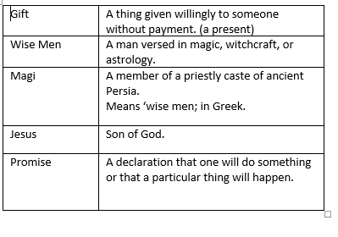
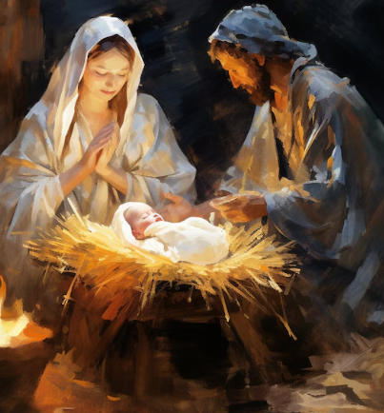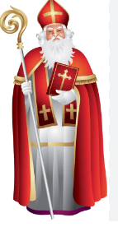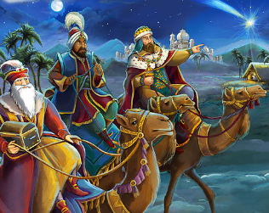
Faith – Explore the Christmas story and the importance of Jesus.
Relationships-Sharing your own experiences / opinions with each other.
Unique-Everyone has different thoughts and experiences. Everybody’s families are different and we have our own traditions at Christmas.
Intellect-retell the story and recall that Jesus is a gift from God to the world.
Treat each other with respect when we share our experiences and thoughts/ opinions.

FRUITS
Why do people give and receive gifts at Christmas?

Why is Jesus described as a gift?

How does it feel when you give and receive gifts?

What is the best gift you have ever received?
I know that Jesus was born on Christmas Day.
I know that Mary and Joseph are Jesus’ parents.
I know that Jesus is the son of God.

Key Facts
To know that not all gifts are objects.
To be able to retell the Nativity story.
To know that the three wise men visited Jesus after Christmas.
To understand that Jesus is a gift from God to the world.
To know who St Nicholas was.
Things I already know
Key Vocabulary

