Year | 3/4 |  |  | Term: | Autumn 2 |  | Unit: | Peace S12
Big Question: | What is Peace?
Prior Substantive Knowledge | Understanding the story of Jesus calming of the storm (Mark 4:35-41) |  |  |  |  |  | Cross-curricular | Art
Prior Substantive Knowledge |  |  |  |  |  |  | Key Vocab  Key questions | Peace, calm, tranquil,  What is peace?, Where is peace?, When is there peace?, Who brings peace?, How is peace created?, Can peace be measured?, What is the opposite of peace?, Why is peace important?
Substantive Knowledge (Know what) |  |  |  |  |  |  | Disciplinary Knowledge (Think like)
- Peace is a fruit of the spirit and a key Christian concept.  - There is a connection between values, action and beliefs. |  |  |  |  |  |  | - Ask important and relevant questions.  - Express in words and art, their own opinion about the value of peace.  - ask and suggest answers to quality questions about values, meaning and commitment.  - Use religious vocabulary to talk about peace showing their understanding of religious text and beliefs.
Teacher Knowledge | Definition of peace, Bible stories/readings that include peace – Galatians 5:22-23, Philippians 4:6-7, John 14:27. Understanding of how to deepen children’s knowledge – how to question and facilitate the children to deepen their thinking.  Understand that peace is part of Kingdom of God (big story) and that this is because Kingdom of God is how Jesus intended us to live out our lives and that through Peace we should be able to do this. |  |  |  |  |  | FRUITS | Faith -  Relationships -  Uniqueness – To understand that Peace means different things to different people – encouraged through individual artwork created.  Intellect -  Treat Others with Respect – Being respectful during discussions that people will have different opinions.  Salvation – Peace can come after a time of difficulty and they can have salvation during this time – discussion based
Key concept |  | Learning objective | Key components |  |  | Lesson Detail |  |  | Adaptive strategies
Kingdom of God |  | L.O. To explore the meaning of peace. | - link back to prior knowledge of peace.  - to discuss the meaning of peace.  - to demonstrate what peace means to them. |  |  | Pose the big question – What is Peace? Explain to children that this is what we will be answering and how this links back to the big story. Ask the children to sit in a circle. Play a piece of peaceful music. How does the music make them feel? What atmosphere/mood is created by the music?  Place the word peace in the centre of the circle along with a few objects representing peace e.g. blue/green fabric, pictures of beautiful countryside, a cross, a candle, a story book with the word peace in the title and a prayer book. Fanning out from the centre put the questions, When? Where? How? What? Why? Who? Read the words aloud and pause for a moment.  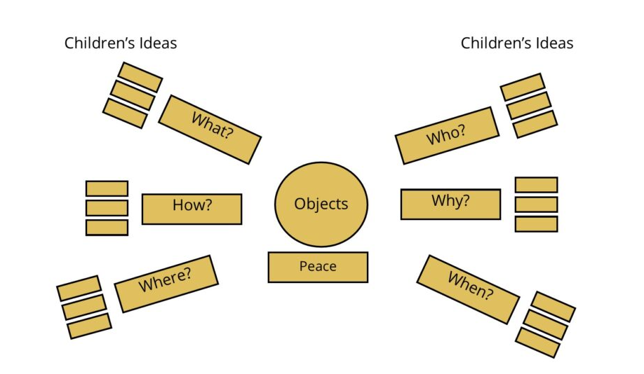  Challenge the children to generate questions about peace using When? Where? How? What? Why? Who? Ask them to write the questions on a slip of paper which are placed next to the first word of the question. Continue generating questions using; Would? Could? Should?  Ask them to write the questions on a slip of paper which will be used in the next lesson. If you are unable to display the questions on a working wall, gather everything together carefully as you will need to reconstruct this mind map at the start of your next lesson.  Take photos of your display for floorbook  Share and discuss the challenging questions that the children have thought of. Give children paper so that they can write or draw an answer to some of the questions discussed. Read the children’s responses aloud and add these to the RE working wall.  Record answers to questions in floorbooks |  |  | Stem sentence of board.  I think that……because…..  Visuals of pictures of different emotions – peace, anger, happy etc.
Kingdom of God |  | L.O. To discuss and explore the meaning of peace. | - link back to prior knowledge of peace.  - identify words and symbols related to peace.  - describe what peace means to them. |  |  | Remind children of some of the questions and answers about Peace from last week. Re look at the objects that were displayed last week. Talk about the objects in the display. Have questions on the board ready for the children to answer in groups - In what ways are they connected to peace? Do they all interpret the same kind of peace?  Children are to create a mind map with the word Peace in the middle and use their discussions and answers to help create their concept of peace. Children can use pictures and words to describe.  Record mind maps in children’s books |  |  | Have key words available on the board to associate with peace.
Kingdom of God |  | L.O. To define Peace | - link back to prior knowledge of peace.  - identify words and symbols related to peace.  - describe what peace means to them. |  |  | Share children’s mind maps from last half term and allow children to discuss whether they agree with what is said and if they can comment further. Using their mind maps, the children can then create several sentences beginning with ‘Peace is…..’  And a second set of sentences beginning with ‘Peace is not…….’  Display key questions on the board to help support their sentences - What is peace? Where is peace? When is there peace? Who brings peace? How is peace created? Can peace be measured? What is the opposite of peace? Why is peace important?  Record in children’s books. |  |  | Sentence starter sheet  Key questions on tables
Kingdom of God |  | L.O. To define Peace in a biblical sense. | - link back to prior knowledge of peace.  - identify words and symbols related to peace.  - describe what peace means in the Bible |  |  | Remind children about what we are looking at – can they remember the key word – peace. What does the Bible say about peace? See Galatians 5:22-23, Philippians 4:6-7, John 14:27. Read these out loud and invite children to read parts as well. Peace is one of the gifts of the Spirit. St Paul also writes that it will guard hearts and minds. Jesus said he gives peace to his disciples and they must not be afraid. What does that tell you about the value of peace?  Record in children’s books.  It is really important that your discussions go beyond ‘peace is when there is no war’ or ‘after war there is peace’. |  |  | Bible readings printed out.  Sentence starter sheet.
Kingdom of God |  | L.O To understand what Peace is in art form | - discuss the meaning of peace  - discuss and decide media type  - explore other artwork of peace |  |  | Collate all the discussions and work that taken place so far and encourage children to have their own interpretation of what peace means to them – allow children to express this in artwork through a variety of media (this may need some pre discussing for resources needed) Create a gallery of the work.  Record in children’s books. |  |  | Variety of media to choose from.

