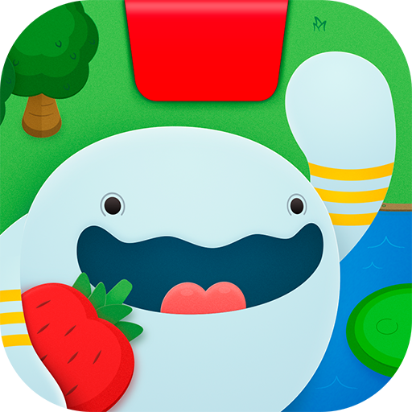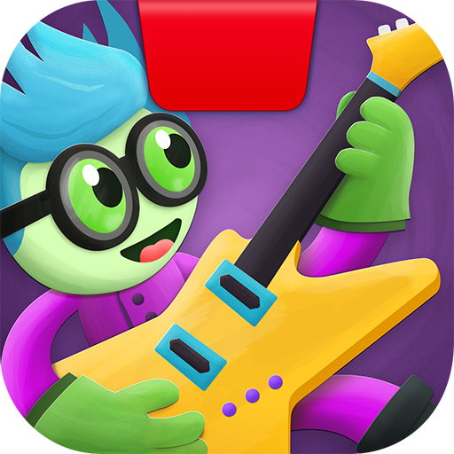
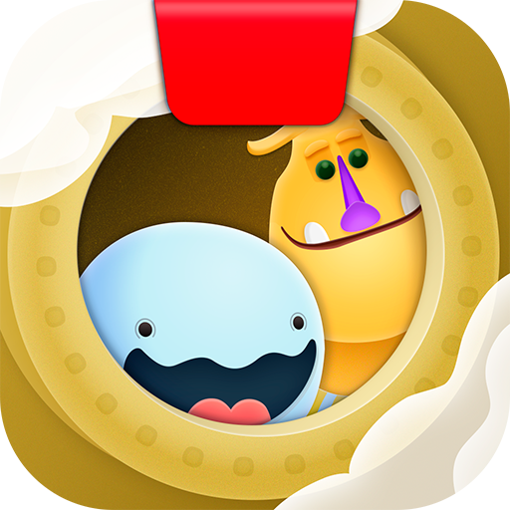

Osmo Coding Planning
Year 3 and 4

OSMO Awbie Coding: Lessons 1 -3
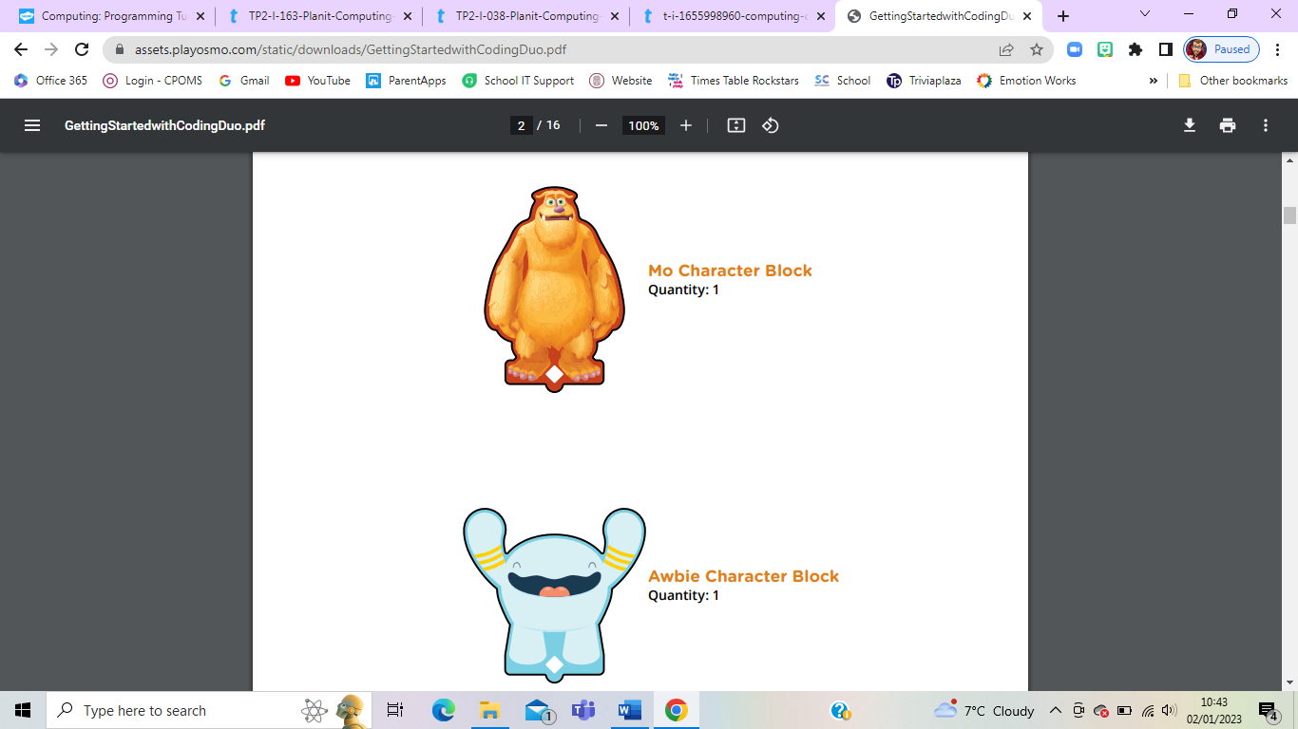
Objectives:
- Using appropriate software, I can work collaboratively to design an interesting and entertaining game which incorporates a form of control technology or interactive multimedia.
- Use logical reasoning to explain how some simple algorithms work and to detect and correct errors in algorithms and programs.
- Design, write and debug programs that accomplish specific goals, including controlling or simulating physical systems; solve problems by decomposing them into smaller part.
- Use sequence, selection, and repetition in programs; work with variables and various forms of input and output.
- Use sequence, selection, and repetition in programs; work with variables and various forms of input and output - Loops
Key Concept 1  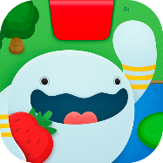 | What is an Algorithm https://www.bbc.co.uk/bitesize/topics/z3tbwmn/articles/z3whpv4  Osmo Coding has seven different Command Blocks, which are the building blocks of Awbie’s interaction with the world. Three of the action commands (Walk, Hand, and Jump) have turnable arrows. Combining multiple commands together will result in longer chains of strawbies, faster movement, and high bonuses!  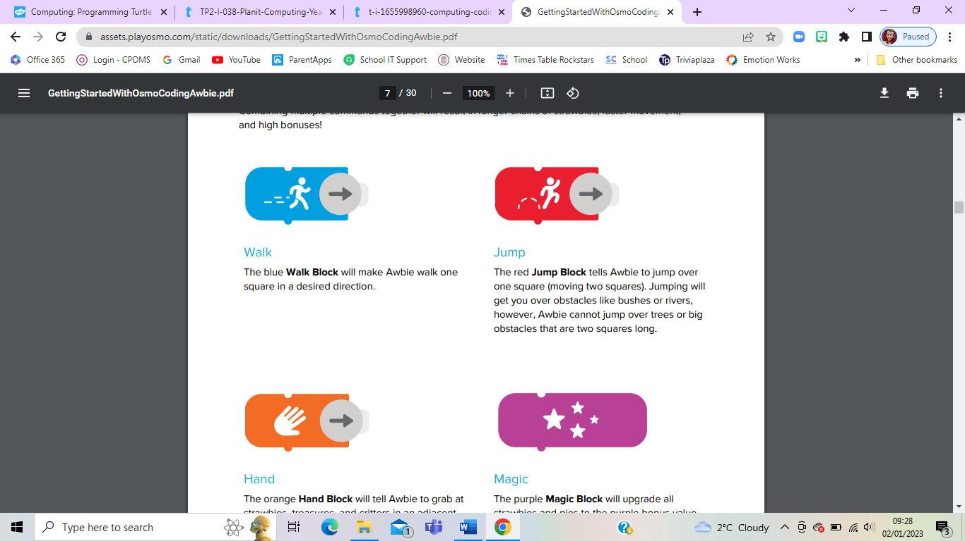  Walk  The blue Walk Block will make Awbie walk one square in a desired direction.  Jump  The red Jump Block tells Awbie to jump over one square (moving two squares). Jumping will get you over obstacles like bushes or rivers, however, Awbie cannot jump over trees or big obstacles that are two squares long.  Hand  The orange Hand Block will tell Awbie to grab at strawbies, treasures, and critters in an adjacent square or obtain items that are hidden in bushes, rocks, or crates.  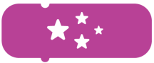  Magic  The purple Magic Block will upgrade all strawbies and pies to the purple bonus value. To use Magic, you will need to have a full magic meter. Fill it by collecting Stars. After activating Magic, the meter will decrease with every command that you play.  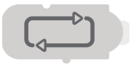  Repeat  Use the Repeat Block to “loop” your code. A loop is when a sequence of commands is repeated. By putting a Repeat Block at the top of a sequence all commands attached below it will repeat by the Quantifier number you attach to it.  Note: Attaching a Quantifier Block is required to make a sequence loop.  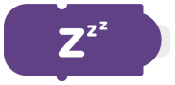  Rest  The dark purple “Zzz” Rest Block is used to pause Awbie’s movement for brief moments of time.  Note: Only included in the new Coding Starter Kit or Coding Family Bundle  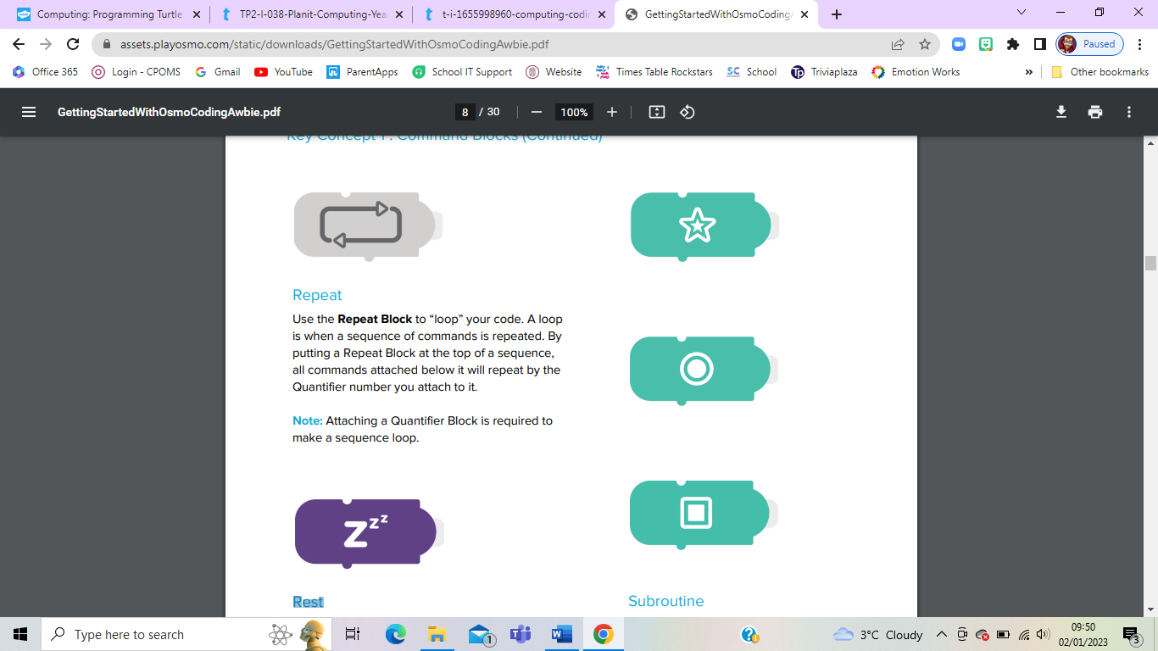    Subroutine  Subroutines are a way to store an entire sequence of code into one of these three special blocks. Use a subroutine block if you want to save or reuse longer and more complex codes.  Note: Only included in the new Coding Starter Kit or Coding Family Bundle  Build Their First Code  The first introduction level will show you the basics of using the coding blocks. Follow the directions you see on the screen to start on your adventure in coding.  1. Start by sliding a WALK in front of the Osmo and turn to the “right.”  2. Tap the screen. A countdown will appear and then watch as Awbie walks one space to the right.  They just made their first code!  Note: Make sure that fingers or hands do not cover any parts of the blocks when you see the countdown or the Osmo may not see your code.  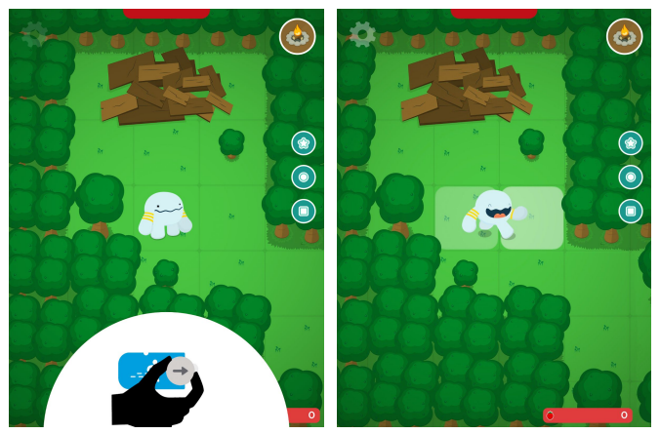
Key Concept 2 | What is Debugging? https://www.bbc.co.uk/bitesize/topics/zs7s4wx/articles/ztkx6sg  A useful feature that can help maximize a high score or to ensure Awbie doesn’t go for a swim too often is Path Projection. In any game level when you put a coding block down in front of the Osmo, you will see a series of lit squares that preview where Awbie will go. This allows you to test your code for errors before Awbie cannonballs into a lake by mistake.  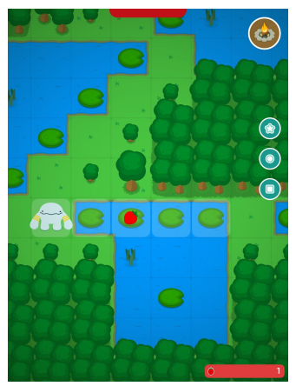  Don’t want Awbie to run into that tree? Take a moment and preview the path first, then look at your blocks to determine which block is causing an error in your desired path and change it. This is called debugging your code. Use it to plan your next move!  Throughout levels there are signs that will help teach new coding concepts, usage of command blocks, and give hints to solve tricky puzzles. Activate a Helper Sign by moving Awbie to the adjacent space next to a sign. Reproduce the code that appears on the sign or use it as a hint.  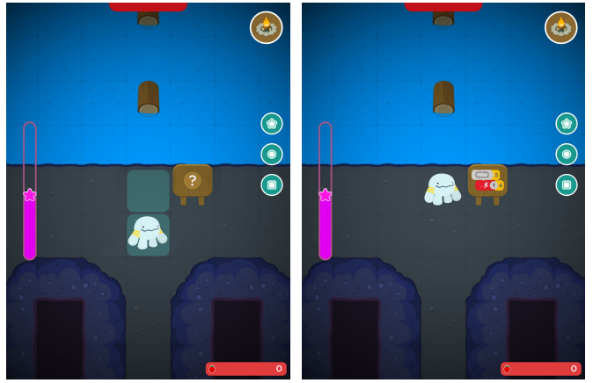  Note: Want an added challenge? You can turn off Helper Signs by going to the Menu (Gear Icon) and selecting Signs Disabled.
Key Concept 3 | What is logical reasoning? https://www.bbc.co.uk/bitesize/topics/zs7s4wx/articles/zxgdwmn  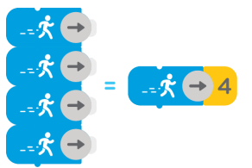  The yellow number blocks are Quantifiers. If you attach a quantifier to a command (Walk, Jump, Hand, Rest, Repeat, or a Subroutine), Awbie will repeat the action X times. Quantifiers range from 2 to 5. Think of quantifiers as parameters to a function.  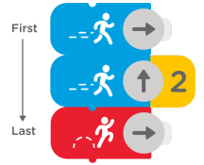  Sequencing is when you connect two or more blocks together. When you start using multiple blocks in a sequence, you begin an important step towards a key computational concept, sequencing. Awbie walks faster when you sequence. The order of actions that Awbie follows is read from the top down. In the sequence below, Awbie will first walk right, then walk up two spaces, then last jump right.  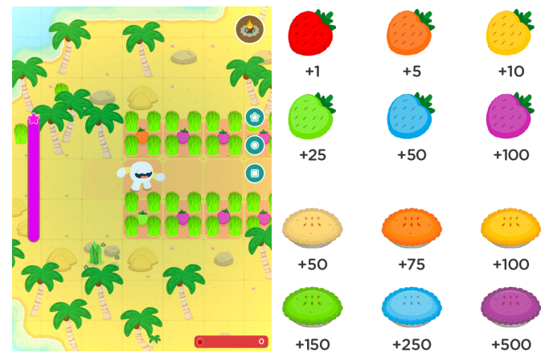  When you create a sequence that lines up more than one strawberry or pie in a row, Awbie becomes super happy and goes into Frenzy. Each pie and strawbie will change colour and increase in bonus value. Get as many purple strawbies or pies as you can for the highest bonus!  The Magic Block activates a special ability of Awbie to upgrade all the strawbies and pies on screen to the highest bonus value of purple. To use magic, you must have a full Star Meter. Fill the meter by collecting Three Stars.  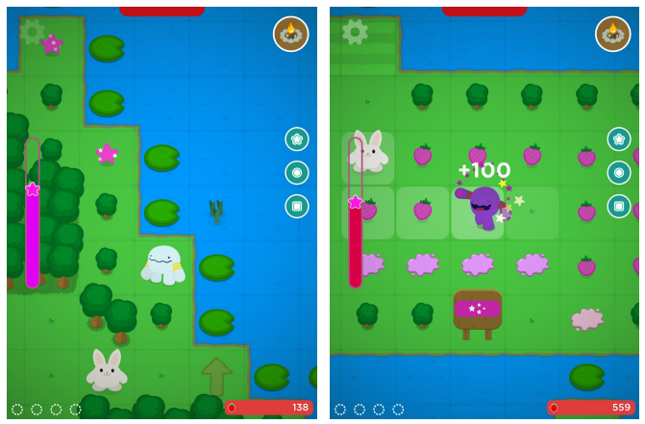  Note: With each sequence you run, the meter will go down. When empty, strawbies and pies will return to their normal but delicious colour.
Key Concept 4 | What is repetition and selection? https://www.bbc.co.uk/bitesize/topics/zs7s4wx/articles/zd3pf82  Use the Repeat Block to “loop” your code. A loop is when a sequence of commands is repeated. By putting a Repeat Block at the top of a sequence, all commands attached below it will repeat by the Quantifier you attach to it.  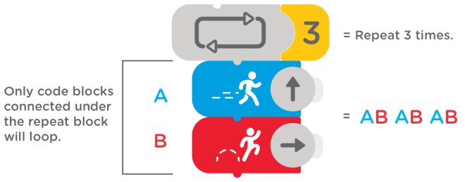  Note: Attaching a Quantifier Block to the Repeat Block is required to make a sequence loop.
Extension (Greater Depth) Task | For more advanced coders, you can save and reuse sequences inside of subroutines.  1. First put down a sequence of code.  2. Then choose one of the three subroutine blocks you’d like to save it to. Tap on the matching symbol of the block and when ready, hit the Green Save Button.  3. Your code is now saved! Slide up the Subroutine Block you chose, connect it into a sequence, or use it by itself.  Note: Subroutines are saved for one level only. If you finish or leave a level, the code will not be saved.  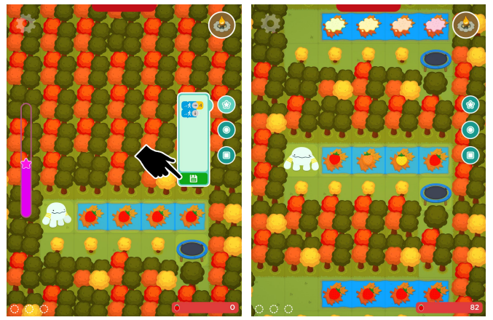

OSMO Coding Duo: Lessons 3 – 5

Objectives:
- Using appropriate software, I can work collaboratively to design an interesting and entertaining game which incorporates a form of control technology or interactive multimedia.
- Use logical reasoning to explain how some simple algorithms work and to detect and correct errors in algorithms and programs.
- Design, write and debug programs that accomplish specific goals, including controlling or simulating physical systems; solve problems by decomposing them into smaller parts.
- Use sequence, selection, and repetition in programs; work with variables and various forms of input and output.
- Use sequence, selection, and repetition in programs; work with variables and various forms of input and output – Loops
Key Concept 1  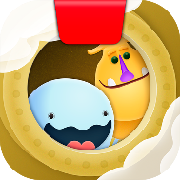 | What is decomposition? https://www.bbc.co.uk/bitesize/topics/zs7s4wx/articles/z8ngr82  Use the character blocks to bring Mo and Awbie into the game!  1. During a game level, choose Awbie or Mo (or both) and place that character block in front of the Osmo Base. Your chosen characters will appear on the corresponding level start markers.  2. Connect a sequence of coding blocks below each character to specify what actions you would like the character to perform.  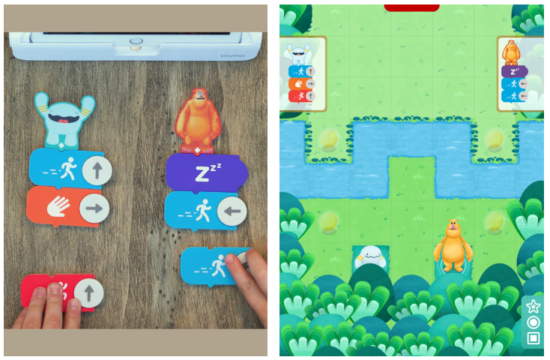  3. When you’re happy with the sequence, tap the screen to see Mo and/or Awbie follow your coding. When the characters reach the level’s finish zone, you’ve completed the level!
Key Concept 2 | What are inputs and outputs? https://www.bbc.co.uk/bitesize/topics/zs7s4wx/articles/zx8hpv4  Compiling in Coding Duo is easy with just a Tap on the screen!  1. Your coding sequence is displayed in the upper corners of the screen. When you’re ready, tap on the screen to compile the code. Awbie and/or Mo will begin to act according to the coding sequence.  2. At any time during the sequence action, you can tap the Stop Button to reset the level. Mo and Awbie will return to their level start markers.  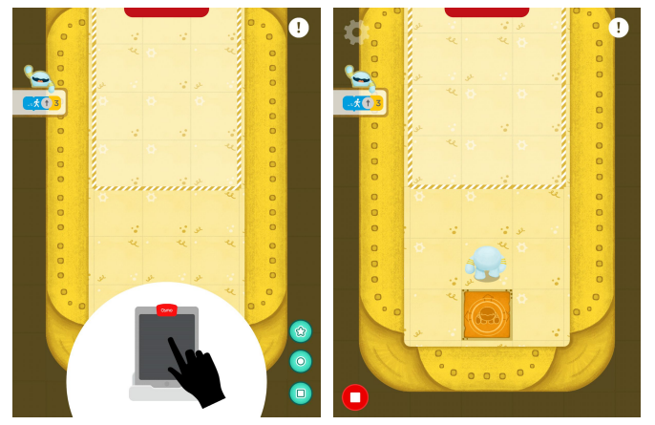  Mo and Awbie perform the Jump Action differently from each other. Keep this in mind when deciding which side to place your characters at the start of each level.  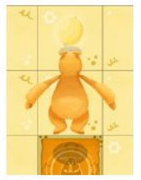  Mo with Jump  Mo jumps only one space when using the Jump block.  Pro Tip: Mo’s shorter jump can be useful in tight spaces!  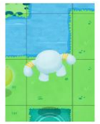  Awbie with Jump  Awbie jumps two spaces when using the Jump block.  Pro Tip: Awbie’s longer jump lets him go over bushes and rivers!  Mo and Awbie each have their own unique actions when the Hand Block is used in a coding sequence. Experiment with different combinations of code sequences to discover how they react and work with each other.  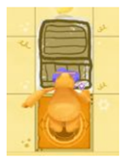  Mo with Hand Block  When Mo uses the Hand Block, he draws a box in front of himself. Walking into a box allows him to push the box forward.  Pro Tip: Push the box over water to create a platform for Mo to walk on!  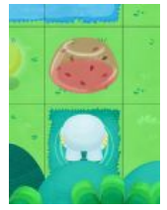  Awbie with Hand Block  When Awbie uses the Hand Block, he creates a strawberry jelly in front of himself. Walking into the jelly bounces a character two spaces!  Pro Tip: Place a strawbie jelly in front of Mo so that he can jump two spaces instead of one!
Extension (Greater Depth) Task | For more advanced coders, you can save and reuse sequences inside of subroutines.  1. First put down only one sequence of code. (It doesn’t matter what side)  2. Then choose one of the three subroutine blocks you’d like to save it to. Tap on the matching symbol of the block and when ready, hit the Green Save Button.  3. Your code is now saved! Slide up the Subroutine Block you chose to Mo or Awbie, connect it into a sequence, or use it by itself.  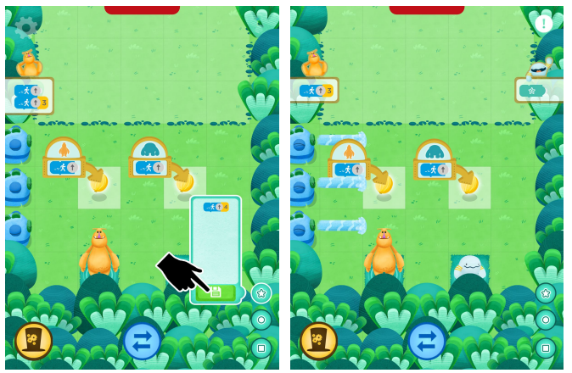  Note: Subroutines are saved for one level only. If you finish or leave a level, the code will not be saved.

OSMO Coding Jam: Lessons 5 – 7
Objectives:
- Using appropriate software, I can work collaboratively to design an interesting and entertaining game which incorporates a form of control technology or interactive multimedia.
- Use logical reasoning to explain how some simple algorithms work and to detect and correct errors in algorithms and programs.
- Design, write and debug programs that accomplish specific goals, including controlling or simulating physical systems; solve problems by decomposing them into smaller parts.
- Use sequence, selection, and repetition in programs; work with variables and various forms of input and output.
- Use sequence, selection, and repetition in programs; work with variables and various forms of input and output – Loops
Music Objectives:
- Use music technology, if available, to capture, change and combine sounds
- Create music and/or sound effects in response to music and video stimulus.
- Play and perform melodies following staff notation, using a small range, as a whole class or in small groups.
Key Concept 1  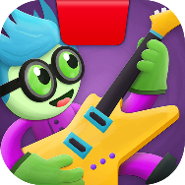 | 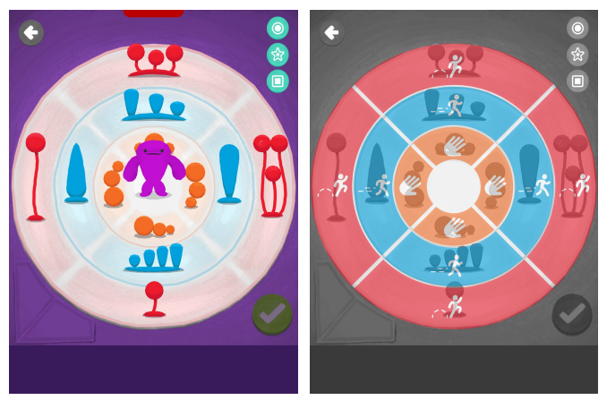  Osmo Coding Musical objects are set up into Three Rings that surround your character. The diagram below shows how the coding blocks relate to the different sections of the rings. Choose the different Command blocks and rotate the arrows to pick what object you want to play.  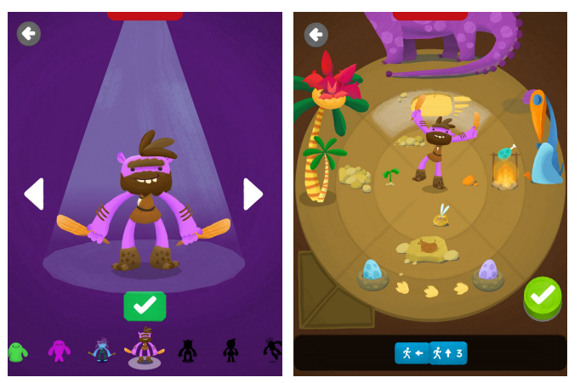  Coding Jam is filled with over 300 musical objects. New and unique characters will join your Jam Crew the more you practice or publish new jams. Each new member of your crew has a different theme and set of musical objects.
Key Concept 2 | 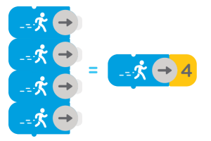  The yellow number blocks are Quantifiers. If you attach a quantifier to a Verb Command block (Walk, Jump, or Hand), the character will play that musical object as many times as the number on the quantifier. Quantifiers range from 2 to 5. Think of quantifiers as parameters to a function.
Key Concept 3 | Sequencing is when you connect two or more blocks together. When you start using multiple blocks in succession, you’re taking an important step towards a key computational concept, sequencing.  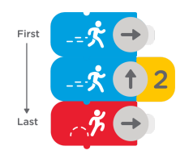  The order of commands is read from the top down. In the below sequence, the character will play the musical object located at Walk Right 1 time, then play the object at Walk Up 2 times, then play the Jump Right object 1 time.
Key Concept 4 | What is a variable and how do computers use them? https://www.bbc.co.uk/bitesize/topics/zs7s4wx/articles/zw3dwmn#z4qckty3  Use the Repeat Block to “loop” your code. A loop is when a sequence of commands is repeated. By putting a Repeat Block at the top of a sequence, all commands attached below it will repeat by the Quantifier you attach to it.  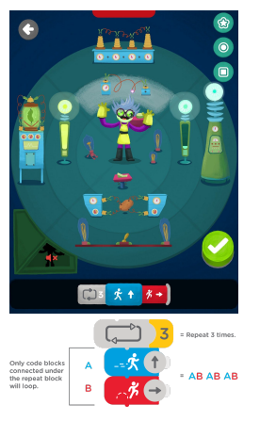  Note: Attaching a Quantifier Block to the Repeat Block is required to make a sequence loop.  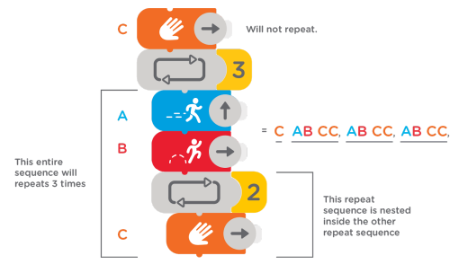  You can add multiple Repeat Blocks to create a nested loop. Each Repeat block adds one indentation. When code reaches the end of a nested loop, it will bounce back up to each Repeat block, going to the one with the deepest indentation first.
Extension (Greater Depth) Task | For more advanced coders, you can save and reuse sequences inside of subroutines.  1. First put down a sequence of code.  2. Then choose one of the three subroutine blocks you’d like to save it to. Tap on the matching symbol of the block and when ready, hit the green save button.  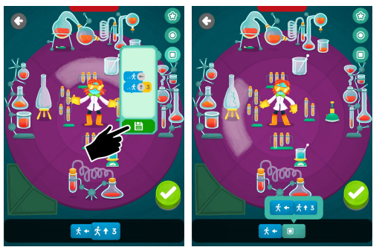  3. Your code is now saved! Slide in the Subroutine Block you chose. Connect it or use it by itself.  Once you earn 300 hearts, you will unlock the Advanced Editor and Chord Machine. Use it to add chord progressions and to access editing features like delete, rewind, and pause.  1. To add a chord progression, create a jam in Studio.  2. Tap on the arrows to switch between different chord progressions.  3. Listen to how these different chords change the tune of your Jam. The keys are shown on the Chord Machine display.  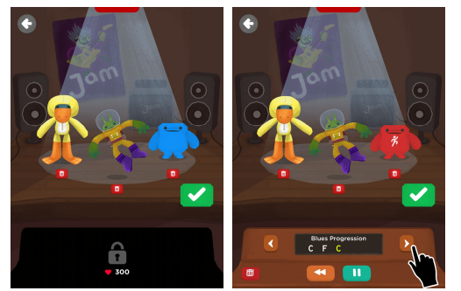  Note: By default, all jams start in the key of C major

