Questions I can answer
FRUITS
Significant people
Rocks
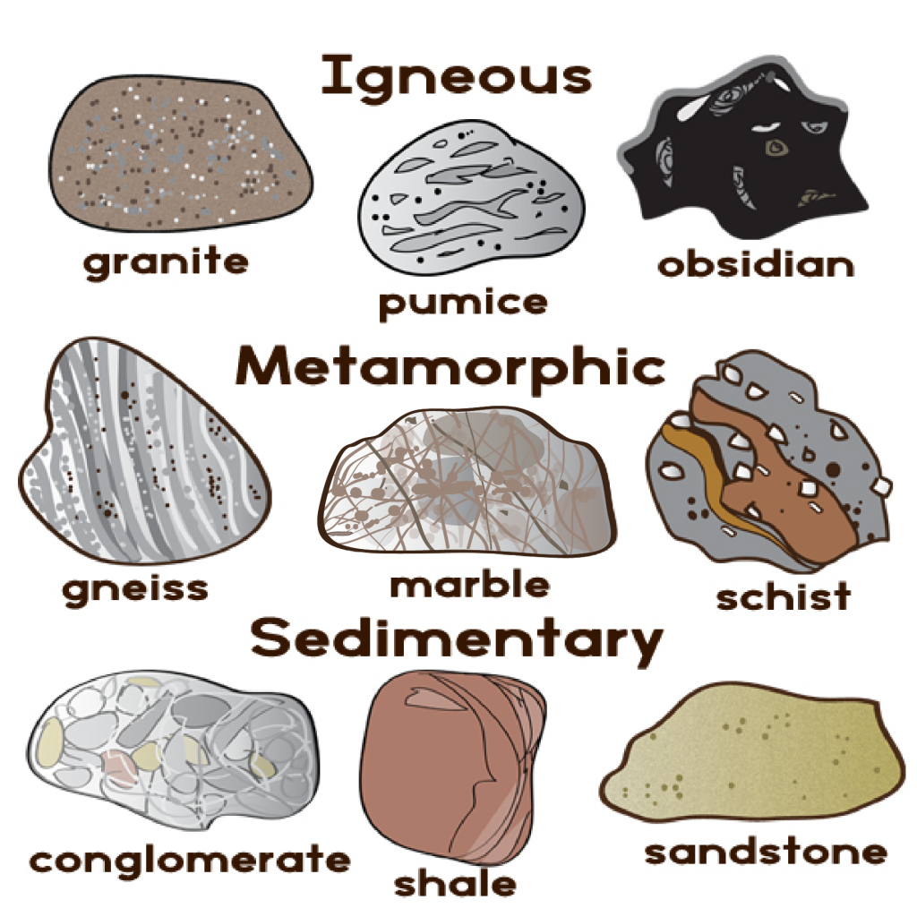
Science
LKS2 – Spring 1 2025
• I can name a variety of everyday materials, including wood, plastic, glass, metal, water, and rock and understand what they are used for.
• Describe the simple physical properties of a variety of everyday materials and their uses.
• Compare and group together a variety of everyday materials on the basis of their simple physical properties.

- Are there different types of rocks?
- How are fossils formed?
- How is soiled created?
- Are rocks use for different purposes?
- Do all rocks have the same durability?
- What is beneath our feet?

Faith – To understand that God created, rocks, minerals, and the earth’s
Relationships –Sharing love for nature can help people build deeper emotional connections.
Uniqueness – Each rock formation, mineral and fossil has its own distinctive characteristics.
Intellect – The study of rocks presents an endless opportunity for exploration, from understanding the Earth's formation to decoding the intricate processes that shape the planet..
Treat Others with Respect – The study of rocks involves teamwork and collaboration with others.
Salvation – Seeing the world as sacred and is looked after.

Igneous: A type of rock that forms from cooled molten material (magma/lava).
Sedimentary: Rocks formed from layers of sediments that accumulate over time.
Metamorphic: Rocks that have transformed from one type to another due to heat and pressure.
Fossil: The preserved remains or traces of a plant or animal.
Magma: Molten rock beneath the earth's surface.

Key Facts
- Compare and group together different kinds of rocks on the basis of their appearance and simple physical properties.
- Fossils are formed when things that have lived are trapped within rock.
- Soils are made from rocks and organic matter.
- Rocks and soils can feel and look different.
- Rocks and soils can be different in different places/environments.

Things I already know
Key Vocabulary

