Questions I can answer
Significant people
Forces and Magnets
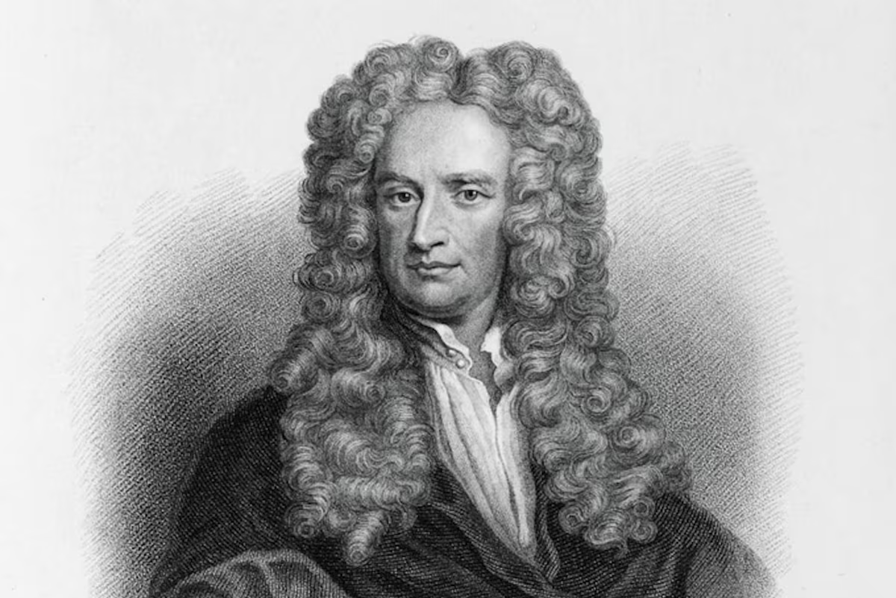
Science
LKS2 – Spring 2 2025
Faith – Forces and magnets show a guiding hand and intelligent design in the world.
Relationships – our relationships can be seen as a forces in our lives guiding how we move through it.
Uniqueness – objects have unique properties which determine how they respond to forces and magnets.
Intellect - Intellect can also be like the invisible force of a magnet — it’s not always seen, but it’s always there, shaping the way we understand the world.
Treat Others with Respect - Respect can act as the magnetic force in interactions. Positive, respectful energy attracts others, creating harmony, while a lack of respect repels or creates tension.
Salvation - could be understood as the force that pulls a person out of despair or chaos and into clarity or peace
FRUITS
Push, pull, twist, squeeze, springy, attract, repel, magnetic, non-magnetic, attraction, repulsion, poles, horseshoe magnet, bar magnet, ring magnet, button magnet.

• Is there iron in cereal?
• Is there iron in cereal?
• How can we slow an object down?
• Can I make things move with magnets?
• Is it magnetic or not?
• Are all magnets the same strength?

Isaac Netwon
I can pushing and pulling objects to make them move
I have used magnets and investigating what they are attracted to.
I know the vocabulary: magnetic, push, pull, metal, stick, attracted, non-metal

Key Facts
- What is a Force? A force is a push or pull that can change the shape, direction, or speed of an object.
- What is Magnetism? Magnetism is a force that can attract or repel certain materials, like iron and steel, even without touching them.
- Magnetic Materials: Iron, steel, nickel, and cobalt.
- Non-Magnetic Materials: Wood, plastic, and most other materials that do not respond to magnetic forces.
- Magnetic Poles: North and South Poles: Every magnet has two poles, called the north pole and south pole. These are the areas where the magnetic force is strongest.
- Like Poles Repel: Two north poles or two south poles will push away from each other (repel).
- Opposite Poles Attract: A north pole and a south pole will pull toward each other (attract).

Things I already know
Key Vocabulary

