Ancient Greece
History
UKS2 – Summer 2 2025
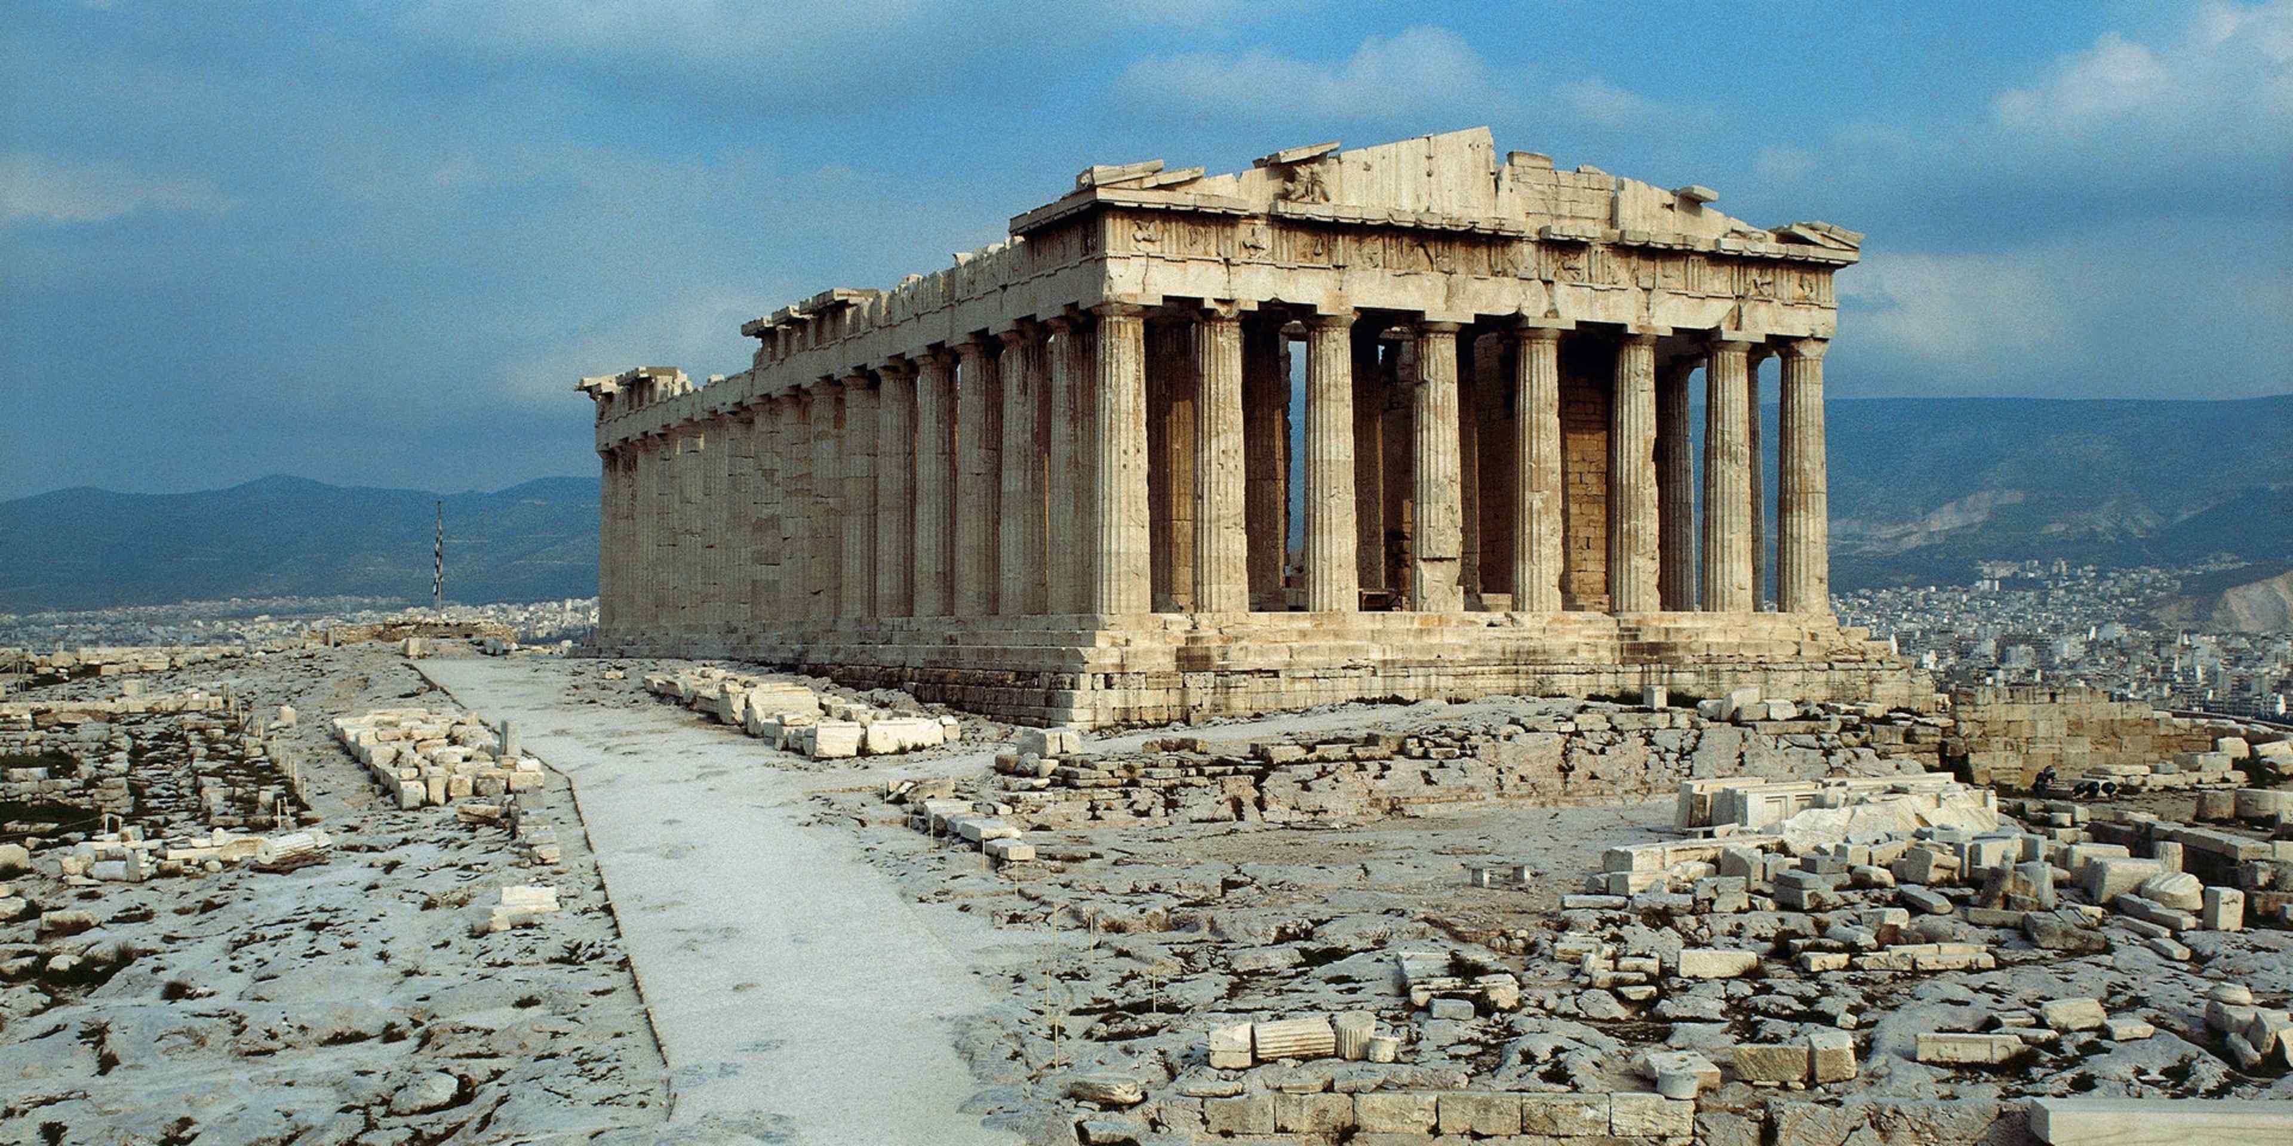
Faith -Ancient Greeks worshipped many gods/goddesses (polytheism).Their faith influenced daily life, decisions, and festivals. Links to how belief systems shape cultures and individuals.
Uniqueness -Greek individuals celebrated for achievements (e.g. philosophers, athletes). Myths and legends highlight unique qualities and heroism. Each city-state had a unique identity and values.
Salvation -Greeks sought favour from gods for a good life and afterlife. Mythology explored morality, punishment, and virtue. Compare their beliefs about life after death to Christian salvation.

Alexander the Great
A powerful military leader who created one of the largest empires in history and helped spread Greek culture across many lands.
Socrates
A famous philosopher who taught people to think deeply and ask questions. He is known as one of the founders of Western philosophy.
Hippocrates
A doctor known as the "father of medicine" who believed illnesses had natural causes, not punishments from the gods. He inspired the Hippocratic Oath used by doctors today.
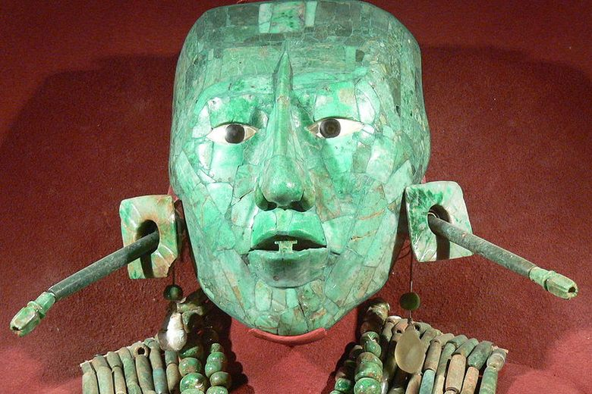
Key Vocabulary
Gods/Goddesses - Powerful beings that people believed controlled parts of the world, like the sky, sea, or love. People prayed to them for help or protection.
Myths/Legends Old stories told to explain things like how the world began, how nature works, or to teach lessons. They often have heroes, monsters, or gods.
Purpose The reason why something was made or done.
Artefact An object made by people in the past that helps us learn about how they lived.
Beliefs Ideas that people think are true, especially about gods, life, and what happens after we die.

Understand that history is divided into periods (chronology). Know the difference between BC (BCE) and AD (CE). Be able to place historical events and civilizations on a timeline.
Know how to compare aspects of different time periods (e.g., homes, food, beliefs). Understand the use of primary and secondary sources. Be able to ask and answer historically valid questions. Show awareness of cause and consequence, continuity and change, and significance.
FRUITS
Significant People

Things I already know

