Physical Education
Questions I can answer
FRUITS
Significant people
Indoor P.E- Gymnastics
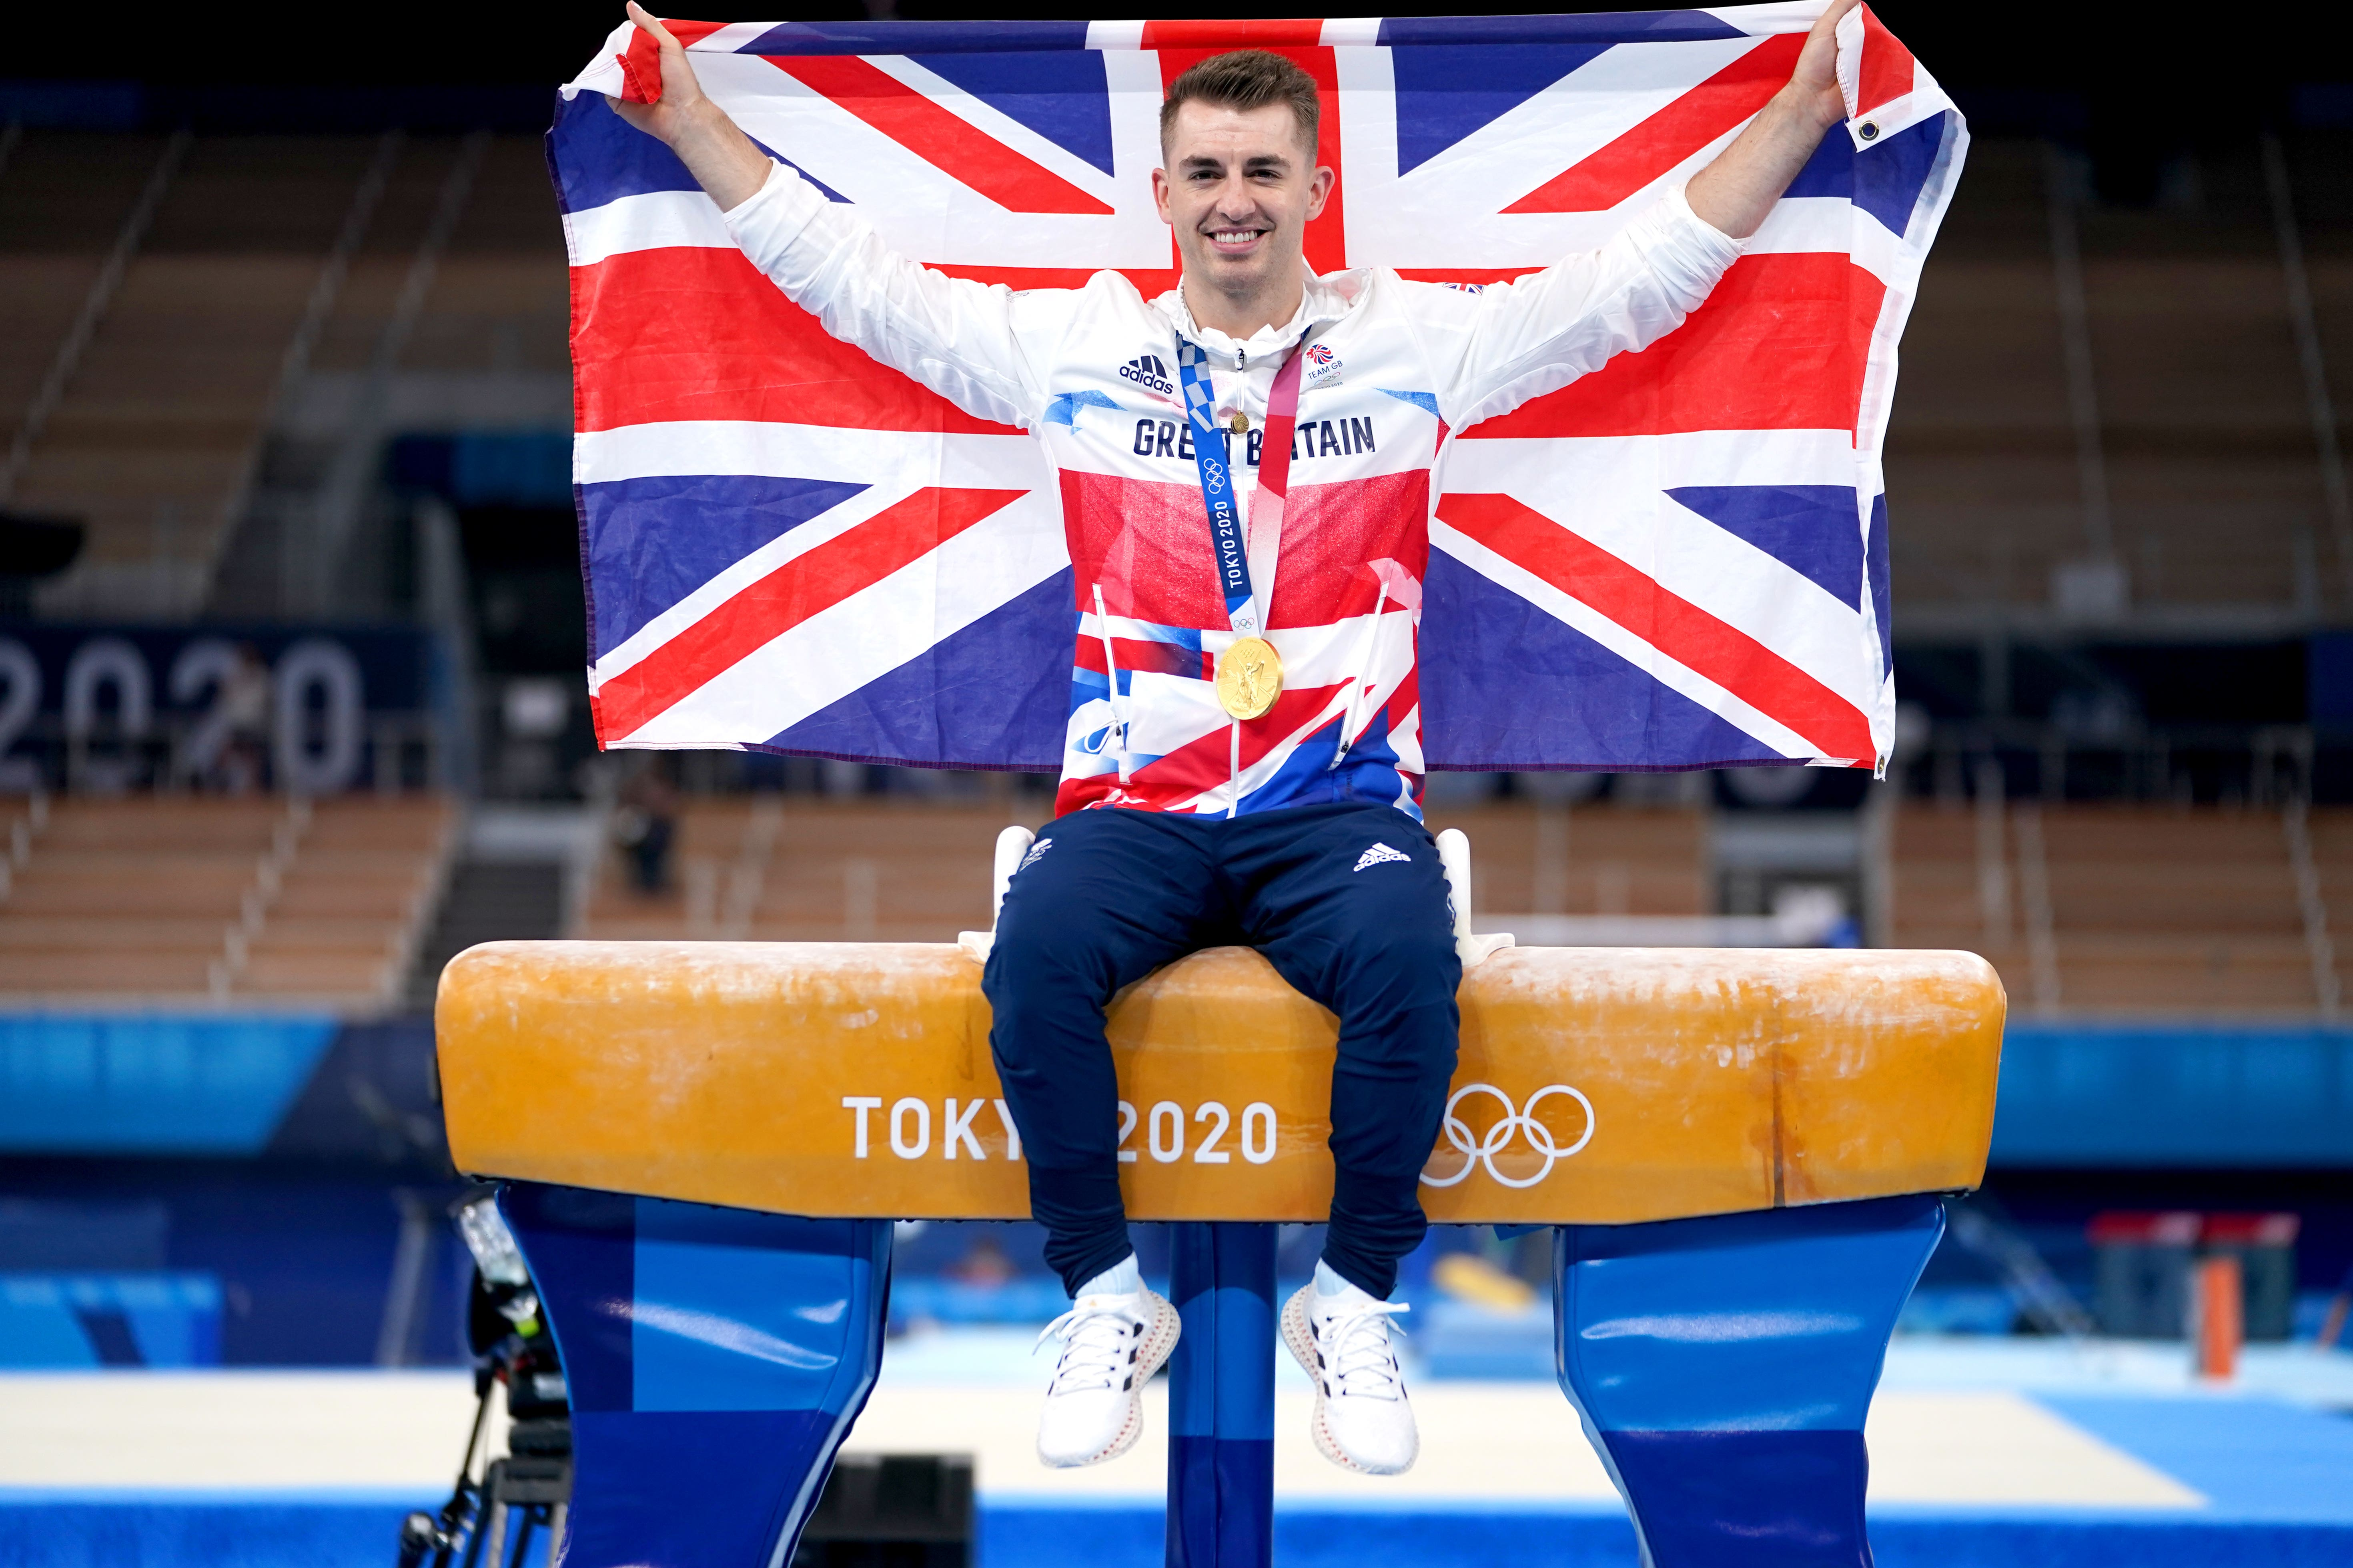
UKS2 – Spring 2 2025
Can I create a sequence independently or with a partner using the gymnastic vocabulary?
Am I able to adapt my sequence for each of the apparatus in the gymnastic lesson?
Actions (what)- Jump, roll, travel and balance.
Space (where)- Forwards, backwards, diagonal, straight, low, middle and high.
Dynamic (how)- Fast, slow, sudden, sharp, delicate, smooth, relaxed, light and heavy.
Relationships (with people and/or space)- Solo, duet, trio, mirrored, shapes, on the spot, lines and canon.
Max Whitlock- Olympic British Gymnast
I know how to perform balances independently and with a partner.
I know how to create a gymnastic sequence with counter balances and counter tension with a partner.
I know how to evaluate and recognise my own progress and success.

Faith – How different cultures and religions come together and compete.
Relationships – Working together as a team.
Uniqueness – Each gymnast has their own unique style.
Intellect – How we use our knowledge to create a sequence.
Treat Others with Respect – Show respect while watching other children’s sequences.
Salvation – Understanding that it’s okay if you fall, just know to get back up and keep going.

Key Facts
- Gymnastics helps to support your coordination and balance.
- The most common skills in gymnastics is a Hand Stand.
- Gymnasts wear something called a Leotard.
- Gymnastics develops strong bones and overall health.
- Did you know that gymnastics began in Germany in the 1800’s?

Things I already know
Key Vocabulary

