EYFS & KS1 – Summer 1 2025
Physical Education
Questions I can answer
FRUITS
Significant people
Fundamental Skills
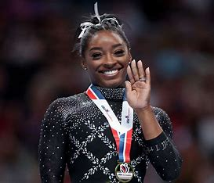
Simone Biles- Olympic Gymnastic
Can I work independently and as a team in fundamental games?

Am I able to throw a ball using an under arm or over arm throw with more accuracy?

Can I move in a variety of ways using co-ordination?
Key Facts
- Fundamental skills are using in all physical sports.
- Gross motor skills are vital as they support fine motor skills.
- We use our fundamental skills daily without even realising!
I know how to jump and land appropriately.
I know how to experiment different ways of travelling.
I know how to roll in a variety of ways.

Faith – How different cultures and religions come together and compete.
Relationships – Working together as a team.
Uniqueness – Everyone is unique in their own way.
Intellect – How we use our knowledge to use our fundamental skills.
Treat Others with Respect – Treat everyone with respect.
Salvation – Understanding that it is okay to not always win, just know to keep going!

Sprinting- to run a short distance at top speed.

Hurdling- to leap over obstacles while running.

Jumping- to push off a surface into the air by using the muscles in your legs and feet.
Throwing- to launch something with force from the hand.

Things I already know
Key Vocabulary

