Key Vocabulary

Friction: The force that resists the movement of one surface against another.
Air Resistance: A type of friction that opposes the motion of objects moving through the air.
Water Resistance: A force that slows down objects moving through water, similar to air resistance.
Gravity: The force that pulls objects towards the Earth (or another planet).
Levers: A simple machine that uses a bar and a pivot (fulcrum) to lift or move heavy objects.
Pulleys: A simple machine with a wheel and rope used to change the direction of a force or lift heavy objects.
Buoyancy: The upward force exerted by a fluid that makes objects float or rise in the fluid.
Key facts I will learn:
- Gravity is the force that pulls objects towards the centre of the earth.
- Air resistance causes a parachute to slow its descent towards the earth, as it is acting against gravity.
- Water resistance prevents some objects moving on water; objects have to be designed (such as boats) to reduce the amount of water resistance, allowing it to move.
- Objects travel easier on smooth surfaces, however, objects find it easier to stop on rougher surfaces (e.g., tyres have tread depth in order for them to stop at a quicker rate compared to them being smooth).

Things I already know:
- Different surfaces affect how things move, with some surfaces providing more friction or resistance than others.
- Some forces, like contact forces, require objects to touch, while magnetic forces can act at a distance.
- Magnets attract or repel each other, and can attract certain materials while not affecting others.
- Magnets have two poles, and the interaction between them (attraction or repulsion) depends on which poles are facing each other.

Forces
UKS2 – Spring 2

Science

FRUITS
Faith - Provide opportunities for children to explore forces and motion through questioning, predicting, and experimenting, encouraging them to trust their curiosity and prior knowledge.
Intellect- Predicting, investigating, and analysing scientific concepts like gravity, friction, and buoyancy, helping them think more deeply. Questions that explore new situations challenge them to apply their knowledge and foster intellectual growth.
Uniqueness- Through unique hands-on experiments like testing friction with toy cars, designing parachutes, and exploring buoyancy, children actively engage with scientific principles.

Questions I can answer
- What are forces?
- How does gravity affect the way objects fall?
- What is air resistance and how does it affect objects when they move?
- What is friction and how does it help slow objects down?
- Why do some objects float?
- How can simple mechanisms help us in our everyday life?

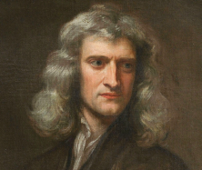
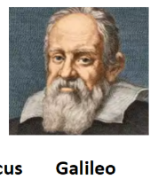
Isaac Newton
Significant people

