Combining Foods
D.T.
KS1 – Spring 2 2025

Cut- to divide into pieces using a knife.
Chop – to cut repeatedly.
Slice- to cut thinly.
Grate- to cut thin shreds using a grater.
Salad- a cold dish made up of a mixture of chopped vegetables.
Investigate- to find out more.
Design- a plan or drawing of what we intend to make.
Make- to form a product.
Evaluate- to assess our product to deside what we like and would like to improve.
Hygiene- keeping us healthy by keeping clean.
- I can create collaboratively, sharing ideas, resources and skills.
- I can return to and build on my previous learning, refine my ideas and developing my ability to represent them.
- I can share creations, talk about process and evaluate my work.
Key Vocabulary
Things I already know

Key Facts
- Salads can be made of chopped up fruits or vegetables.
- Hygiene is important to keep us safe.
- Knife blades should always point away from us and we should keep our fingers away.
- Salads have a variety of textures, presentations, colours and tastes, depending on the needs and likes of a consumer.
- Chefs and cooks create salads in their kitchens.

Significant People:

Jamie Oliver- Georgina Hayden- makes known for healthy eating. Greek food.

Questions I Can Answer:

- What foods are in salads?
- What foods would I like in my salad?
- How can I assemble my salad?
- What makes a salad?


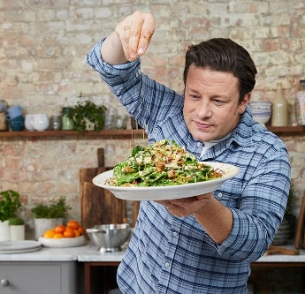

FRUITS
Faith- That food is plentiful and there is enough for everyone to share.
Respect- We look out for one another’s safety by following the rules of using blades and use of chopping boards.
Unique- fruits and vegetables are unique and are used for different purposes and flavours.

