Physical Education
Questions I can answer
FRUITS
Significant people
Outdoor P.E- Cricket
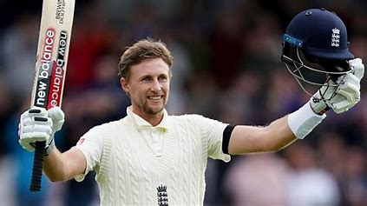
LKS2 – Summer 1 2025
Joe Root- English Cricketer.
Key Facts
- Cricket is the second most popular sport in the world.
- Cricket is played with a bat and ball, and involves two competitive teams with 11 players in each team.
- Two sets of three sticks, called wickets, are set in the ground at each end of the pitch.
Can I work together as a team?

Am I able to play on both sides- the batting team, and the fielding team?

If I am batting, can I decide when to stop running during a game of cricket?
I know how to demonstrate an over arm throw for distance.
I know how to strike a ball.
I know how to play simple striking and fielding games.
Faith – How different cultures and religions come together and compete.
Relationships – Working together as a team.
Uniqueness – Each cricket team is unique.
Intellect – How we use our knowledge in a cricket game.
Treat Others with Respect – Treat all team members and the opposite team with respect.
Salvation – Understanding that it is okay to not always win, just know to keep going!

Batsman- the person batting.

Bowler- the person bowling.

Run- the act of running between the wickets to score.

Wicket- the stumps behind the person batting.

Wicketkeeper- the player who stands behind the stumps to catch the bowl from the bowler.

Things I already know
Key Vocabulary

