Year A | Computing - Programming | Term: | SPRING 1 | Unit: |  | LEGO Spike Education Prime
Big Question: | How can we program robots to make our world a better place?
Prior Substantive Knowledge | - I can create algorithms for use when programming  - I can decompose tasks (such as animations) into separate steps to create an algorithm  - I understand abstraction is focusing on important information  - I can identify patterns in an algorithm  - I can use repetition in algorithms  - I can use abstraction to focus on what’s important in my design  - I can write increasingly more precise algorithms for use when programming.  - I can use simple selection in algorithms  - I can use logical reasoning to detect and correct errors in programs  - I can design and create programs  - I can write programs that accomplish specific goals  - I can use repetition in programs I can work with various forms of input  - I can use simple selection in programs  - I can work with various forms of output  - I can use logical reasoning to systematically detect and correct errors in programs  - I can work with various forms of output |  |  | Cross-curricular |  | English:  - composing and rehearsing sentences orally (including dialogue), progressively building a varied and rich vocabulary and an increasing range of sentence structures  - organising paragraphs around a theme  - in narratives, creating settings, characters and plot  - in non-narrative material, using simple organisational devices  Maths:  - tell and write the time from an analogue clock, including using Roman numerals from I to XII, and 12-hour and 24-hour clocks  - estimate and read time with increasing accuracy to the nearest minute; record and compare time in terms of seconds, minutes and hours; use vocabulary such as o'clock, am/pm, morning, afternoon, noon and midnight  - know the number of seconds in a minute and the number of days in each month, year and leap year  - compare durations of events  Design and Technology:  - evaluate their ideas and products against their own design criteria and consider the views of others to improve their work
Prior Substantive Knowledge |  |  |  | Key Vocab/  Essential vocab |  | Algorithms, decompose, abstraction, patterns, repetition, logical, debugging, programs and systematically
Substantive Knowledge:
Declarative Knowledge (Know what) |  |  |  |  | Procedural Knowledge (Know how)
- I can recognise the need for conditions in repetition within algorithms  - I can use logical reasoning to explain how a variety of algorithms work  - I can recognise, and make use, of patterns across programming projects  - I can identify variables needed and their use in selection and repetition |  |  |  |  | - I can solve problems by decomposing them into smaller parts  - I can use selection in algorithms  - I can use logical reasoning to detect and correct errors in algorithms  - I can evaluate my work and identify errors  - I can write precise algorithms for use when programming  - I can decompose code into sections for effective debugging  - I can critically evaluate my work and suggest improvements  - I can create programs by decomposing them into smaller parts  - I can use selection in programs  - I can use conditions in repetition commands  - I can work with variables  - I can create programs that control or simulate physical systems  - I can evaluate my work and identify errors  - I can use a range of sequence, selection and repletion commands combined with variables as required to implement my design  - I can create procedures to hide complexity in programs  - I can identify and write generic code for use across multiple projects  - I can critically evaluate my work and suggest improvements
Teacher Knowledge | To effectively teach Year 6 students using the LEGO Spike Prime Education set, teachers should have a strong understanding of the hardware (LEGO Technic components, sensors, and motors) and how they can be used to build functional robots. Knowledge of block-based programming (and transitioning to Python for advanced students) is essential, covering key concepts like loops, conditionals, variables, and functions. Familiarity with basic robotics principles, such as mechanical design, stability, and problem-solving, is important, as is the ability to integrate the technology across subjects like math, science, and engineering. Additionally, teachers should be skilled in project-based learning, classroom management, and differentiation to support diverse learning needs. Understanding safety protocols for both tools and digital platforms, as well as how to assess and provide feedback, ensures a comprehensive and engaging learning experience for students. |  |  |  |  |  | 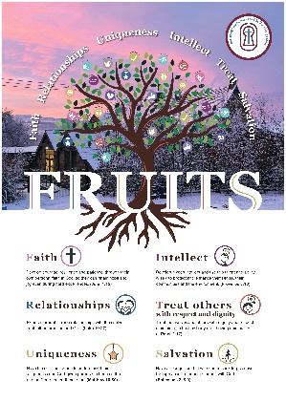  Fruits | - Faith - Encouraging a growth mindset and faith in students' abilities to solve problems and overcome challenges in robotics and programming.  - Relationships - Collaboration is a key aspect of learning with LEGO Spike Prime. Working in teams to design and build robots fosters strong relationships, with students learning to communicate, collaborate, and support one another  - Uniqueness – Recognizing and celebrating this uniqueness in design, problem-solving approaches, and programming strategies encourages creativity and innovation, as students realize that there are multiple ways to achieve solutions and contribute to the team's success.  - Intellect- Teaching students to think critically, analyse problems, and apply their intellectual abilities to design and code reinforces the importance of education and intellectual growth.  - Treat Others with Respect - This value teaches students to appreciate different perspectives and work cooperatively, fostering a respectful classroom environment where everyone's contributions are valued.  - Salvation - In robotics and coding, this might translate to the idea that mistakes are learning opportunities, and perseverance leads to eventual success. Just as salvation is about transformation and hope, students learn that through persistence and continuous effort, they can overcome challenges and improve.

Key concept | Learning objective | Key components | Main input and Activity | Adaptive strategies
- Develop a sequence to solve a problem  - Decompose problems into smaller parts  - Recount an experience using relevant facts and descriptive details | River Ferry: Lesson 1  Help Daniel reach the Spike Tower by programming the river ferry to move!  https://education.lego.com/en-gb/lessons/spikeessential-happy-traveler/spikeessential-river-ferry/#prepare | - Review the River Ferry lesson in the LEGO® Education SPIKE™ App.  - If you feel that it would be beneficial, pre-teach these related vocabulary words: improve, modify, program, sequence, test and upgrade.  - Consider the abilities and backgrounds of all your pupils. Differentiate the lesson to make it accessible to everyone. Please refer to the Differentiation section below for suggestions on how to do this.  - If time permits, plan and facilitate the maths extension. Please refer to the Extension section below for further information.  - https://education.lego.com/v3/assets/blt293eea581807678a/blt0ecb573d64149baa/6049f176fef76d094c703b4e/ENGB_SPIKE_Essential_Minifigure_bios_posters.pdf | - Engage Whole Class 5 Minutes  - Facilitate a quick discussion about creating a sequence in order to complete an activity.  - Talk with your pupils about a situation in which they had to follow a sequence in order to reach a destination, like their classroom or a playground.  - Ask questions like these: When you want to go from one classroom to another, how do you get there? How do you know how to get there?  - Introduce your pupils to the story’s main characters and the first challenge: sending the river ferry to the Spike Tower.  - Distribute a brick set and a device to each group.  - Explore Small Groups 30 Minutes  https://education.lego.com/v3/assets/blt293eea581807678a/blte0961649ada62484/5f57301dd0db724679d620a1/U3L1.pdf  https://education.lego.com/en-gb/lessons/spikeessential-happy-traveler/spikeessential-river-ferry/student-worksheet  - Have your pupils use the LEGO® Education SPIKE™ App to guide them through their first challenge:  - Create and test the program that sends the river ferry to the Spike Tower.  - Have your pupils iterate and test their models to complete the next two challenges in the app:  - Modify the program to improve the river ferry ride.  - Upgrade the river ferry for Daniel’s next journey  - You can find coding and building help in the Tips section below.  - Explain Whole Class 5 Minutes  - Gather your pupils together to reflect on their completed challenges.  - Ask questions like these: What steps did you follow to send the river ferry to Spike Tower? What did you modify in order to improve the river ferry ride?  - Elaborate Whole Class 5 Minutes  - Prompt your pupils to discuss and reflect on the process of creating a sequence to solve a problem.  - Ask questions like these: Why does it help to break a problem down into smaller parts when you're trying to solve it? How can you use these smaller parts to create a sequence?  - Have your pupils tidy up their workstations.  - Tips - Coding Tips  - After your pupils have completed their first challenge, they'll be provided with three Inspiration Coding Blocks, which will help them to modify their programs.  - The Inspiration Coding Blocks are intended to spark their imaginations as they experiment to find their own solutions.  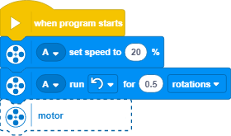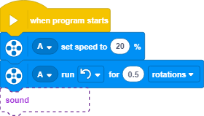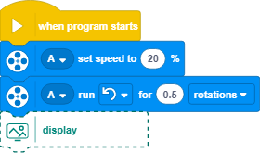  - After your pupils have completed their second challenge, they’ll be provided with three Inspiration Images and an open-ended prompt, which will help them to improve their models.  - The Inspiration Images are meant to help spark their imaginations as they experiment and change their models  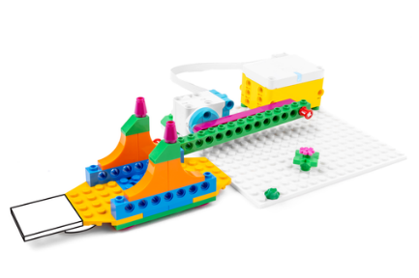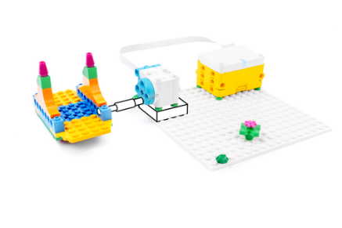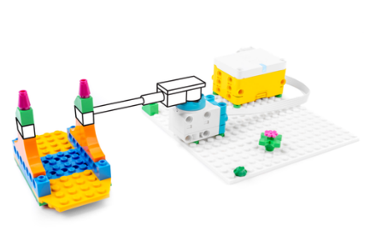 | - Reading the River Ferry story and instructions from the LEGO® Education SPIKE™ App aloud to your pupils  - Selecting one Inspiration Image to help your pupils to change their models
- Identify and fix errors within a program (test and debug) https://www.bbc.co.uk/bitesize/topics/zs7s4wx/articles/zjmj2v4  - Explore two-dimensional shapes and angles  - Recount an experience using relevant facts and descriptive details | Taxi! Taxi!: Lesson 2  Leo needs help in getting to the art museum. Hail a taxi, and let’s go  https://education.lego.com/en-gb/lessons/spikeessential-happy-traveler/spikeessential-taxi-taxi#prepare | - Review the Taxi! Taxi! lesson in the LEGO® Education SPIKE™ App.  - If you feel that it would be beneficial, pre-teach these related vocabulary words: backwards, debug, direction, forwards, frustrated and route.  - Consider the abilities and backgrounds of all your pupils. Differentiate the lesson to make it accessible to everyone. Please refer to the Differentiation section below for suggestions on how to do this.  - If time permits, plan and facilitate the maths extension. Please refer to the Extension section below for further information.  - https://education.lego.com/v3/assets/blt293eea581807678a/blt0ecb573d64149baa/6049f176fef76d094c703b4e/ENGB_SPIKE_Essential_Minifigure_bios_posters.pdf | - Engage Whole Class 5 Minutes  - Facilitate a quick discussion about having to make a change in order to complete a task.  - Talk with your pupils about taking different routes to get from one place to another, like between classrooms.  - Ask questions like these: Would you be able to get to that classroom if you were only allowed to make right turns? What would you have to change in order to reach the other classroom?  - Introduce your pupils to the story’s main characters and the first challenge: driving the taxi.  - Distribute a brick set and a device to each group.  - Explore Small Groups 30 Minutes  https://education.lego.com/v3/assets/blt293eea581807678a/bltad482daa5492437d/612e28618f8f7644bdf4d50b/U3L2.pdf  https://education.lego.com/en-gb/lessons/spikeessential-happy-traveler/spikeessential-taxi-taxi/student-worksheet  - Have your pupils use the LEGO® Education SPIKE™ App to guide them through their first challenge:  - Create and test the program that drives the taxi.  - Have your pupils iterate and test their models to complete the next two challenges in the app:  - Modify the program to make the taxi follow the route on Leo’s map.  - Design a new route for Leo’s next trip  - You can find coding and building help in the Tips section below.  - Explain Whole Class 5 Minutes  - Gather your pupils together to reflect on their completed challenges.  - Ask questions like these: What were you thinking about as you modified the program to follow the route on Leo’s map? How was your program for Leo’s next trip different from the one that you made for Leo’s trip to the art museum?  - Elaborate Whole Class 5 Minutes  - Prompt your pupils to discuss and reflect on the process of testing a program in order to identify and fix errors.  - Ask questions like these: Why is it important to test a program to make sure that it works as you’d intended? How can you use the results of your tests to improve the program?  - Have your pupils tidy up their workstations.  - Coding Tips  - After your pupils have completed their first challenge, they'll be provided with a map.  - Using the map, they should experiment with the available coding blocks to modify their programs to follow the route for the trip. | - Reading the Taxi! Taxi! story and instructions from the LEGO® Education SPIKE™ App aloud to your pupils  - Selecting one Inspiration Image to help your pupils to change their models
- Describe the choices that they've made when creating a program  - Create and test automated solutions  - Recount an experience using relevant facts and descriptive details | Hovering Helicopter: Lesson 3  Help Maria get to Spike Mountain for a hike!  https://education.lego.com/en-gb/lessons/spikeessential-happy-traveler/spikeessential-hovering-helicopter#prepare | - Review the Hovering Helicopter lesson in the LEGO® Education SPIKE™ App.  - Consider the abilities and backgrounds of all your pupils. Differentiate the lesson to make it accessible to everyone. Please refer to the Differentiation section below for suggestions on how to do this.  - If time permits, plan and facilitate the language arts extension. Please refer to the Extension section below for further information.  - https://education.lego.com/v3/assets/blt293eea581807678a/blt0ecb573d64149baa/6049f176fef76d094c703b4e/ENGB_SPIKE_Essential_Minifigure_bios_posters.pdf | - Engage Whole Class 5 Minutes  - Facilitate a quick discussion about describing a decision, choice or experience to a friend.  - Talk with your pupils about telling a friend about a new experience (e.g. an activity or movie).  - Ask questions like these: How do you feel when you tell someone about a new experience you’ve had? Why do you think it's valuable to share your experiences?  - Introduce your pupils to the story’s main characters and the first challenge: starting the helicopter.  - Distribute a brick set and a device to each group.  - Explore Small Groups 30 Minutes  https://education.lego.com/v3/assets/blt293eea581807678a/blt4a781db4f91fa814/5f57301927a6ca5b5b1a6e4b/U3L3.pdf  https://education.lego.com/en-gb/lessons/spikeessential-happy-traveler/spikeessential-hovering-helicopter/student-worksheet  - Have your pupils use the LEGO® Education SPIKE™ App to guide them through their first challenge:  - Create and test the program that starts the helicopter.  - Have your pupils iterate and test their models to complete the next two challenges in the app:  - Create the program that makes the helicopter act differently when it's been tilted.  - Upgrade the helicopter for Maria’s next adventure.  - You can find coding and building help in the Tips section below  - Explain Whole Class 5 Minutes  - Gather your pupils together to reflect on their completed challenges.  - Ask questions like these: How did Maria’s helicopter get to Spike Mountain? How did you modify Maria’s helicopter in order to improve it for her next adventure?  - Elaborate Whole Class 5 Minutes  - Prompt your pupils to discuss and reflect on the choices they've made while developing their programs.  - Ask questions like these: Why is it important to describe the choices you've made while creating your program? How can describing your program to others help you to improve it?  - Have your pupils tidy up their workstations.  - Tips - Coding Tips  - After your pupils have completed their first challenge, they'll be provided with three Inspiration Coding Blocks, which will help them to modify their programs.  - The Inspiration Coding Blocks are intended to spark their imaginations as they experiment to find their own solutions.  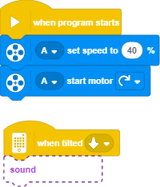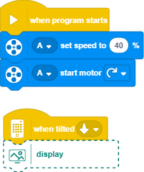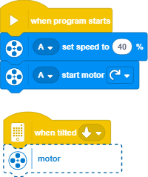  - After your pupils have completed their second challenge, they’ll be provided with three Inspiration Images and an open-ended prompt, which will help them to improve their models.  - The Inspiration Images are meant to help spark their imaginations as they experiment and change their models.  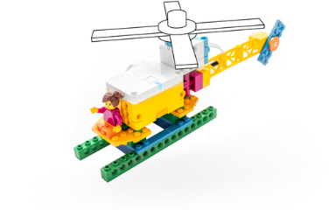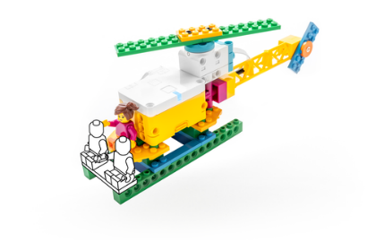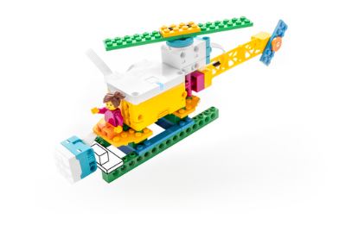 | - Reading the Hovering Helicopter story and instructions from the LEGO® Education SPIKE™ App aloud to your pupils  - Selecting one Inspiration Image to help your pupils to change their models
- Identify the parts of an existing program that should be modified (Variables)  - Carry out tests to identify where a program can be modified  - Recount an experience using relevant facts and descriptive details | Swamp Boat: Lesson 4  Sofie has found crocodile eggs! Could there be crocodiles nearby?  https://education.lego.com/en-gb/lessons/spikeessential-happy-traveler/spikeessential-swamp-boat#prepare | - Review the Swamp Boat lesson in the LEGO® Education SPIKE™ App.  - If you feel that it would be beneficial, pre-teach these related vocabulary words: content, modifications, notify, observe and predict.  - Consider the abilities and backgrounds of all your pupils. Differentiate the lesson to make it accessible to everyone. Please refer to the Differentiation section below for suggestions on how to do this.  - If time permits, plan and facilitate the maths extension. Please refer to the Extension section below for further information.  - https://education.lego.com/v3/assets/blt293eea581807678a/blt0ecb573d64149baa/6049f176fef76d094c703b4e/ENGB_SPIKE_Essential_Minifigure_bios_posters.pdf | - Engage Whole Class 5 Minutes  - Facilitate a quick discussion about modifying an existing object to achieve a goal.  - Talk with your pupils about needing to see what's under the water.  - Ask questions like these: What could you change about your eyes in order to make it possible to see under the water? What would you need?  - Introduce your pupils to the story’s main characters and the first challenge: telling Sofie when her boat is near a crocodile.  - Distribute a brick set and a device to each group.  - Explore Small Groups 30 Minutes  https://education.lego.com/v3/assets/blt293eea581807678a/bltccaa3a1dd4179dde/5f573022d0db724679d620a5/U3L4.pdf  https://education.lego.com/en-gb/lessons/spikeessential-happy-traveler/spikeessential-swamp-boat/student-worksheet  - Have your pupils use the LEGO® Education SPIKE™ App to guide them through their first challenge:  - Create and test the program that tells Sofie when her boat is near a crocodile.  - Have your pupils iterate and test their models to complete the next two challenges in the app:  - Modify the program to tell Sofie in a different way when her boat is near a crocodile.  - Upgrade the swamp boat to help Sofie find other animals.  - You can find coding and building help in the Tips section below.  - Explain Whole Class 5 Minutes  - Gather your pupils together to reflect on their completed challenges.  - Ask questions like these: How did Sofie know when she was near a crocodile? What did you change about how the swamp boat told Sofie when she was near a crocodile? What did the swamp boat do then?  - Elaborate Whole Class 5 Minutes  - Prompt your pupils to discuss and reflect on making modifications to an existing program.  - Ask questions like these: Why is it important to be able to modify an existing program? How did you decide which Coding Blocks to use when you modified your program?  - Have your pupils tidy up their workstations.  - Coding Tips  - After your pupils have completed their first challenge, they'll be provided with three Inspiration Coding Blocks, which will help them to modify their programs.  - The Inspiration Coding Blocks are intended to spark their imaginations as they experiment to find their own solutions.  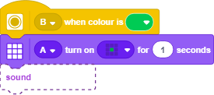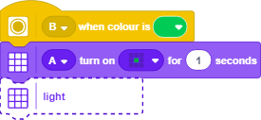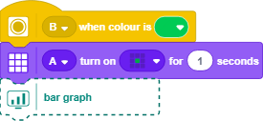  - After your pupils have completed their second challenge, they’ll be provided with three Inspiration Images and an open-ended prompt, which will help them to improve their models.  - The Inspiration Images are meant to help spark their imaginations as they experiment and change their models.  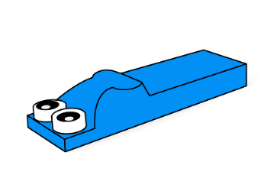 | - Reading the Swamp Boat story and instructions from the LEGO® Education SPIKE™ App aloud to your pupils  - Selecting one Inspiration Image to help your pupils to change their models
- Use sequences and loops to program their models  - Identify and fix errors in a program to ensure that it works as intended (test and debug)  - Recount an experience using relevant facts and descriptive details | Cable Car:  Lesson 5  Leo is nervous about crossing Spike Lake in the cable car today. Can Maria help him to conquer his fear?  https://education.lego.com/en-gb/lessons/spikeessential-happy-traveler/spikeessential-cable-car#prepare | - Review the Cable Car lesson in the LEGO® Education SPIKE™ App.  - Consider the abilities and backgrounds of all your pupils. Differentiate the lesson to make it accessible to everyone. Please refer to the Differentiation section below for suggestions on how to do this.  - If time permits, plan and facilitate the language arts extension. Please refer to the Extension section below for further information.  - https://education.lego.com/v3/assets/blt293eea581807678a/blt0ecb573d64149baa/6049f176fef76d094c703b4e/ENGB_SPIKE_Essential_Minifigure_bios_posters.pdf | - Engage Whole Class 5 Minutes  - Facilitate a quick discussion about repeating a motion in order to repeat a task.  - Talk with your pupils about moving people from one place to another.  - Ask questions like these: What are some ways of moving people from one place to another? How could that mode of transport be repeated to make sure that everyone gets to where they want to go?  - Introduce your pupils to the story’s main characters and the first challenge: moving the cable car across the lake.  Distribute a brick set and a device to each group.  - Explore Small Groups 30 Minutes  https://education.lego.com/v3/assets/blt293eea581807678a/blta3c8901c4931f79e/5f57302ad4365e467aa95f2b/U3L5.pdf  https://education.lego.com/en-gb/lessons/spikeessential-happy-traveler/spikeessential-cable-car/student-worksheet  - Have your pupils use the LEGO® Education SPIKE™ App to guide them through their first challenge:  - Create and test the program that moves the cable car across the lake.  - Have your pupils iterate and test their models to complete the next two challenges in the app:  - Modify the program to improve the cable car ride.  - Upgrade the cable car for Leo and Maria’s next trip.  - You can find coding and building help in the Tips section below  - Explain Whole Class 5 Minutes  - Gather your pupils together to reflect on their completed challenges.  - Ask questions like these: How did you improve the program for the cable car ride? Why did you make those improvements?  - Elaborate Whole Class 5 Minutes  - Prompt your pupils to discuss and reflect on how they’ve used sequences and loops.  - Ask questions like these: How did introducing a loop to your program improve the cable car ride? Why do you think it's valuable to have something on a loop?  - Have your pupils tidy up their workstations.  - Coding Tips  - After your pupils have completed their first challenge, they'll be provided with three Inspiration Coding Blocks, which will help them to modify their programs.  - The Inspiration Coding Blocks are intended to spark their imaginations as they experiment to find their own solutions.  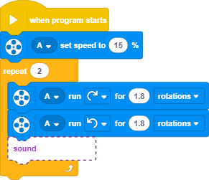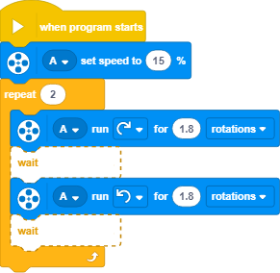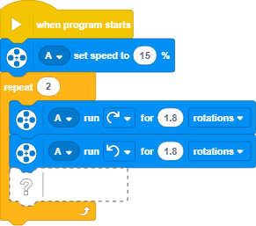  - After your pupils have completed their second challenge, they’ll be provided with three Inspiration Images and an open-ended prompt, which will help them to improve their models.  - The Inspiration Images are meant to help spark their imaginations as they experiment and change their models.  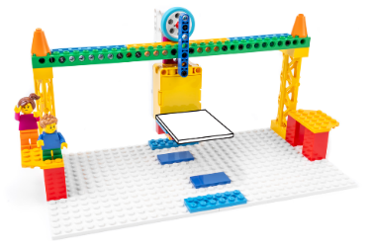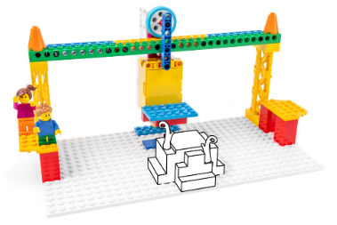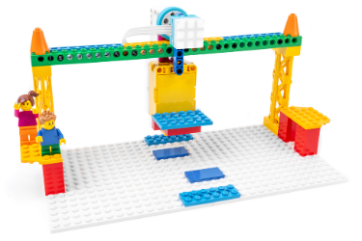 | - Reading the Cable Car story and instructions from the LEGO® Education SPIKE™ App aloud to your pupils  - Selecting one Inspiration Image to help your pupils to change their models
- :Activity Description (30-45 minutes)  - Improve a program in order to meet a specific need  - Test and evaluate solutions to determine whether they meet a specific need  - Recount an experience using relevant facts and descriptive details | BIG Bus: Lesson 6  Today is going to be an awesome day! Help Daniel get to the sports stadium to see the big game.  https://education.lego.com/en-gb/lessons/spikeessential-happy-traveler/spikeessential-big-bus#prepare | - Review the Big Bus lesson in the LEGO® Education SPIKE™ App.  - Consider the abilities and backgrounds of all your pupils. Differentiate the lesson to make it accessible to everyone. Please refer to the Differentiation section below for suggestions on how to do this.  - If time permits, plan and facilitate the language arts extension. Please refer to the Extension section below for further information.  - https://education.lego.com/v3/assets/blt293eea581807678a/blt0ecb573d64149baa/6049f176fef76d094c703b4e/ENGB_SPIKE_Essential_Minifigure_bios_posters.pdf | - Engage Whole Class 5 Minutes  - Facilitate a quick discussion about making improvements in order to make something work better.  - Talk with your pupils about how buses stop at different bus stops.  - Ask questions like these: How does the bus driver know where to stop? What happens if people are waiting at the bus stop? What happens if no one is waiting?  - Introduce your pupils to the story’s main characters and the first challenge: making the bus stop at the green stop.  Distribute a brick set and a device to each group.  - Explore Small Groups 30 Minutes  https://education.lego.com/v3/assets/blt293eea581807678a/blt78943cfe8fcad767/61bac26e191c5560467dc51e/U3L6.pdf  https://education.lego.com/en-gb/lessons/spikeessential-happy-traveler/spikeessential-big-bus/student-worksheet  - Have your pupils use the LEGO® Education SPIKE™ App to guide them through their first challenge:  - Create and test the program that makes the bus stop for Daniel at the green stop.  - Have your pupils iterate and test their models to complete the next two challenges in the app:  - Modify the program to change the bus ride.  - Upgrade the bus route to make different stops.  - You can find coding and building help in the Tips section below.  - Explain Whole Class 5 Minutes  - Gather your pupils together to reflect on their completed challenges  - Ask questions like these: What did you want to include in your program to ensure that it met Daniel’s needs? What was the most challenging part of trying to make the bus stop at the right place?  - Elaborate Whole Class 5 Minutes  - Prompt your pupils to discuss and reflect on improving a program to meet a specific need.  - Ask questions like these: Why do you think it's important to accommodate specific needs in your programming? How do you feel when something that you need is included?  - Have your pupils tidy up their workstations.  - Coding Tips  - After your pupils have completed their first challenge, they'll be provided with three Inspiration Coding Blocks, which will help them to modify their programs.  - The Inspiration Coding Blocks are intended to spark their imaginations as they experiment to find their own solution:  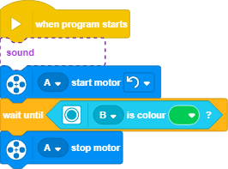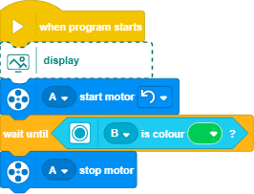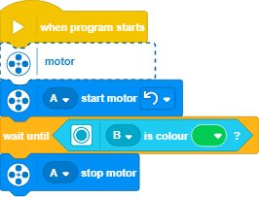  - After your pupils have completed their second challenge, they’ll be provided with three Inspiration Images and an open-ended prompt, which will help them to improve their models.  - The Inspiration Images are meant to help spark their imaginations as they experiment and change their models.  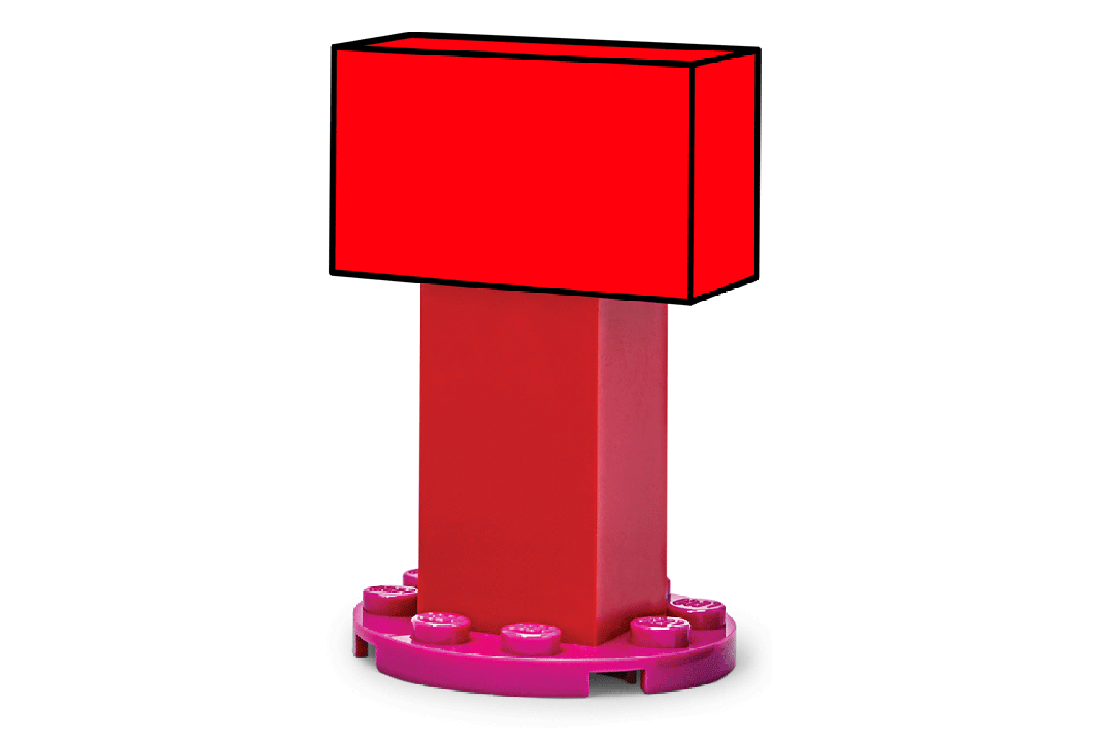 | - Reading the Big Bus story and instructions from the LEGO® Education SPIKE™ App aloud to your pupils  - Selecting one Inspiration Image to help your pupils to change their models

