Year A | Computing | Term: | SPRING 2 | Unit: | Animation - 3D Animation
Big Question: | How can we use animation to tell a story and bring characters to life?
Prior Procedural Knowledge | - I can create animations of faces to speak in role with more life-like realistic outcomes.  - I can improve stop motion animation clips with techniques like onion skinning.  - I can use animation tools in presenting software to create simple animations  - I can take multiple animations of a character I have created and edit them together for a longer video.  - I can use software to create a 3D animated story.  I can use line draw tool to create animations |  |  | Cross-curricular | Art and Design: Visual Storytelling: Students will use drawing and design skills to create their animated characters and settings. This links to developing skills in sketching, character design, and using artistic principles to communicate a story.  English (Creative Writing & Narrative Skills): Story Development: Students can create a narrative around their invention or inventor and animate the story. This encourages storytelling skills, including plot development, character creation, and writing dialogue.  Descriptive Writing: Writing scripts for their animations allows students to focus on describing actions, settings, and characters in detail.  Science (Inventions and Inventors): Students can learn about famous inventors (e.g., Thomas Edison, Nikola Tesla) and how their inventions changed the world. They can animate the process of an invention being created or demonstrate how a specific invention works.
Prior Procedural Knowledge |  |  |  | Key Vocab/  Essential vocab | Staging, aspect ratio, computer generated imagery (CGI) angles, overlay, cut scene
Substantive Knowledge:
Declarative Knowledge (Know what) |  |  |  | Procedural Knowledge (Know how)
- I can evaluate and improve the best video tools to best explain my understanding.  - Animation is the process of creating moving images by displaying a series of individual frames, each slightly different from the last*  - 3D Animation creates digital characters and objects that have depth, appearing more realistic (e.g., Toy Story).*  - Storyboards are visual outlines of an animation that show the sequence of events, helping to plan and organize the scenes.* |  |  |  | - I can record animations of different characters and edit them together to create an interview.  - I can plan, script and create a 3D animation to explain a concept or tell a story.  - I can sequence clips of mixed media in a timeline and record a voiceover  - I can trim and cut film clips and add titles and transitions  - I can add music and sound effects to my films  - I can add animated titles and transitions
Teacher Knowledge | D.A.R.E.S is an innovative approach to teaching computing which encourages pupils to be critical thinkers, problems solvers and computational thinkers while creating purposeful content to demonstrate how learning can be applied across the wider curriculum.  Through these projects, pupils are able to deepen their knowledge of computing by applying it to solve problems and create content. These may take place in computing lessons over a half term with any spare lessons used for word processing or e-safety. This will then allow pupils to apply these creative ideas more regularly across the curriculum. We do not want to make these projects too prescriptive as we know some classes may need some more time to complete different elements. As teachers, you will know the ability of your class so please feel free to change or adapt these ideas to fit the ability of your class. The stages which can be adapted into lessons are as follows:  D - Design: Pupils start to discuss the desired outcome for their project and are given time to tinker with the software before planning what they will do to achieve their outcome.  A - Apply: Pupils are given the opportunity to create, make and produce content using the app or software explored in the Design lesson(s)  R - Refine: Pupils spend time considering ways to modify and improve their projects to get the best results possible.  E - Evaluate: Upon completing their desired outcome, pupils are given the opportunity to reflect and consider how effectively they have achieved their goal.  S - Share: Learners are given the opportunity to publish and exhibit their work to the world embedding skills from the Digital Literacy curriculum    The main app for this project will be Plotagon.  Tutorial video for the app.  https://drive.google.com/file/d/13gRqkp0kox_mkYm7eQG77suoxP9btp31/view?pli=1 |  |  |  |  | 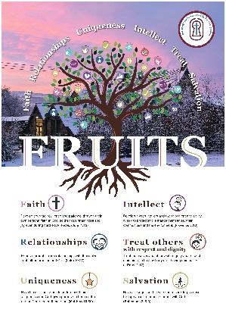  Fruits | - Faith - The theme of faith could be represented by characters who believe in themselves, their abilities, or a higher power. For example, an inventor could trust their creativity to solve a problem, or a character may have faith in others, showing resilience despite challenges.  - Relationships - Relationships can be represented through characters working together, helping each other, or overcoming challenges through teamwork and communication.  - Uniqueness – This value can be reflected in characters who are different from others, whether through their talents, appearance, or ideas.  - Intellect- The value of intellect can be portrayed through characters using their intelligence, problem-solving skills, and creativity.  - Treat Others with Respect - This value can be demonstrated through characters interacting with kindness, understanding, and treating others fairly.  - Salvation - Salvation can be symbolized through redemption, overcoming challenges, or a character saving another from danger, or even saving themselves through perseverance or moral growth.

Key concept/  Learning objective | Key components | Main input and Activity | Adaptive strategies
I can plan, script and create a 3D animation to explain a concept or tell a story. | - Introduction to Digital Animation  - Explain to the class that creating animations like Toy Story 4  - Give students 15 minutes to explore the Plotagon app.  - Reflect on how Plotagon can help them create an animation | Design: Share the following clip with your class: https://www.youtube.com/watch?v=bn82dUJopKo Ask your class how do you think they were able to create this film clip? Share this clip that explains how digital animation works - https://www.youtube.com/watch?v=5TqPl3MSSow . This was taken from 1995, discuss the ways in which the process may have been improved and then move onto this clip exploring the improvements in Toy Story 4 - https://www.youtube.com/watch?v=fT_LdcWFHkA . Explain to the class that the process of creating animations like this would take years so we are going to do a similar project in a simpler way.  Tinker Time - Give the class 15 minutes to explore the app Plotagon, encouraging children to investigate all the different options, features and tools available. Use mini-plenaries regularly to encourage pupils to share what they have learnt. What top tips can they share with the class? Come back together in a class and ask the children if they can see a way in which this app can help create a similar outcome to the film we watched at the start.  - Did anyone work out how to add yourself as a character?  - How do we change a scene?  - How do I record my own voice?  - What other things have we learnt | - Encourage students to share tips and tricks they’ve discovered with the class. For example, how to add themselves as characters, change scenes, or adjust the characters’ actions.  - For students who may need extra support, provide additional time during Tinker Time to explore the app. Use step-by-step instructions or video tutorials to guide them.
I can plan, script and create a 3D animation to explain a concept or tell a story. | - Explaining to the class that they will be creating their own 3D animated video.  - Emphasize the key components involved, such as character design, setting, plot, and animation techniques.  - Give students time to plan their animation:  - Title of the Animation  - Main Character(s):  - Setting:  - Plot Overview:  - Key Scenes  - Dialogue/Script | Explain to the class that we are going to try and create their own 3D animated video. Give children time to plan how they will create their own 3D Animation. Use the following template for them to use. Here’s a link to the Planning Template as a PDF to print or as a JPEG to complete digitally. Click the following link to watch a tutorial for how your pupils can complete the plan digitally.  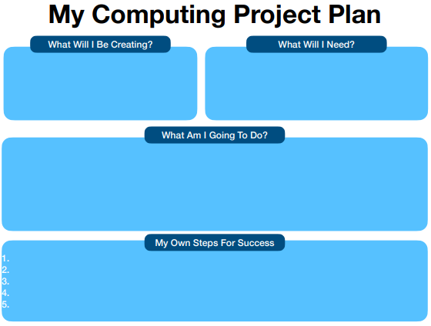  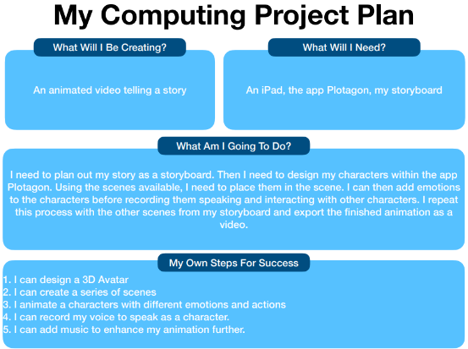  https://drive.google.com/file/d/13_Xbw5hCChkjvDoeT3uQbyTrEhgpS5pD/view | - Tutorial Link: Provide the tutorial link, making sure it’s accessible for all students  - For students who may struggle, provide more structured guidance on each section of the planning template. Walk them through the process step by step.
I can sequence clips of mixed media in a timeline | - Begin with a brief discussion about the significance of inventions and how they can inspire stories.  - Explain that storyboarding is a tool used by filmmakers, animators, and storytellers to visualize a story’s events  - Discuss The Inventor,  Wild Robot and  Big Hero 6  - Create the Storyboard, encourage students to be creative while also maintaining clarity in their storytelling. | Begin with a brief discussion about the importance of inventions and how they inspire stories. Use an engaging question: "How do you think inventors’ ideas change the world?"  Storyboarding is a useful tool for organizing and visualizing a story’s events through sketches or images. For example, in the story of Jack and the Beanstalk, a storyboard can break down the key elements into four boxes. Box 1, the setting, shows the story beginning in Jack’s small village before moving to the giant’s castle in the sky. Box 2 focuses on the character, with Jack as the brave and adventurous main character. Box 3 highlights the conflict, where Jack faces the challenge of climbing the beanstalk, stealing valuable items from the giant to help his family. Finally, Box 4 reveals the resolution, where Jack cuts down the beanstalk, defeating the giant and ensuring a happy ending for his family with newfound riches. By using a storyboard, the story's sequence is clearly mapped out, helping visualize how each part unfolds.  In small groups, students will explore one of three stories: The Inventor, Wild Robot, or Big Hero 6. They will read excerpts or watch short clips from these stories and discuss key elements. First, they’ll identify the inventor or robot involved in the story. Next, they’ll examine the challenges the characters face—whether it’s the robot learning to survive in the wild, an inventor overcoming obstacles to bring their creation to life, or a young hero confronting a high-tech villain. Lastly, they’ll discuss how the invention plays a crucial role in each story, whether it’s shaping the characters’ journey, helping to solve problems, or creating conflict. This activity encourages critical thinking about the relationship between invention, technology, and the characters’ development.  The Inventor - https://www.youtube.com/watch?v=Ez1NHnJrk2Y  Wild Robot - https://www.youtube.com/watch?v=cJbYE4wU0Xc  Big Hero 6 - https://www.youtube.com/watch?v=Iuum5--i2tE  Students will be given a blank storyboard template, consisting of a series of boxes for both sketching and writing. They will be instructed to first draw their main character and the settings of their story in the appropriate boxes. Afterward, they will write a brief description in each box, summarizing key events of their story. The focus should be on creating a clear sequence of events, with a defined beginning, middle, and end. This activity helps students practice organizing their thoughts and structuring a story, while also encouraging creativity through drawing and concise writing.  Once storyboards are complete, students will share their storyboards with a partner, providing constructive feedback using the "Two Stars and a Wish" method (two things they like about it and one suggestion for improvement). | - Give examples of inventions and how they inspire stories, such as the invention of a robot that leads to challenges and adventures.  - Provide visual aids or pre-made examples to clarify what each box should look like  - Allow them to use simple shapes or stick figures for their drawings. Alternatively, they can print images from the internet to paste in the boxes.  - Offer a template with sentence starters to help them focus on key events (e.g., "The character faces a problem when...").
I can record animations of different characters and edit them  I can trim and cut film clips and add titles and transitions  I can add music and sound effects to my films | - Follow their storyboards to create scenes and animations.  - Improve and Polish Your Animation:  - Add More Scenes  - Record Your Voice, add emotion and tone  - Add Soundtrack and Sound Effects:  - Use Emotions and Actions | Apply: Give the class a lesson or two to put their animated movies together using the app Plotagon. The following videos explains how this can be done: https://www.mrpict.com/plotagon.html  Refine: Taking the videos they have created in the apply lessons, and their plan with their steps for success, ask the children to consider how they can now improve and polish their videos. Demonstrate how they can improve their videos by:  - Considering the moral of the story they have created.  - Adding multiple scenes,  - Recording your own voice to add more intonation and emotion.  - Soundtrack and Sound Effects  - Using the emotions and actions  - Add different angles within the scene.  The following tutorials can help: https://www.mrpict.com/plotagon.html | - Offer step-by-step instructions or pair them with a buddy to guide them through the app.  - Provide a checklist to help them stay on track with the key parts of their animation.  - Allow students to work in pairs or small groups to reduce frustration and provide collaborative learning.
I can evaluate and improve the best video tools to best explain my understanding. | - Evaluate: Review their completed animation, then fill out the form, considering both strengths and areas for improvement.  - Reinforce Digital Safety: Explain how the act of sharing their animation online connects to the Digital Literacy curriculum.  - Showcase: Offer the opportunity for students to have their animations featured on the MrPICT website’s showcase page and Class Dojo. | Evaluate: Ask the children to take their plans created in the design phase and watch back their efforts and fill in the following form to evaluate their work. Here’s a link to the Evaluation Template as a PDF to print or as a JPEG to complete digitally. Click the following link to watch a tutorial for how your pupils can complete the plan digitally.  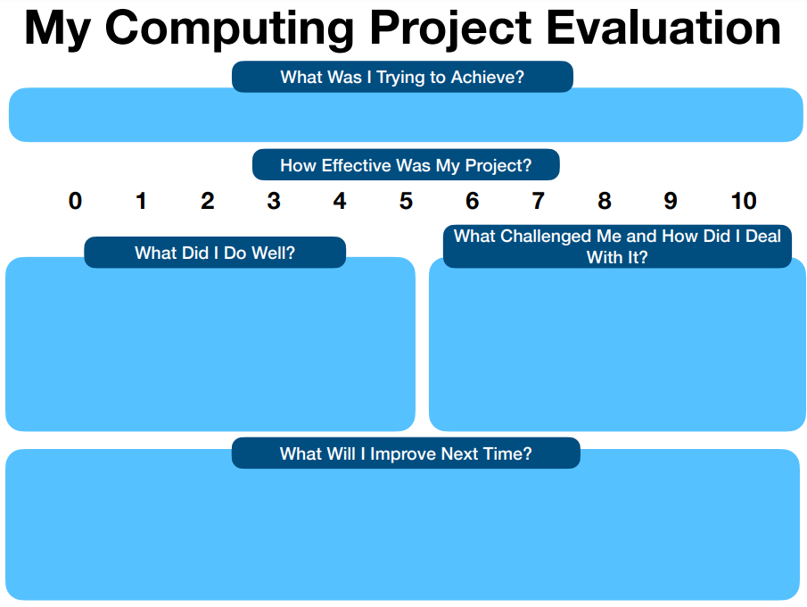  Share It is important to make sure the pupils save their work to a safe space online Class Dojo or YouTube).  In uploading their work, it is important to make links to the Digital Literacy Objectives from the Progression Document. Ask questions such as: Why do we want to upload this? What personal information are we sharing? Who will be able to see this work? Will this affect our online reputation in a positive or negative way? Explain to the children what you are doing and why. Again, use this as an opportunity to re-enforce some of the messages from the digital literacy curriculum.  Please feel free to email Mr PICT mrparkinsonict@gmail.com and it will feature them on the MrPICT.com/showcase page. | - Provide verbal prompts or a peer to help students watch and reflect on their video. You can also model filling out the form by walking through an example together  - .  - Provide sentence starters to help structure their feedback, such as: "The animation works well because…" or "I think the voiceover could be improved because…

