Year A |  |  |  | Term: | Autumn 2 |  | Unit: |  | Healthy Humans
Big Question: | How can we create our own
Prior Substantive Knowledge | 3D  - To confidently use sculpting techniques to confidently explore the use of line, texture, colour, shape, to create different effects.  - To begin to demonstrate control of tools and materials of their choice to create a desired effect  Textiles  - To confidently use sculpting techniques to confidently explore the use of line, texture, colour, shape, to create different effects.  - To begin to demonstrate control of tools and materials of their choice to create a desired effect |  |  |  |  |  | Cross-curricular |  | D.T
Prior Substantive Knowledge |  |  |  |  |  |  | Key Vocab  Essential vocab |  | • Texture: Both 3D sculptures and textiles have tactile and visual textures that contribute to their aesthetic and conceptual qualities.  • Pattern: Both fields can involve repeating designs or motifs that create visual rhythm.  • Structure: Refers to how a piece is physically organised or assembled, whether it's a textile's weave or a sculpture's form.  Running stitch, blanket stitch, Papier Mache, natural, synthetic, stitching, threading, decoration, viewpoint
Substantive Knowledge: |  |  |  |  |  |  |  |  |  |  | Disciplinary Knowledge (Think like)
Declarative Knowledge (Know what) |  |  | Procedural Knowledge (Know how) |  |  |  |  |  |  |  | Textiles  - To begin to use learnt techniques in textiles in different contexts e.g. work on different scales both independently and collaboratively.  - To demonstrate control of chosen tools and materials to create a desired effect.  - To use learnt techniques in textiles in different contexts and with a variety of materials.  3D  - To begin to use learnt techniques in sculpture in different contexts e.g. work on different scales both independently and collaboratively.  - To demonstrate control of chosen tools and materials to create a desired effect.  - To use learnt techniques in sculpture in different contexts and with a variety of materials.
- To discuss the styles of artists, craft makers or designers and use this to inform their own work.  - To analyse the styles of artists, craft makers or designers.  - To begin to understand the historical and/or cultural significance of a chosen artist/ art form. |  |  | To show confidence and independence when working creatively e.g. range of media on different scales.
Teacher Knowledge |  |  |  |  |  |  |  | FRUITS |  | Faith  Relationships  Uniqueness  Intellect  Treat Others with Respect  Salvation
Key concept |  | Learning objective | Key components |  |  | Main input |  |  |  |  | Activity | Adaptive strategies
Visual Literacy |  | To be able to look at different artists and see how they portray fruit within art | Understand why the artists have painted/ created these pieces.  Draw the fruit from eye and add in the textures  Shade the fruit to show the different textures. |  |  | Show the children the different artists on the PowerPoint.  Ask the children these questions:  How are these artists similar?  How are these artists different?  How have they brought their design to life?  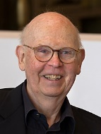  Which one is your favourite piece and why?  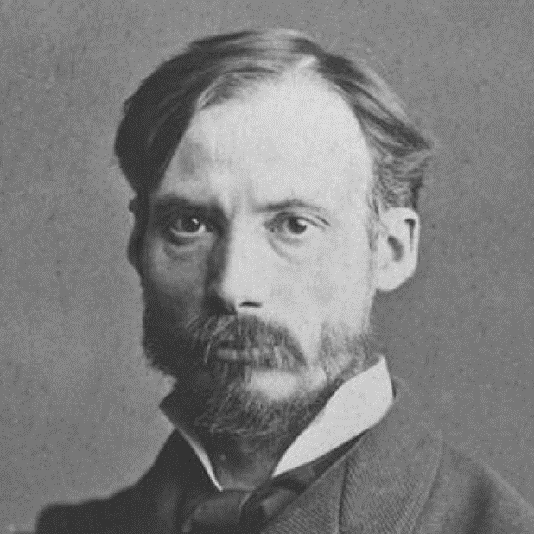  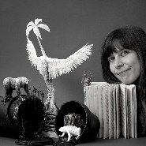  Show the children a fruit bowl and ask them to pick a piece to draw.  Show the children some real fruit e.g. strawberries, apples, pears, pineapple  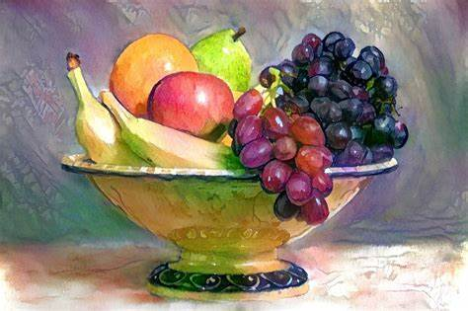 |  |  |  |  | Children to draw their own piece of fruit and look at the different shades | Give the children a printed picture of the fruit bowl and allow them to touch and feel the fruits they are drawing.
Generate ideas |  | To be able to plan and create a realistic fruit using Papier Mache |  |  |  | Papier Mache- plan and make  Show the children some pictures of Papier Mache fruit and vegetables.  Get the children to decide if they want to make an apple, pear or orange (these will the easiest to make)  Ask the children to draw their chosen fruit and shade it in to help with the final product.  Begin to model how to do Papier Mache and talk about how many layers are needed- 3 to 4 is the recommended layers. |  |  |  |  | Children will need to plan their own piece of fruit
Create |  | To be able to add different shades of colour to create a realistic fruit |  |  |  | Papier Mache- paint  Show the children a finished one and how to the shading of painting can be done to show the different textures and gradients of the shade of colour.  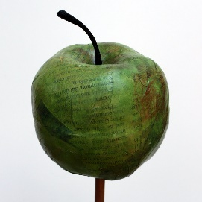 |  |  |  |  | Children will need to paint their fruits using watercolours or poster paints.  Paint the fruit white to start with. | Have different colours and shaded painted on some paper to allow the children to know how to make these shades.
Textiles |  | To be able to understand different stitches |  |  |  | Stitching- practise
Generate |  | To be able to plan a simple design and include the stitch |  |  |  | Stitching- Planning  Show the children the Christmas pudding
Present |  | To be able to apply the stitch to make a finished piece |  |  |  | Stitching, stuffing and sticking

