Physical Education
Questions I can answer
FRUITS
Significant people
Indoor P.E- Athletics
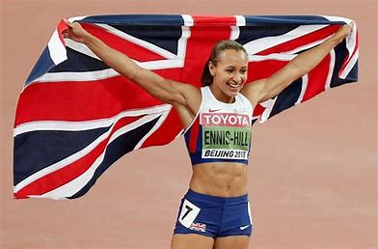
UKS2 – Summer 1 2025
Am I able to work independently and as a team in competitive games?

Can I name 5 athletic games that take part in the Olympics?
Jessica Ennis-Hill – Olympic Gold Medal for the Heptathlon.
Sprinting- to run a short distance at top speed.
Hurdling- to leap over obstacles while running.
Throwing- to launch something from one hand with force.
Jumping- to jump over obstacles while running.
Key Facts
- Athletics is both an outdoor and indoor sport.
- The Olympic Games feature athletics as one of the main events.
- Athletics develops the most basic human skills- running, walking, jumping and throwing.
- Athletic games are competed all over the world.

I know how to perform push, pull and sling throw.
I know how to perform a combination of 5 jumps.
I know how to recognise strengths and areas of improvement in my own performance.

Faith – How different cultures and religions come together and compete.
Relationships – Working together as a team.
Uniqueness – Each Athlete has their own unique style.
Intellect – How we use our knowledge in each race
Treat Others with Respect – Show respect during all competitive games.
Salvation – Understanding that it’s okay if you fall, just know to get back up and keep going.

Things I already know
Key Vocabulary

