Things I already know:
- Identify, name, draw and label the basic parts of the human body and say which part of the body is associated with each sense.
- Notice that animals, including humans, have offspring which grow into adults.
- Identify that animals, including humans, need the right types and amount of nutrition, and that they cannot make their own food; they get nutrition from what they eat.
- Identify that humans and some other animals have skeletons and muscles for support, protection, and movement.
- Describe the simple functions of the basic parts of the digestive system in humans.
- Identify the different types of teeth in humans and their simple functions.

Animals including humans
Science
UKS2 – Summer 2

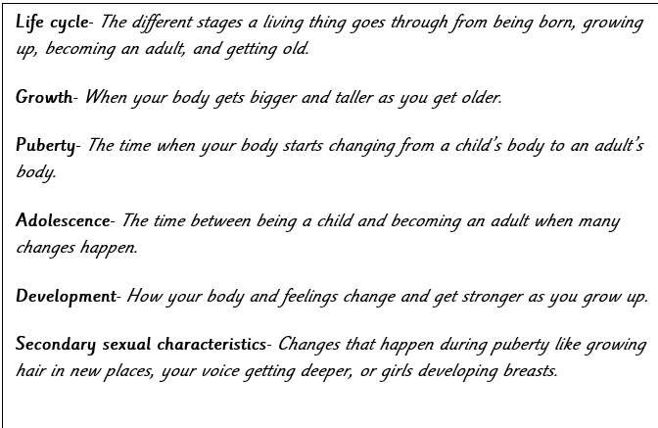
Key facts Key vocabulary
- That humans start as babies, move into childhood, then into puberty (teenagers), to young adults and into adulthood.
- That humans have multi stages of growth throughout their lives.
- That as humans become older, things such as their bones fuse together and their muscles develop.
- An adolescent is a young person between 10 and 19.
- Puberty is the stage of development between childhood and adulthood.
- Two parts of the brain- the hypothalamus and the pituitary gland- start to make more of certain hormones.

