Things I already know:
- Identify that most living things live in habitats to which they are suited and describe how different habitats provide for the basic needs of different kinds of animals and plants, and how they depend on each other.
- Recognise that living things can be grouped in a variety of ways.
- Identify that most living things live in habitats to which they are suited and describe how different habitats provide for the basic needs of different kinds of animals and plants, and how they depend on each other.

Science
UKS2 – Summer 1
Animals and plant life cycles

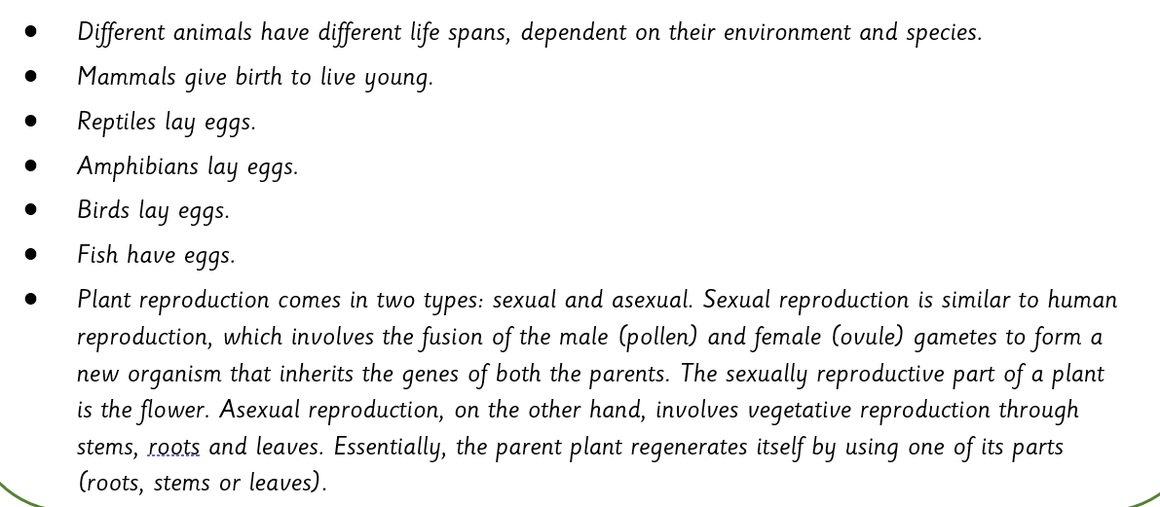
Key facts Key vocabulary
