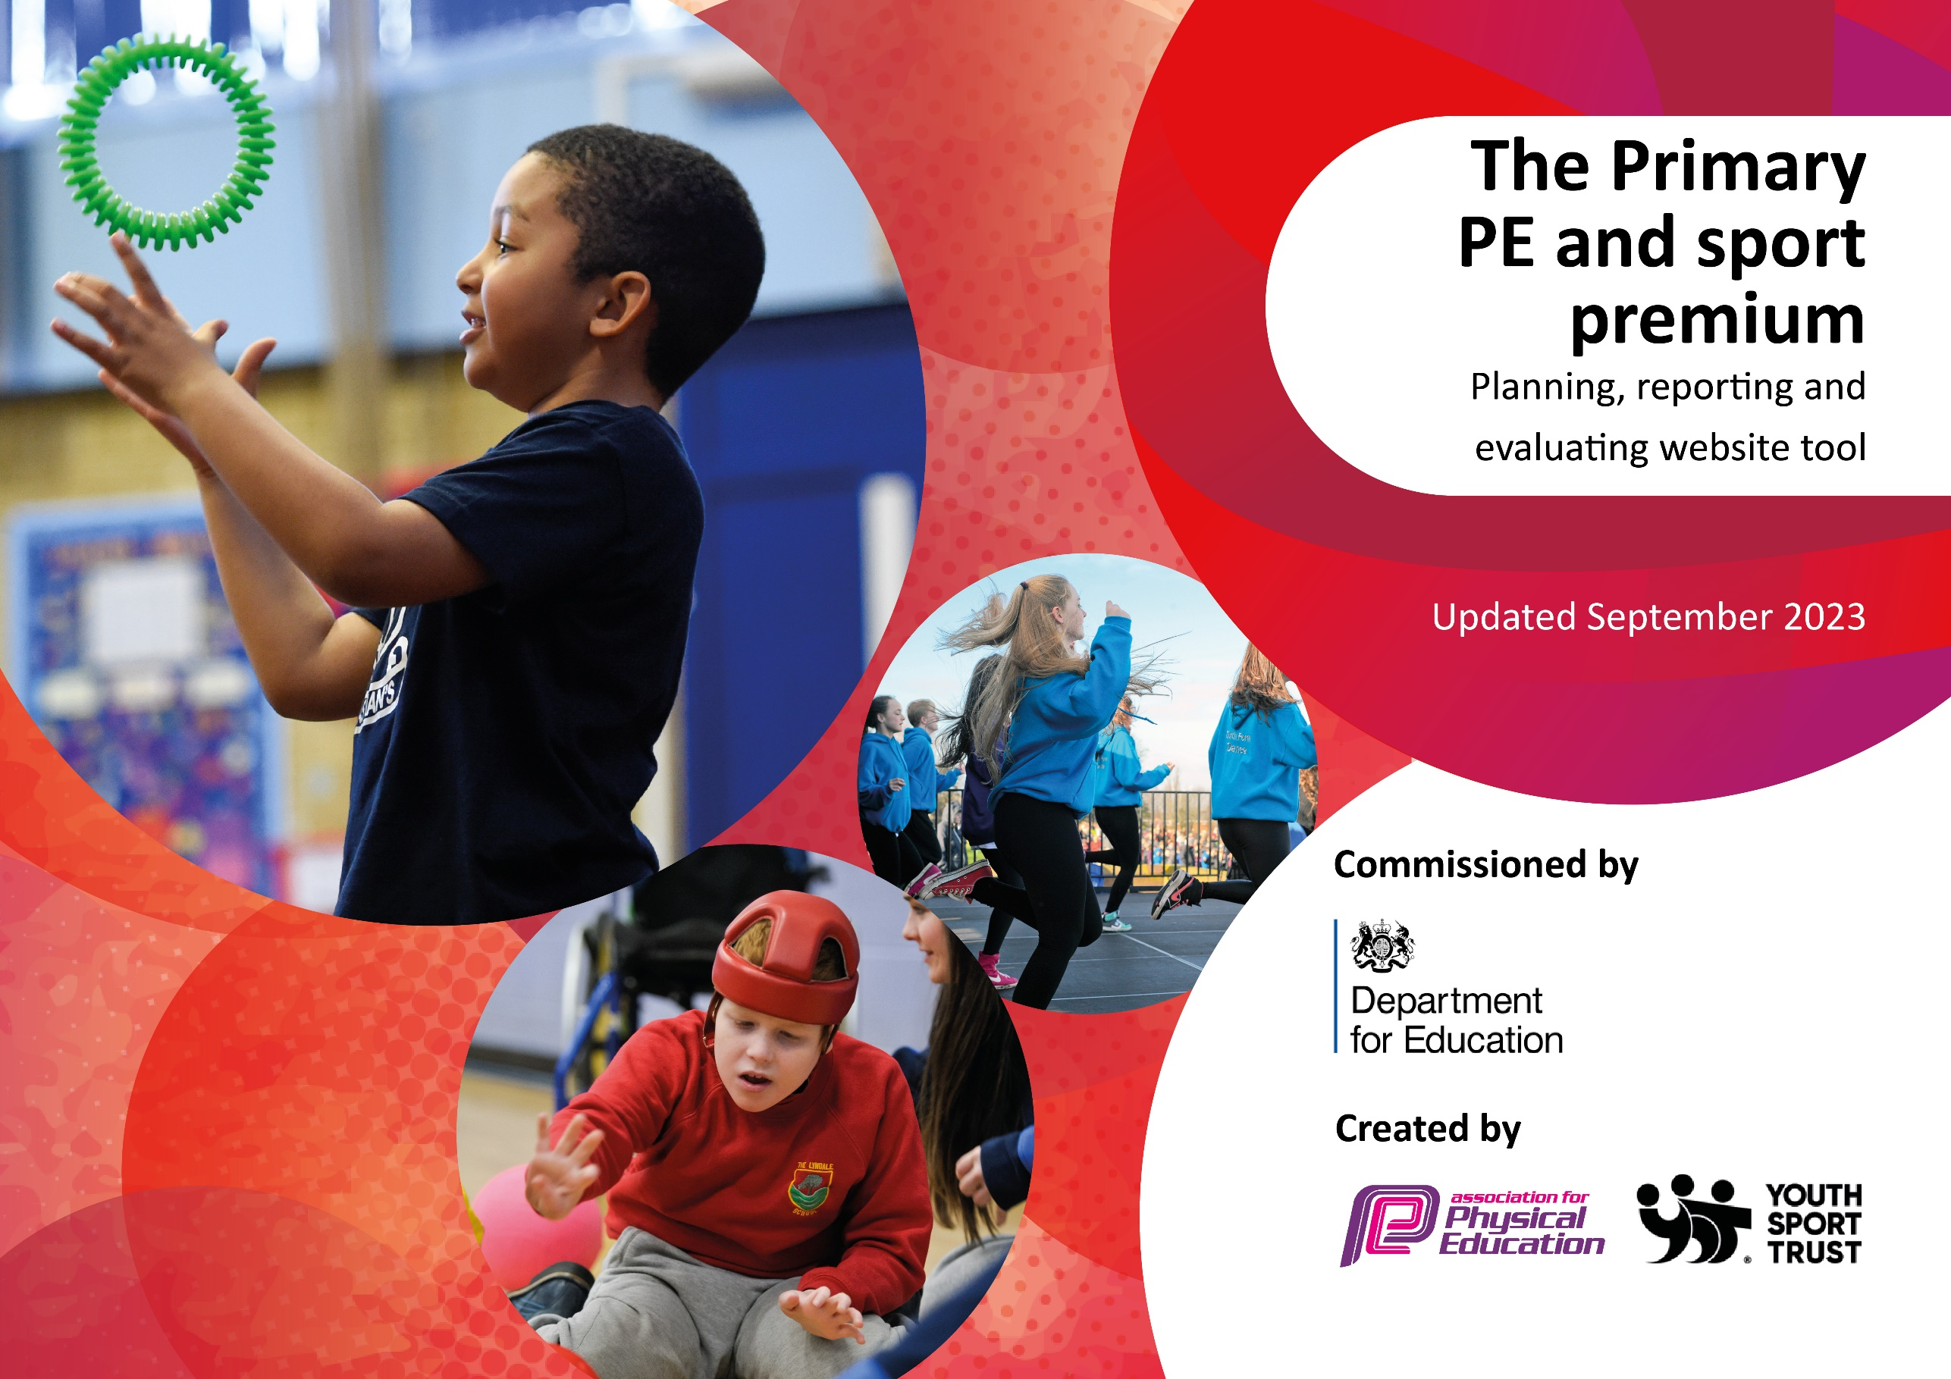
,.;v;/

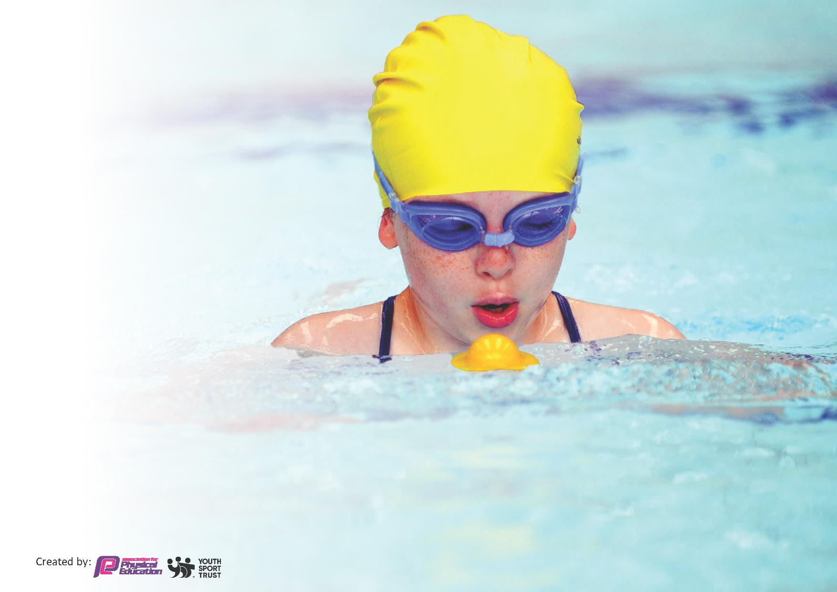
This template can be used for multiple purposes:
by:
- It enables schools to effectively plan their use of the Primary PE and sport premium
- It helps schools to meet the requirements (as set out in guidance) to publish information on their Primary PE and sport premium
- It will be an effective document to support Ofsted inspections enabling schools to evidence progress in Physical Education (PE) and evidence swimming attainment, which forms part of the PE National Curriculum. We would recommend schools consider
the Intent, Implementation and Impact of any spend, as examined within the Education Inspection Framework.

It is important that your grant is used effectively and based on school need.

Schools must use the funding to make additional and sustainable
improvements to the quality of the PE, School Sport and Physical Activity (PESSPA)
they offer. This means that you should use the Primary PE and sport premium to:

- Build capacity and capability within the school to ensure that improvements made now will benefit pupils joining the school in future years
- Develop or add to the PESSPA activities that your school already offers.

The Primary PE and sport premium should not be used to fund capital spend projects; the school’s core budget should fund these. Further detail on capital expenditure can be found in the updated Primary PE and sport premium guidance.

The Primary PE and sport premium guidance, outlines 5 key priorities that funding should be used towards. It is not

necessary that spending has to meet all the key priorities, you should select the priorities that you aim to use any funding towards.

Although completing this template is not a requirement for schools, schools are required to publish details of how they spend this funding. Schools must also outline what the impact this funding has had on pupils’ PE and sport participation and attainment and how any spending will be sustainable in the future. All funding must be spent by 31st July 2024.

The Department for Education has worked closely with the Association for Physical Education (afPE) and the Youth Sport Trust (YST) to develop this template and encourages schools to use it. This template is an effective way of meeting the reporting requirements of the Primary PE and sport premium.
Review of last year’s spend and key achievements (2022/2023)

We recommend you start by reflecting on the impact of current provision and reviewing your previous spend.

Activity/Action | Impact | Comments
- Replenish PE equipment  - EYFS facilities/equipment  - Gymnastic mats and benches repairs  - ED and LS to attend level 5 PE leaders’ course  - Introduction of the climbing wall to ks2 children.  - Water sports  - Dance sessions  - Fishing sessions  - Swimming  - SSP events | Having the correct equipment is key in that we want the children to practice the correct techniques. For example, in athletics we will be working on the push throw. It will be more successful using the shots rather than tennis balls.  The confidence and coordination have improved massively in the children from EYFS. Intervention work takes place in small groups to give more attention on the throwing and catching skills of the children.  The children throughout the school can perform consistent gym sequences on and off the apparatus. Therefore, it is essential for our equipment to be made safe for practice.  Staff are more competent when delivering the curriculum. Throughout the course staff learnt new ways to adapt their sessions. For example, how to challenge the children in physical education and school sport.  Children thoroughly enjoyed the session as it is a new experience to most children. Children have talked about going to similar experiences at Burnley College and in the Lake District.  Again, these are opportunities that children are less likely to uptake outside of school. Therefore, it is important we broaden children’s horizons as not everyone will enjoy dance or invasion games.  Children have become more creative learners and are able to communicate with group members when planning a dance performance.  Children have become more patient and calmer around the lake. The instructors have introduced a scheme where they are rewarded with badges when they achieve the success criteria.  Majority of children leaving St Leonard’s achieve their 25 meters and are competent when performing self-rescue techniques. We need to encourage more children to go swimming out of school hours.  Children feel a sense of pride and achievement when they represent the school in a sporting event. Children always perform to the best of their abilities and their behavior is second to none. | £1340  £1000  £889  £1800  £1500  £730  £1675  £900  £4000  £1140

Key priorities and Planning
This planning template will allow schools to accurately plan their spending.

Action – what are you planning to do | Who does this action impact? | Key indicator to meet | Impacts and how sustainability will be achieved? | Cost linked to the action
Dance and Gymnastics Cpd  ED and LS swimming course  Balance bike session- Reception and Nursery  Swimming for ks1/2 and booster session  Dance sessions  Climbing Wall  Gym equipment repairs  Fishing sessions | Lauren Shirtcliffe and 18 children from upper ks2 who attended the dance club in preparation for the event.  Elliot Deakin and Liam Simm  Children from EYFS  Ks1, 2 and EYFS children  KS1, 2 and EYFS children  Ks2 students  KS2 children | Increased confidence, knowledge and skills of all staff in teaching PE and sport  Broader range of activities for all pupils  Profile of PE and sport is raised across the school as a tool for whole-school improvement  Broader range of activities  Profile of PE and sport-whole school improvement  Broader range of activities | From this we will have another staff member who will be able to deliver dance and gymnastics.  Lauren quoted “I have enjoyed the course and gained in confidence and knowledge of gymnastics and dance”.  From the CPD swimming, teachers have more understanding of the curriculum and are positive in their delivery which will make the children feel at ease if staff are in the water with them.  The bike sessions have developed children’s balance and coordination. (40 children from year 5 and 46 children from EYFS)  Supporting children to be more aware of the outdoors. Joshua, a pupil from reception class said “I loved the session- can we do it again”. We are looking to book in more sessions with the company.  Swimming has increased children’s stamina and confidence around water. Improves strength and flexibility.  Dance sessions have supported student’s cognitive functions. Support communication skills when working in groups. This shows with 84% of year six children being able to swim 25 meters.  Climbing activities have developed motor skills, confidence and social skills. Having a broader range of activities has allowed students to experience new activities. Oliver in year 5 “I was able to challenge myself and definitely want to do this again”.  As we use the gymnastics tables almost every day it is important to have an annual inspection for the safety of the children. Children can continue to perform high quality sequences.  Students have grown in confidence and particularly enjoy providing feedback to their peers about their performances.  Children feel a sense of accomplishment when catching fish. The sessions have improved coordination and patience.  Hattie “I love the sessions. It is good to meet other children from other schools”.  Water sports helps children build strength and endurance. Sessions will help children to relax and take in their surroundings.  From the experience of White moor Lakes, a pupil in year 3 regularly attends kayaking sessions most weekends. | £700  N/a  £320  £2268  £2065  £750  £746  £1530

Cooking with Burnley Leisure  Pe equipment  Skills to play sessions  SSP Buy in  Mapping of grounds for orienteering  Healthy heads  Level 1 bike ability | Year 5 and 6 children  Ks1 and 2 children  Ks2 children  All children | Profile of PE and sport  Broader range of activities  Broader range of activities  Profile of PE and sport  Increased participation of competitive sport | Giving children roles and responsibilities (looking after playtime equipment) have supported their decision-making skills and self-esteem.  Cooking sessions have developed fine motor skills and promoted healthier eating habits.  Pupils have become more interested in preparing meals with their families at home.  New pe equipment- having the correct tools will support children’s techniques. For example, throwing a javelin or a howler will be more appealing and relevant for the children.  Skills 2 play sessions- 30 children from a ks1 class have taken part in the weekly sessions. Children have developed their fundamental skills such as hopping, throwing, catching and rolling a ball. We can use these sessions to help with assessments and intervention work.  SSP buy in-  56 children from ks1 and 2 have took part in a sporting event ranging from cricket to a SEN event. From these events children have gained in confidence, displayed good character values such as resilience and teamwork.  Aiden (year 6) “I have enjoyed representing the school in football and cricket. As a team we worked well together”.  Orienteering mapping-  From the new resource’s children have developed skills of how to read a map, exercising the brain, working quickly and effectively as a team.  Healthy heads- from these sessions’ children are emotionally literate and be mindful of themselves. Children have more understanding about their mental health and how to look after ourselves.  Level 1 bike sessions- healthier habits will ultimately determine successful results academically and increase their school attendance. Pupils have gained independence and hopefully ride to school.  Handball sessions have improved children’s teamwork skills, determination and dealing with winning and losing situations.  Children develop physical skills and have fun through the use of new equipment.  KS2 Students can explain confidently why it is important to move into space once they have passed the ball.  Competition in children have supported their decision-making skills, develop confidence and determination.  39.6 % of children have attended after school clubs and events. 30 children from ks1 and 102 from ks2. | n/a  n/a  £2677  n/a  £6000 (ssp buy in)  £370  £675

Key achievements 2023-2024
This template will be completed at the end of the academic year and will showcase the key achievements schools have made with their Primary PE and sport premium spending.

Activity/Action | Impact | Comments
Weekly swimming sessions for EYFS, ks1 and ks2.  Broad range of extra-curricular activities and School sport partnership events.  Cooking classes with parents and children  Friday fishing sessions | Year 6- 84% achieving 25 metres and gaining level 2-3.  Year 5- 86% (25 metres)  Year 4- 57% (level 2/3)  Year 3- 38% level 2/3  39% of children have attended an after-school activity (102 from ks2 and 30 from ks1).  24 children from years 4,5 and 6 took part in several dance practices in preparation for the dance event at Life Church. Children grew in confidence and resulted in bronze medals.  Children have developed culinary skills, learning to cook affordable meals whilst spending time with their parents. Students are more aware of healthier habits and the importance of being active.  10 children from years 5 and 6 have taken part in the Friday fishing sessions. Children have built their resilience, learnt new and different techniques of how to attract the fish. The students are working at different stages, two students are working towards their gold award. Other students are at bronze and silver. | Ks1 activities- football, tri golf, gymnastics, multi sports.  Ks2- dodgeball, dance, gymnastics, sea cadets, board games, athletics.

Swimming Data
Meeting National Curriculum requirements for swimming and water safety.
Priority should always be given to ensuring that pupils can perform safe self-rescue even if they do not fully meet the first two requirements of the National Curriculum programme of study

Question | Stats: | Further context  Relative to local challenges
What percentage of your current Year 6 cohort can swim competently, confidently and proficiently over a distance of at least 25 metres? | 84%
What percentage of your current Year 6 cohort can use a range of strokes effectively [for example, front crawl, backstroke, and breaststroke]? | 84%

What percentage of your current Year 6 cohort are able to perform safe self-rescue in different water-based situations? | 84% | Use this text box to give further context behind the percentage.
If your schools swimming data is below national expectation, you can choose to use the Primary PE and sport premium to provide additional top-up sessions for those pupils that did not meet National Curriculum  requirements after the completion of core lessons. Have you done this? | Yes | We tend to take small groups of 7-8 children on Tuesday mornings for children who need that extra push of confidence to become a more proficient swimmer.
Have you provided CPD to improve the knowledge and confidence of staff to be able to teach swimming and water safety? | Yes | ED and LS attended swimming CPD on 28 June 2024

Signed off by:

Head Teacher: | Beverly Holmes
Subject Leader or the individual responsible for the Primary PE and sport premium: | Elliot Deakin Pickard
Governor: | Simon Butterworth - Chair
Date: | 09.07.24

